The Work Zone Signing leading into the Lane and Ramp Closure
(TA-33 with Speed Reduction to 60 mph)
(TA-44 used at entrance ramp)

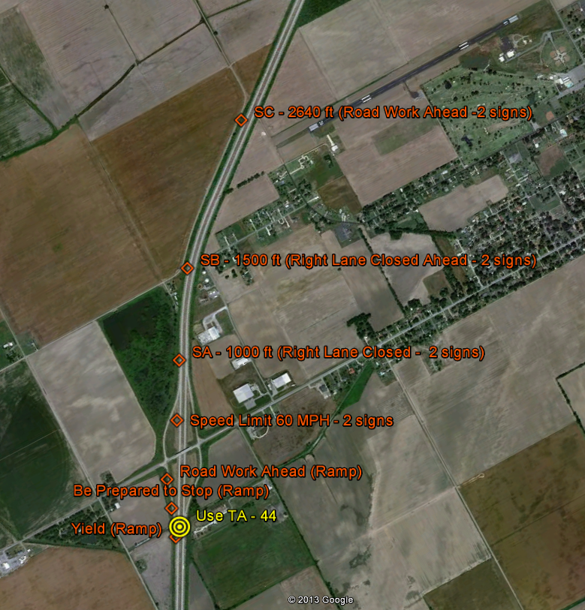

The Work Zone Signing of Lane Closure leading into the Exit Ramp.
(TA-42 used at exit ramp)

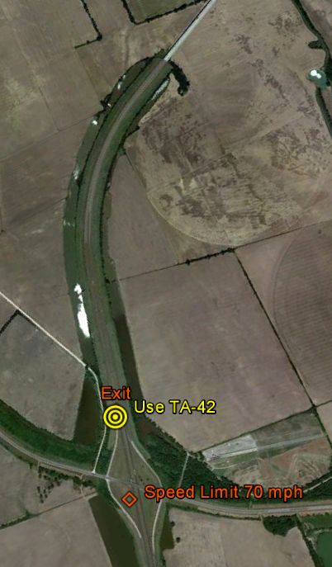

Location of Shoulder Taper, Lane Taper and Beginning of lane clsosure.
Arrow Panel installed on shoulder at beginning of lane taper.
Channelizers used at 100 ft spacing through lane closure.

