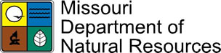

_____________________________

STORMWATER DISCHARGES FROM THIS LAND DISTURBANCE SITE ARE AUTHORIZED BY THE MISSOURI STATE OPERATING PERMIT NUMBER:

M0-R100007

IF YOU HAVE QUESTIONS OR CONCERNS ABOUT STORMWATER DISCHARGES FROM THIS SITE, PLEASE CONTACT THE MISSOURI DEPARTMENT OF NATURAL RESOURCES AT

1-800-361-4827

