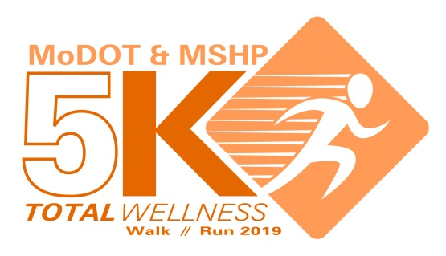

**5K Volunteer Form**

**Volunteers will be critical to the success of the 5K. We need volunteers for before, during, and after the 5K. If you would like to participate in the 5K and volunteer, you will be assigned to an area that will allow you to do both.**

**To volunteer please send the completed form to Rory Forck at** [**Rory.Forck@modot.mo.gov**](mailto:Rory.Forck@modot.mo.gov) **by September 5.**

***Volunteers must be at least 18 years old.***

**First Name:**

**Last Name:**

**Agency (MoDOT or Patrol):**

**Shirt size:**

**Email Address:**

**Do you have any special skills you would like to share for this event?**

**FYI – You will be assigned to one of these areas. Please let us know if you have a preference.**

**Event set up**

**Registration/check-in table**

**Water station**

**Food/water table**

**Direct runners on route**

**Finish line**

**Event clean up**

**Thank you!**