

MEMORANDUM

Missouri Department of Transportation

(Name) Area Team
SL District

TO: (Project number ) Project Files

CC: (name), SL District Engineer
(name), SL Communications Manager
(name), SL Project Manager

FROM: (name)
Area Engineer

DATE: (date)

SUBJECT: (Project public meeting name)

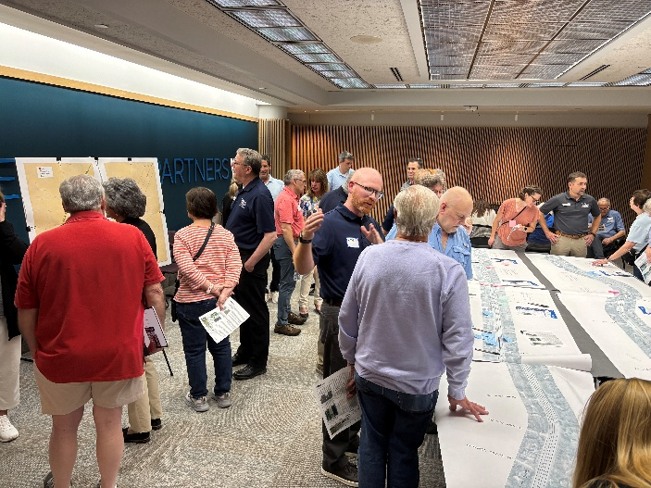
Overall – include pictures or graphs where necessary.
- Meeting summary: Include info on the when and where the public meeting was held, number of attendees, number of on-line visitors, number of comment forms, and call out any organizations or attendees of note (major stakeholders, neighborhoods, elected officials) – include a short summary for the reason for the public meeting, how many boards, any special items (maps or interactive activities) and who from district leadership attended, as well as how many project team staff were available.
- Comment themes and responses – These should be kept fairly high level, unless there was an area of contention, or something specific the team feels is important to address. These should have the general concerns (or area of concerns) and the response from MoDOT.
- Further breakdown of comments – This can be more specific about each of the comment questions, and can talk about general trends (positive or negative) and an evaluation of what those comments discussed – This could be include some of all of a chart showing where comments, or themes. A lot of this info can be obtained through analysis from survey monkey (or other survey programs.
- Next steps – What will MoDOT being doing next – working toward another public meeting, incorporating comments into final plans, etc. If some of these issues will be addressed in future project, share that information here; if it has to wait for a project to be prioritized and funded, state that.

