
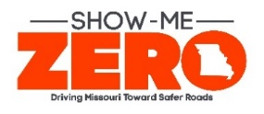




— KC MCRS Resource Directory —
Debra.Huwar@modot.mo.gov
816.607.2187 www.savemolives.com

VERSION: Tuesday, June 27, 2023
Resource Directory KCMCRS OneDrive

Grants Available in KC
$ KC Regional MoDOT MCRS GRANT $

GRANT IS MANAGED & FUNDED BY MODOT MCRS
- MoDOT M.C.R.S. grant application opens March 2 – April 6.
- Monies awarded in July for FY24 (July – next June 2024).
- MODOT MCRS (Missouri coalition for roadway safety) grant application will be housed on MARC Destination Safe Coalition web portal.
  - Suggested Micro Grant Award Range: $100. – $30K
  - Application found on MARC Destination Safe Coalition Website
  - Prospective applicants, review the “MCRS FUNDING GUIDELINES” found on this site: Coalition for Roadway Safety Kansas City Region | Missouri Department of Transportation (savemolives.com)
Contact Debra Huwar 816.607.2187
Visit: https://savemolives.com/mcrs/Kansas-City-Region

$ ANOTHER MoDOT FUNDING SOURCE $
MoDOT Statewide Highway Safety & Traffic Grant (from Central Office)
Annual Grant Opportunity
  - Application Date: Jan – March
  - Prospective Applicants can attend pre-grant meetings (information available December)
  - Grant Award Range: $2,000 - $1 million
  - Interested applicants must (a) address the State’s safety plan, SHOW ME ZERO www.savemolives.com) and (b) create a “User ID & Password” by contacting MoDOT Highway Safety & Traffic division at (573)751-4161
  - Contact: Scott Wilson with questions. (573)751-5408

$ ANOTHER MoDOT FUNDING SOURCE $

E-Citation / Data Grants — MODOT CENTRAL OFFICE ENFORCEMENT GRANTS
- Need E-Citation / Data Grants? Contact Mandy Kliethermes at 573.751.5434 Mandy.Kliethermes@modot.mo.gov

$ ANOTHER MoDOT FUNDING SOURCE $

- Enforcement Grants (Overtime, Equipment, and more) Contact Scott Wilson at 573.751.5408 . Inquire about mini grants prior to applying for larger grants. Funding from: MO Dept of Public Safety Funds Federal Programs - Department of Justice

$ ANOTHER MoDOT FUNDING SOURCE $

- Occupant Protection Funding: Child Passenger, Bicycle, Pedestrian, Safety Programs. Contact Tara Van Loo 573-751-5420

$ ANOTHER MoDOT FUNDING SOURCE $
- Funding for License Plate Recognition (LPR) and More: Contact Missouri Dept. of Public Safety, Program Manager, 573-751-5954

- CITY & COUNTY FUNDING - Transportation Projects: Metropolitan Planning Organization (MPO) for Greater Kansas City, the Mid-America Regional Council funds transportation project proposals for Federal Fiscal Years. Federal Highway Administration funding programs within the MARC metropolitan planning boundary (Johnson, Leavenworth, Miami, and Wyandotte Counties in Kansas and Cass, Clay, Jackson, and Platte Counties in Missouri). This includes funding through these programs: Surface Transportation Block Grant Program (STBG), STBG Set-aside (formerly Transportation Alternatives or TAP) and Congestion Mitigation Air Quality (CMAQ). Please contact Marc Hansen (mhansen@marc.org) with questions.

- MPO & RPG Funds - MPO’s and RPC, although similar in some ways don’t always have equal or identical programs. MPO’s are given the STBG funding directly to use at their discretion (under federal and state guidelines of course). As you can tell, the counties they have listed are only for the MPO and are not rural. The rural county MARC has does not qualify for them (Ray County). The rural funds that exist from the STBG program are utilized for the TAP program, typically offered every other FY (last round was FY2020 funding). That program excludes the MPO counties and only is accessible to my 4 counties and Ray County. TAP is handled by MoDOT, with the input of the RPC

Join the  KC Coalition  M.A.R.C.  DESTINATION SAFE COALITION | We welcome you to join the  Kansas & Missouri Safety Coalition.  Click on link below  About Destination Safe - Destination Safe - Safety - Transportation (marc.org)  Call: Kayla Zacharias 816.701.8281
KC DISTRICT  Law Enforcement Liaisons  (LEL) | Mike Davis covers all counties in the KC District except Johnson County  Email: MDavis.Wmolel@gmail.com  Education & Outreach  Law Enforcement Training  Johnson County Contact: Brian Phillips (417) 880-0089  Education & Outreach  Law Enforcement Training
L.E.T.S.A.C.  Law Enforcement Traffic Safety Advisory Council | Sgt. Doug Ruediger, Chair, Jefferson City PD  Corp. A.J. Silvey, Secretary, Sedalia PD  http://mopca.com/letsac-information-center/
 | Local Motorcycle Safety Program Outreach  Contact Email: Ray rpierce@ucmo.edu  George tart@ucmo.edu
* * *  INVOLVE KC MCRS  INVITE KC MCRS  816 607 2187  * * *  We will attend your functions | P R O M O T E S A F E T Y  EVENTS, MEETINGS, COMMUNITY COALITION,  SCHOOL FUNCTIONS, COUNTY FAIRS, CITY FESTIVALS  What is going on in your community?  What is going on in your schools?  What is going on in local government?  What is going in your city?
F R E E  BUPD  PERMANENT SIGNS | 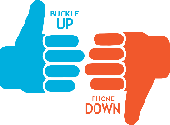  Free  Permanent signs. Four sizes & two images available. You provide posts and installation.  Call or Email Debra Huwar at 816.607.2187 Debra.Huwar@modot.mo.gov
Invitation to use  BUPD  Q.R. Code | You are invited to use this QR Code in your publications!  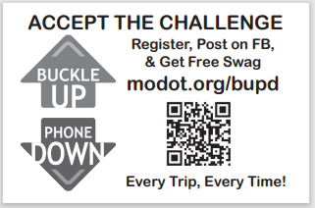
Obtain a  MOBUYS VENDOR NUMBER | Receive Payments from Missouri,  obtain a VENDOR NUMBER.  Contact Email: MissouriBUYS@mo.gov  https://missouribuys.mo.gov/registration  You must first submit a W-9.  Entire process can take 30 days.  Vendor numbers are 11 digits.
Schedule  KC MoDOT Crash Truck  816.607.2187  We deliver |  | 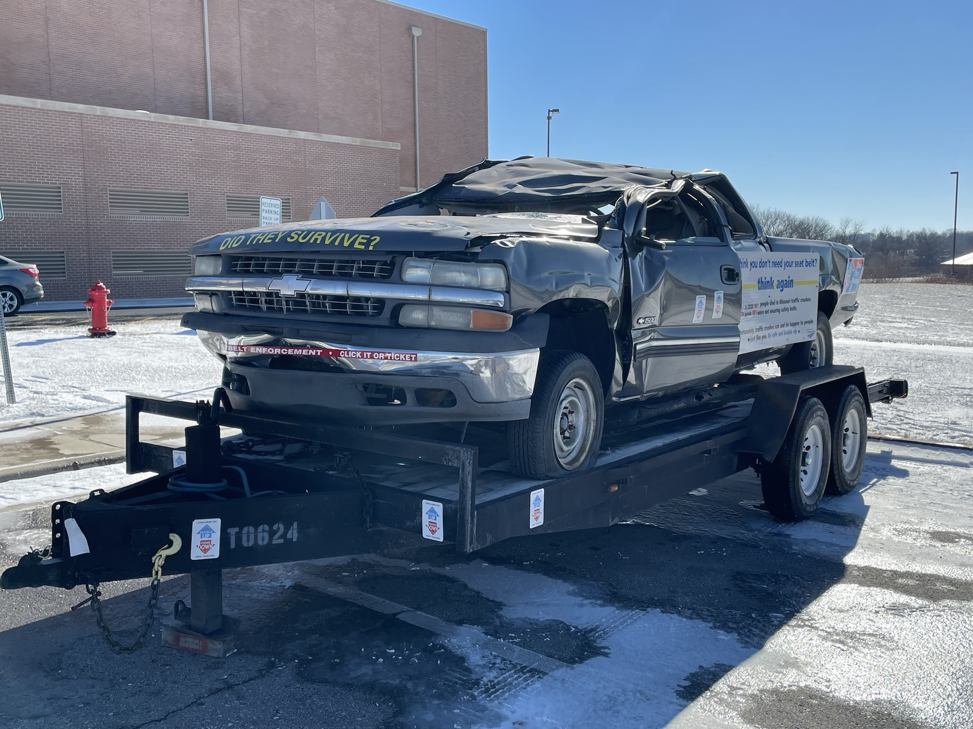  DID THEY SURVIVE?  Crash Truck and Trailer “drives” home the message: WEAR YOUR SEAT BELT  The Crash Truck sends a powerful visual message about the advantage of clicking your seat belt. Every Time! Every Trip!
Kids and Cars. Org |  | Good resource… check this out.  Home | KidsandCars.org
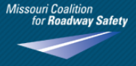  School PROGRAMS  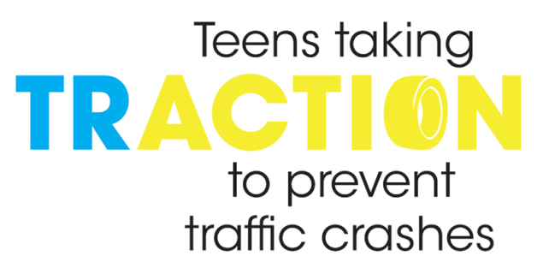 |  | MODOT Youth Leadership Programs involve Students, Educators & Community  MODOT Staff will assist  Contact Debra.Huwar@modot.mo.gov  - Smart Riders (Youth Program)  - Fit to Drive  - TRACTION (Teen Leadership Program)  - B.R.A.K.E.S. www.putontheBRAKES.org  - DOCUDRAMA (Mock Crashes)
MoDOT  Safety  Resource |  | www.MODOT.org/safety
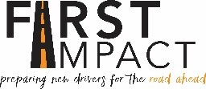  Graduated Driver’s License (GDL) for Parents & Teens |  | FREE G. D. L. Classes for Teens  A must have to get license  Contacts in KC to schedule a free course in your area 816 607 2187 –Debra.Huwar@Modot.mo.gov  Allyn Workman <gawcft@health.missouri.edu>  Contact: firstimpact.missouri.edu  CONTACT: 573.884.3463  First Impact website: umhsfirstimpact@health.missouri.edu  FIRST IMPACT – Traffic Crashes are the #1 Killer of TEENS – that statistic can change… Preparing New Drivers for the road ahead with this free Graduated Driver’s License class.  https://www.youtube.com/watch?v=GPK1JJlhtwA  (For Safety partners, educators, school admin, health officials, and parents of teen drivers)
 |  | thinkfirst.missouri.edu  Free Programs - The mission of ThinkFirst is to prevent traumatic injuries through education, research, and policy. The award-winning ThinkFirst for Teens School Assembly Program presents high-impact injury prevention presentations to Missouri schools free of charge. Invite ThinkFirst to your school or organization and be part of the solution to reduce the impact of injuries in Missouri.  ThinkFirst of Greater Kansas City  Youth Traffic Offenders Program (YTOP)  RoadWise – Youth Driving Program  CALL: 816 276 4955
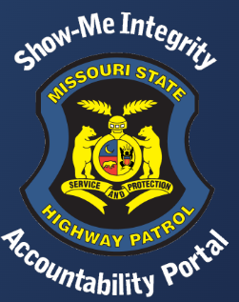 |  | Seatbelt Convincer & Schedule Safety Program  Contact MSHP TROOP A  Bill Lowe or Andy Bell 816.622.0800
Keep Your Keys  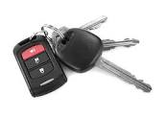  Mature Driver Program |  | Keep Your Keys program is a driver-safety course geared toward people 55 and older, caregivers and facilitators, typically health educators, policy or highway patrol departments, nurses, etc. University of Missouri Health Care's Injury Prevention and Outreach Program provide resources for adults – both individuals and caregivers – who may need support to continue driving or retire from driving.  Contact: Beth Koster 573-884-7143
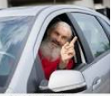  Older Driver Safety Resources |  | - Susan Cohen, Co-founder & President, Americans for Older Drivers Safety, PH 443.520.9716, www.afods.org  - Older Drivers | NHTSA  - Show-Me Zero | Missouri Department of Transportation (savemolives.com)  - www2.modot.org/BuckleUpPhoneDown/  - Older Drivers | National Institute on Aging (nih.gov)  - Older Drivers | Missouri Department of Transportation (modot.org)
  KC SCOUT |  | KC - 816.622.6500 http://www.kcscout.com/  Don’t be on the HWY alone ! ! !  IF YOU BREAK DOWN ON A MO HWY or see anything posing  a danger to drivers we will send help –  objective to keep you safe.
MoDOT Travelers Map |  | http://traveler.modot.org/map/?district=KC  Great resource – check this site out ! ! ! Pass it on.
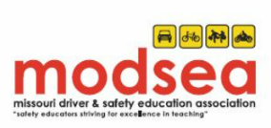  Missouri Driver Safety Education Association |  | The vision of the Missouri Driver Safety Education Association (MODSEA) is to be actively involved and recognized in Missouri as the leader in the delivery of driver and traffic safety education & to be included as an integral part of Missouri’s driver safety plan.  Missouri Driver Safety Education Association | MODSEA  (Live link)
“Show Me Zero”  MoDOT’s Safety Plan |  | Visit: www.savemolives.com
  Motorcycle  Yard Signs & Safety Materials |  | Motorcycle  Yard Signs, Safety Materials  Attend functions  Contact  Scott Wilson 573.751.5408  Debra Huwar 816 607 2187
MoDOT Customer Service  REPORT - Roadway issues |  | Report issues. Get road conditions and more… the possibilities and answers are endless  KC - 816.622.6500 or 888.275.6636
Virtual Driver Interactive  Distracted  &  Impaired Driving Simulator |  | Contact Debra Huwar for scheduling. debra.huwar@modot.mo.gov  One simple decision allows students to experience first-hand the dangers and consequences of distracted and impaired driving. First-person consequence videos, interactive quizzes, and advise from experts. A session consists of the PRACTICE DRIVE to gain experience. The Consequence videos will play based on the unique outcome of each drive. Students are free to repeat any of the drives to experience several different outcomes. This can be taken by an individual or be demonstrated in front of a large audience. MoDOT staff must operate and attend to this simulator.  Time will be based on the number of Students, estimate 6-8 minutes per student.
CPS - Car Seat Install Certification |  | Become certified to install car seats.  Car Seat Certification program  Safety & Health Council of Western MO & KS  CONTACT: Kathy Zents 816 842 5223  For appointments: Beverly - office 816 842 5223
Driver Permit to Age 25 |  | Driver Permit Academy for License & “Alive 25” course.  Safety & Health Council of Western MO & KS  CONTACT: Kathy Zents 816 842 5223
Decrease Youth Impaired Driving |  | To learn more about this program contact  Tri County Mental Health Services  Sherri Miller 816 877 0411
Car Seats  Education Program |  | Car Seats for Littles of Lafayette County Program  Please contact Breanna Jensen  660 259 4371
Where do you belong? |  | Strategies | Missouri Department of Transportation (savemolives.com)
Charlie’s House  913.375.7123  schedule a tour |  |   Prevent accidents & injuries to children in & around the home.
Graduated Driver License (GDL) |  | Teen Drivers (mo.gov)
M.A.D.D. |  | Contact: 816 318 4515  Get involved! Schedule a speaker.  Great Resource: Ron Replogle, Natl’ Law Enforcement Initiatives Coordinator (retired MSHP)  Ron.Replogle@MADD.org
Mo. Dept of Revenue |  | Driver Licensing (mo.gov)
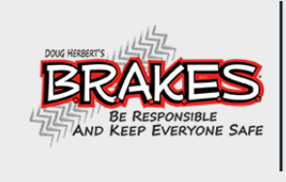 |  | B.R.A.K.E.S. Program – Saving lives across America  Hands on Driving Experience – Invaluable Driver’s Training  Mission: Prevent injuries & save lives by training & educating teenage drivers & their parents about the importance of safe & responsible driving.  www.facebook.com/BRAKES  WWW.PutOnTheBRAKES.org  (Check with MoDOT local office for trainings. Partner with MoDOT to sponsor a BRAKES event in your area)
MASA – MO Assoc of School Administrators |  | REGIONS & DISTRICT DATA: Missouri Association of School Administrators - MASA Map of Regions & Districts (masaonline.org)  MAP 2019 - MASA Counties and Districts (1).pdf (sharepoint.com)
FREE  Order Hwy Safety Materials |  | - www.savemolives.com  - “About Us”  - Order Highway Safety  - Welcome to the on-line system for ordering highway safety materials. If you have an account on our system, please Login to order. If not, please Create an Account to login. To place an order, complete the order form by entering a quantity next to the item Add to Cart; Continue Check Out; and Finish Order.

