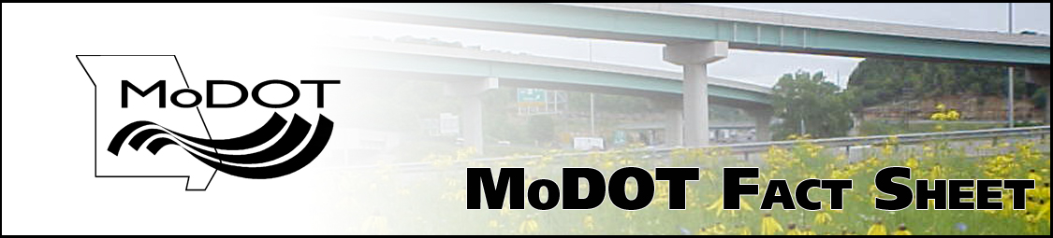

Route 61/67 from Route 231 to Richardson Road Improvements

Improve safety, install two-way left turn lane

What’s the issue?
The purpose of this project is to improve safety on Route 61/67 from Route 231 to Richardson Road in Jefferson County by installing a Two Way Left Turn Lane (TWLTL). By adding this lane, it will improve safety and reduce the number of crashes, as well as help overall traffic flow on Route 61/67.

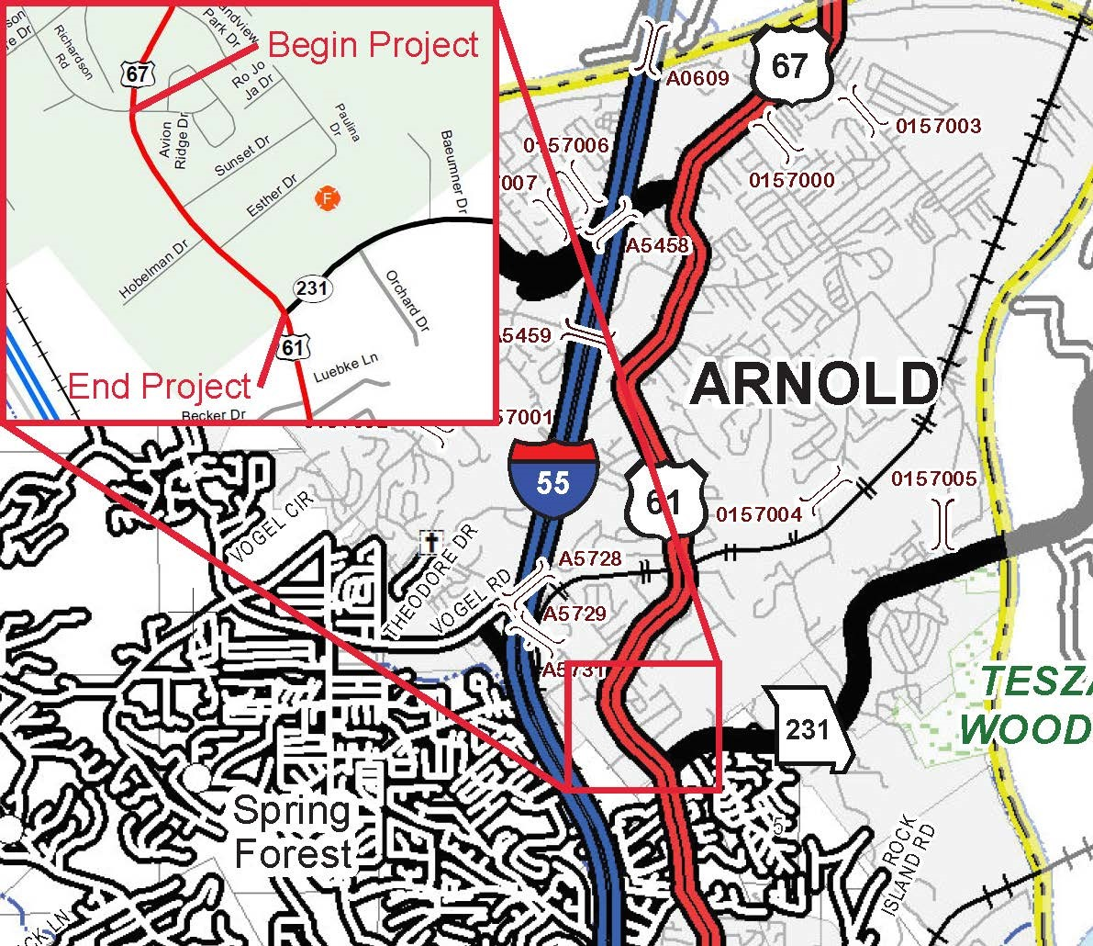

What are the anticipated impacts?
Construction details have not been finalized at this time. MoDOT will work with business owners and residents to ensure that access is available during construction.

What is the anticipated project schedule?
Virtual Public Hearing | November 12, 2020
Right of Way Acquisition | Spring 2021
Contract Award | January 2022
Construction Begins | Spring 2022
Construction Complete | Fall 2022

Is MoDOT purchasing property from landowners?
MoDOT will need to purchase some property and/or obtain temporary easements in order to construct the additional lane through the project limits. A Right of Way representative will be contacting affected landowners during winter of 2020 to begin the acquisition process.

How much will this project cost?
The cost of construction is estimated at $1.2 million.

What if I have questions?
Please contact Project Manager Shirley Norris at 314-565-5648 or via email at Shirley.Norris@modot.mo.gov.

