MoDOT’s 22nd Annual Bridge Building Competition

For high school juniors and seniors

**IMPORTANT INFORMATION FOR TEACHERS**

1. 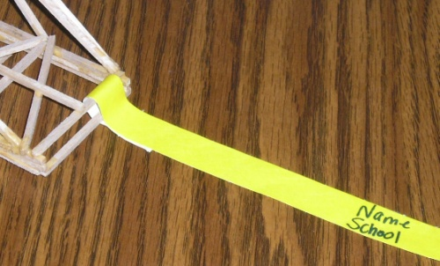The Bridge Competition will be held on Nov. 12th in Academic Hall at Southeast Missouri State University in Cape Girardeau, MO. It will begin at 9:00 a.m.
2. The bridge pick-up dates are Oct. 28th -29th.
3. Please be sure to attach the provided identification tag to the end of your completed bridge before we pick up.
4. If a bridge entry is not completed, please return any unused bridge materials to the MoDOT District Office in Sikeston.
5. You must be *PRESENT* at the competition/awards ceremony on Nov. 12 to win.

**OFFICIAL COMPETITION RULES**

These are the Official Competition Rules to follow. The object of this competition is to design and construct the most efficient bridge within these rules using the provided bridge kit materials.

Follow the rules explicitly, and if you have *any* questions about the competition rules, design or construction, please contact us. It’s always better to ask than be disqualified.

1. Students may use only materials provided by MoDOT. Each student will receive an individual bridge kit containing 15 pieces of 1/8” square balsa wood, a bottle of glue, and string. No other materials may be used, and no more may be used than what’s provided to each student.
2. The bridge must have a deck. The deck should 1) be rectangular in shape, 2) be supported at each end, 3) run the entire length of the structure, 4) be constructed of provided balsa wood, and 5) support the loading car.
3. A solid deck surface is not required, but the loading car must be able to pass the bridge from end to end along the deck (i.e. there should be no string or wood member restricting the car’s passage, see picture).

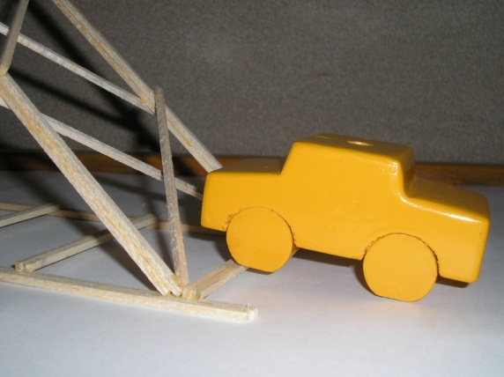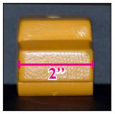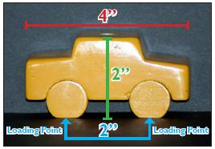

Don't

1. The loading car will be placed on the center of the bridge for loading. The wheels of the car are 2 inches apart, which are 1 inch from the center of the car, with each wheel resting on a loading point. Loading points on the bridge should be located 1 inch on each side of the center of the bridge and no greater than 1 inch above the support surfaces. **If any portion of the loading car, except the wheels, makes contact with the bridge, it will be disqualified.**

1. 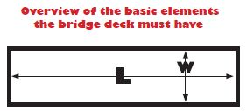Width (W) must be greater than or equal to 2 inches, but less than 9 inches (**for the entire length of the bridge**) so that no part of the car touches the bridge other than the wheels. **At no point shall the bridge width (W) be less than 2 inches or greater than 9 inches.** **Remember the car is 2 inches wide!**
2. 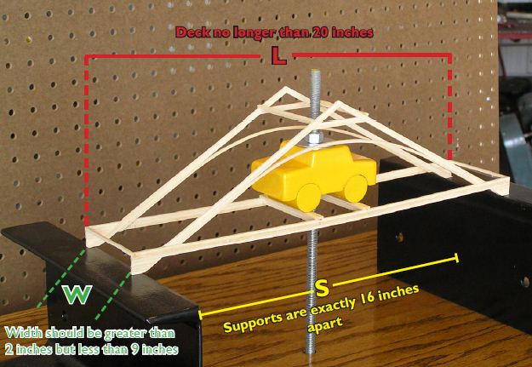The bridge must span (S) both support surfaces. The support surfaces are exactly 16 inches apart and cannot be adjusted during the competition. Keep in mind, if the supports are 16 inches apart, your deck must be longer than 16 inches and must rest on top of the support surfaces. The length (L) of the bridge should be no longer than 20 inches. **Therefore, your bridge Length (L) should be greater than 16 inches but less than or equal to 20 inches.**
3. Bridge height cannot be more than 18” tall.
4. 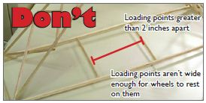The bridge must be constructed with a minimum 1-inch square opening centered on the bridge at mid-span, to allow the loading rod to pass vertically through the bridge and all the way through the top.

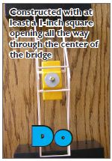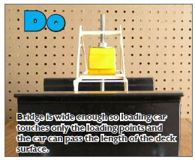

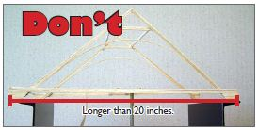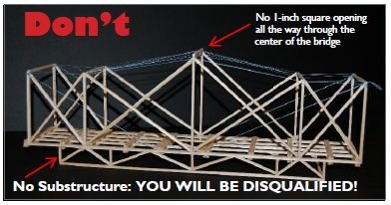

1. 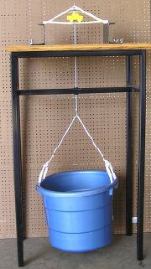The load will be applied to the threaded rod from below. The bridge must support a minimum load of 7 pounds (3.2 kg) and a maximum load of 80 lbs (36.3 kg) will be used to evaluate efficiency (E). Loading will continue until bridge failure. **For bridges supporting a load greater than 80 lbs, the additional load above 80 lbs will not be included in the efficiency calculation.**
2. The bridge with the highest structural efficiency will be declared the winner.

## **DISQUALIFICATIONS**

* All bridges are thoroughly inspected at our office.
* Bridges that do not meet the requirements listed in the Official Competition Rules or use any materials not provided by MoDOT, such as other balsa wood (including leftover competition/practice, will be disqualified.
* If the bridge is constructed with a substructure.
* If any portion of the loading car, except the wheels, makes contact with the bridge.
* Participants will be notified approximately one week prior to the competition of disqualification.
* During the competition, if a condition becomes apparent (use of ineligible materials, etc.) that violates any of the competition rules, that bridge will be disqualified.
* **Decisions of the judges are final.** No discussions regarding disqualified bridges will take place at the competition.

## **DEFINITIONS**

* Load includes loading rod bolted to the loading car through the center with a water bucket hooked to the bottom. The car is 4 inches long, 2 inches wide, and 2 inches tall. The wheels are 2 inches apart, 1 inch off center for loading points.
* Efficiency is calculated using the load, which is the weight of the bucket plus water to bridge failure in pounds (lb) divided by the bridge weight in grams, E=load/weight.
* Bridge failure is defined as the inability of the bridge to carry additional load or a load deflection of 1 inch under the loading location, whichever occurs first.

## **CONTACT US**

We highly recommend that if you have any questions, contact us or send us a photo/drawing of your bridge before we pick them up.

Katy Bower

[Kaitlyn.bower@modot.mo.gov](mailto:Kaitlyn.bower@modot.mo.gov)

573-380-0744

Ashley Metelski

[Ashley.metelski@modot.mo.gov](mailto:Ashley.metelski@modot.mo.gov)

573-380-9432

Katie Bond

[Katie.bond@modot.mo.gov](mailto:Katie.bond@modot.mo.gov)

573-472-5276



Missouri Department of Transportation

Southeast District Office

[2675](mailto:kaitlyn.bower@modot.mo.gov) North Main Street

Sikeston, MO 63801