Excel2Oracle Assistance
This Quick Reference Guide (QRG) lists the most common support needs and error messages that are returned when a report is rejected by the Excel2Oracle server. After reviewing these errors if you need additional assistance please call or email:

HQ - Jon Varner | Jonathan.Varner@modot.mo.gov | (573) 526-4353
NW – Janique Flora  NE – Macy Rodenbaugh  KC – David Brown  CD – Lori Greer  SL – Brian Lange  SW – Adam McRae  SE – Brandon Voyles | Janique.Flora@modot.mo.gov  Macy.Rodenbaugh@modot.mo.gov  David.Brown@modot.mo.gov  Lori.Greer@modot.mo.gov  Brian.Lange@modot.mo.gov  Adam.McRae@modot.mo.gov  Brandon.voyles@modot.mo.gov | (816) 387-2431  (573) 248-2458  (573) 607-2113  (573) 751-7691  (314) 453-1819  (417) 621-6303  (417) 252-0018

Picklist Information missing:

If there is information missing in the picklists please contact the appropriate person for support as follows:

- Contract Tab: contract/project/line#s: Contact the district representative to verify and/or adjust the AWP requirements. This is a common issue with change orders or substitutions. The following may prevent contracts/projects/lines from showing up in picklists:
  - Some picklists have additional filters to keep the picklists shorter, but these filters may remove some valid contracts
  - All CRE2O: The contract must be active in AWP – if a contract has been closed out it will no longer show up in the picklist
  - MiscConcrete Sheet: picklist report filters out contracts where the material summary is complete but the contract must have the “095 Materials Summary Approved by HQ” contract time associated. If the contract time is missing the contract will not appear in the picklists. Contact HQ to add this contract time to the contract in AWP accordingly
  - Aggregates Sheet: conversion factor for the material on the line in AWP must be >0, if the conversion factor is 0 or the conversion factor is null then the line will not show up in the picklist. The district will need to add a non-zero conversion factor accordingly

- Mix Designs: First please check the producer and material code entered on your sheet. (The mix designs are filtered from those inputs.) Also, note that mix designs may take a couple of days after being approved to be entered into AWP. Contract the district if you believe a mix is not showing up correctly.
  - The Mix’s material code in AWP must match the material code selected on the CRE2O General tab, if the mix has an incorrect material code please contact HQ

- All others: Producers, Plants, Ledges, Technicians, etc. contact the district representative first, they may need to activate materials for the producer. If they cannot address the issue they should contact HQ
  - Concrete technician list is based on Tech Cert records in AWP. To be listed they will need an active Certification in one or more of the following:
    - CF – Concrete Field
    - CM – Compressive Strength
    - CS – Concrete Strength
    - LS – Low Slump
    - RI – Registered Intern

Major Version History
Version 1 – original release of CRE2O sheets compatible with AWP
Version 2 – re-release due to database changes with update to AWP Version 4.4 in December 2020
Version 3 – changed website address CRE2O sheets pull picklist files from
Version 4 – re-release due to database changes with update to AWP Version 4.7 in July 2022
Version 5 – CRE2O sheets will now enter AWP as authorized July 11, 2024

Uploading issues:

Generally, you should receive an email within 20 minutes of sending in your sheet. If you don’t, please contact HQ to see if there is a known issue. Be aware that if you miss type your email address in the Send/Sync tab the system won’t be able to email you. There are two send methods provided, please try the other one if you are experiencing issues.

The Email Send option relies on an actual Outlook client being installed and configured correctly to work. Using an online Outlook webapp may not work.

Email = AWPCRE2O@modot.mo.gov

Macro Buttons not Working

If macros are enabled in excel but the buttons aren’t working, the General setting “When using multiple displays” may need to be changed to “Optimize for compatibility”. This issue seems to come up when the user has multiple monitors. You may need to close and re-start excel for the setting change to take effect.

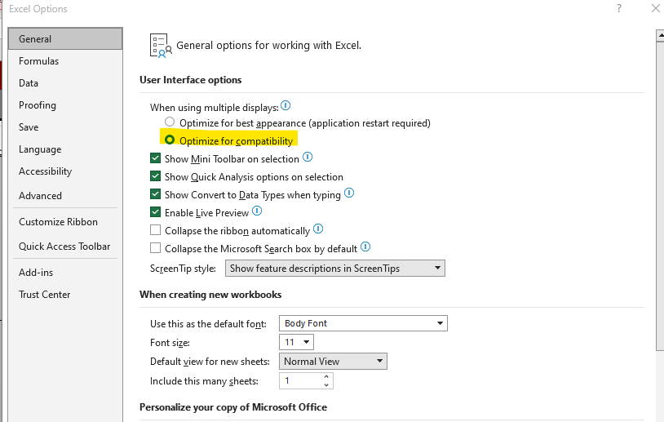
List of Typical Rejection Errors:
- Database Error: ORA-00001: unique constraint (AASHTOWAREADM.SAMPLERECORD_UC1) violated.
- Invalid number at C14. ← MoDOT inspectors will not be notified when this error occurs!
- Error occurred while reading CntrctPrjitmMatSet Id in SmplRecContMatSetAssoc data Type mismatch.
- integrity constraint (AASHTOWAREADM.SMPLRECCONTMATSETASSOC_FK1) violated - parent key not found. It is rejected.
- Contractor password is incorrect.
- 23QMAAA0700 is already in AWP but with a different sample date than this excel file. Please re-submit your file with a different Unique Record Number on the General tab accordingly. If you are revising the sample date the MoDOT inspector will need to change the sample date of 23QMAAA0700 in AWP before you can re-submit.
- startIndex cannot be larger than length of string. Parameter name: startIndex
- Error occurred while reading RetestQuantity in SampleRecordTest data. Required field is empty
- Errors from Cut/Paste and/or altering fields
Errors message received in rejection emails:

“Database Error: ORA-00001: unique constraint (AASHTOWAREADM.SAMPLERECORD_UC1) violated. It is rejected.”
Any time the Unique Constraint error is given the program has found existing data in AWP. Excel2Oracle will not overwrite existing data without being told to do so. This is a done to protect existing information from accidentally being lost. It is common to get this message when submitting a spreadsheet for the second time. Another common reason to receive this error is that the sample ID has already been used for another sample record. Whenever you receive this message, please check AWP to see what is on that sample ID before proceeding.

The CRE2O worksheets have an “Update” switch built in that will allow existing data to be overwritten. The Inspector should check the sample id within AWP to make sure it is appropriate to overwrite. If it is correct to do so, the “Click Here to Allow Updating” button is located on the Send/Sync page of each spreadsheet. Once clicked, the “Click Here to Allow Updating” button will change to “Updating Enabled” and allow overwriting for that spreadsheet however many times it is submitted. Once "Updating" is enabled, the file must still be re-submitted to MoDOT for processing.

Button displays “Updating Enabled” after clicking, sheet must still be re-submitted to MoDOT for processing:
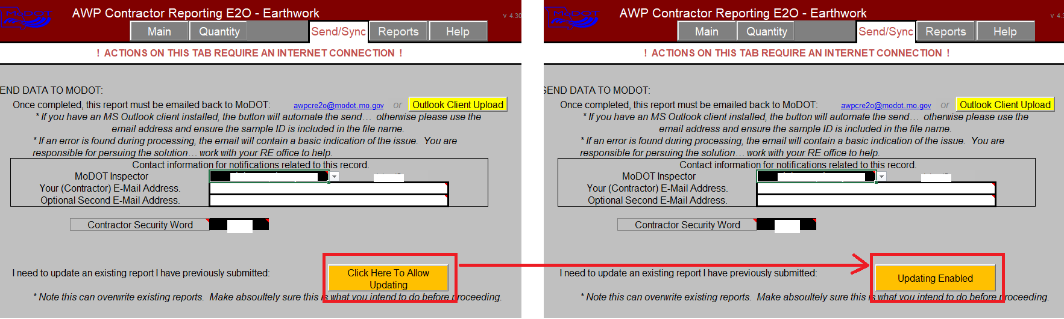
“Invalid number at C14. It is rejected” – the inspector will not receive notification of files rejected with this error!
Inspector wasn’t selected on the Send/Sync Tab when this error occurs:
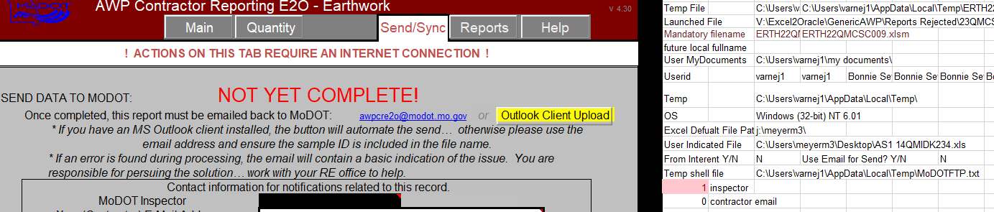
Error also occurs if the inspector’s userid doesn’t appear. In thise case they are no longer in the picklist. They may have left MoDOT or there’s an error in AWP. The inspector must have an active “Universal Sampling” sampling qualification and the “Disable User” field for their user record in AWP must be unchecked for them to appear in the picklist. HQ will need to be contacted to force a picklist update

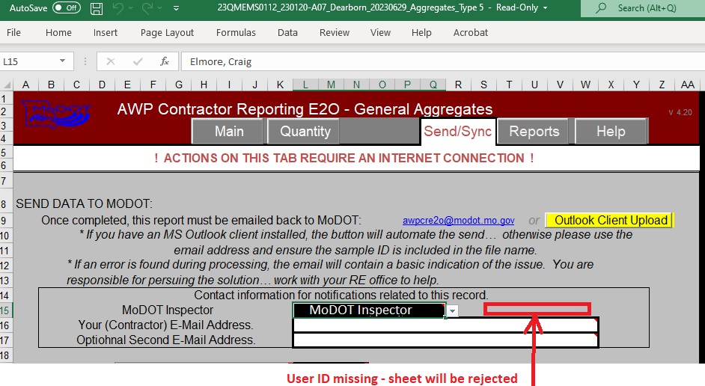
The inspector will need to be selected and the sheet re-submitted
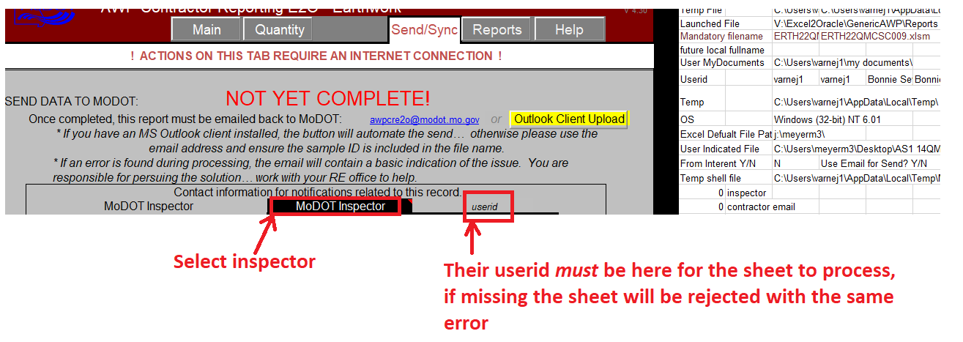

Excel2Oracle looks at the value in cell C14 (AWP_Oracle tab) to find the inspector’s email address. If C14 has an invalid value the rejection notice cannot be emailed to the MoDOT inspector accordingly.
“Error occurred while reading CntrctPrjitmMatSet Id in SmplRecContMatSetAssoc data Type mismatch. It is rejected.”
The line number selected on the contract tab doesn’t match AWP. You’ll need to update picklists on the Send/Sync tab, re-enter the quantity by the line numbers and re-submit. With this error code updating picklists on the rejected sheet will remove the quantity by a line number on the contract tab.

The number value in column AM on the contract tab for the line number will not match when you compare the rejected sheet to the sheet after updating picklists and re-entering the quantity by the line number. AWP identifies each line number by the value displayed in column AM**, this number will change if the “Regenerate Materials and Acceptance Actions” process is run for the line number in AWP. This process should rarely be run, but this Excel2Oracle error may happen if that process is run in AWP.

**column AM displays the CntrctPrjitmMatSet Id, the field referenced in the error code

Sheet as rejected:
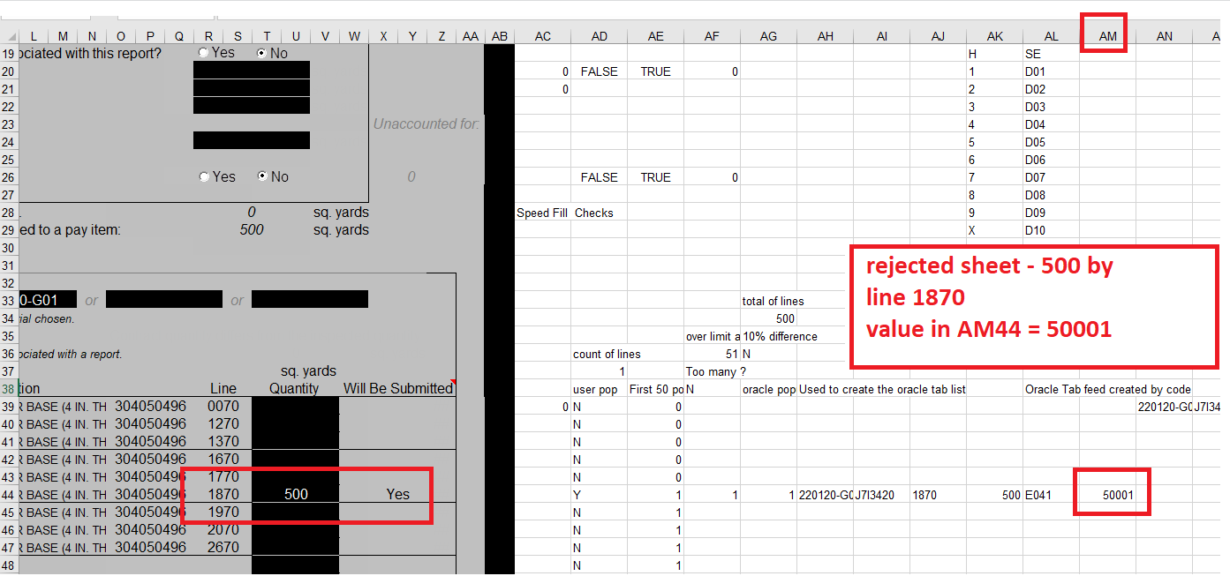
Updated picklists on the rejected sheet and the 500 quantity by line 1870 disappearred: 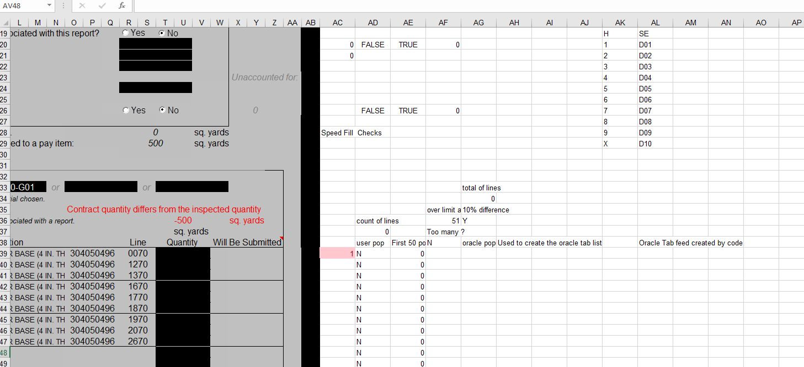

after adding back 500 to line 1870, the value in column AM has changed, the sheet needs to be re-submitted but should process now:
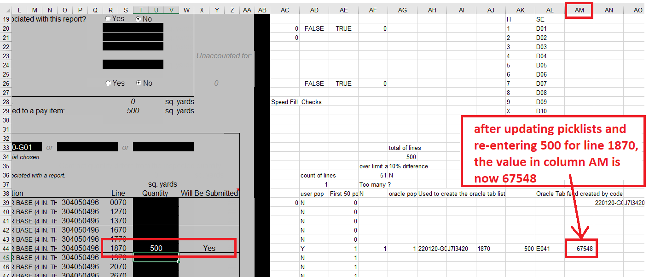
“integrity constraint (AASHTOWAREADM.SMPLRECCONTMATSETASSOC_FK1) violated - parent key not found. It is rejected.”
Similar error to “Error occurred while reading CntrctPrjitmMatSet Id in SmplRecContMatSetAssoc data Type mismatch. It is rejected.” Solution is the same.

Contract and Quantities tab, sheet rejected, note cell AM49 shows 57355
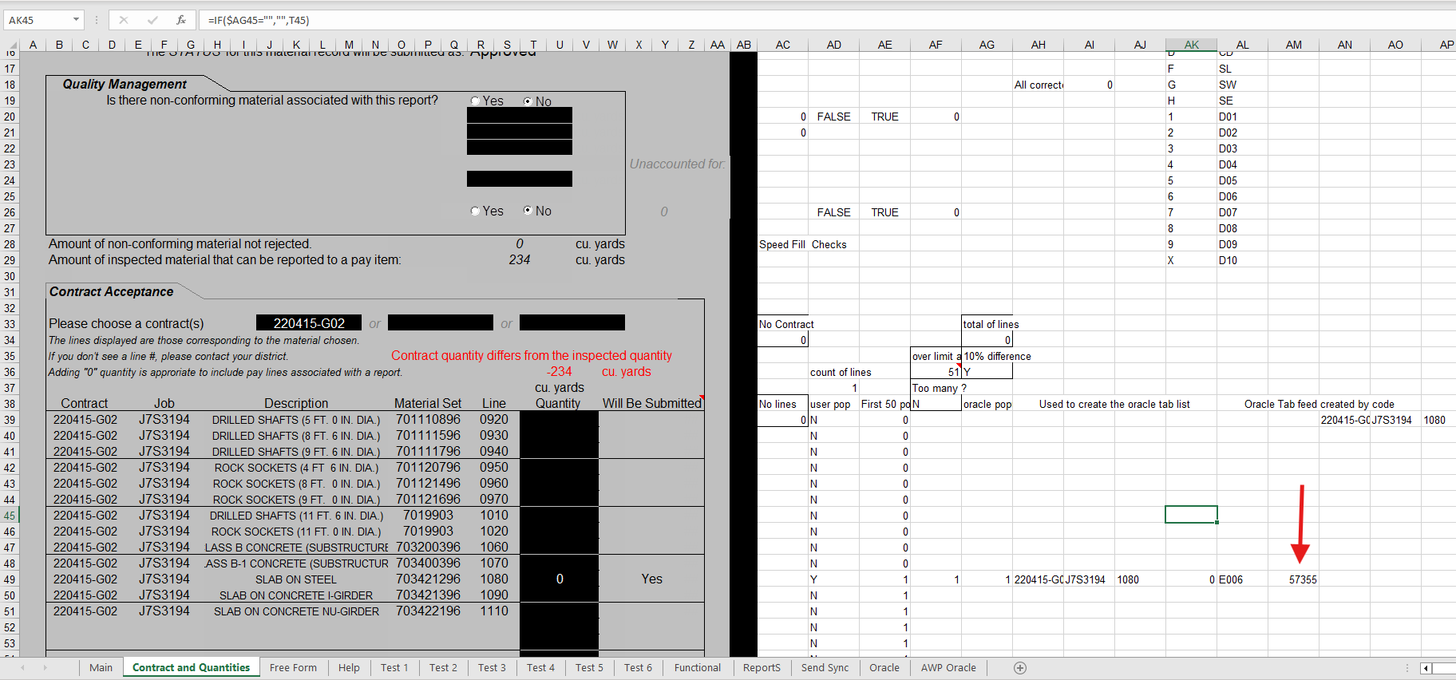
Updated picklists on the rejected sheet and the 0 quantity by line 1080 disappearred:
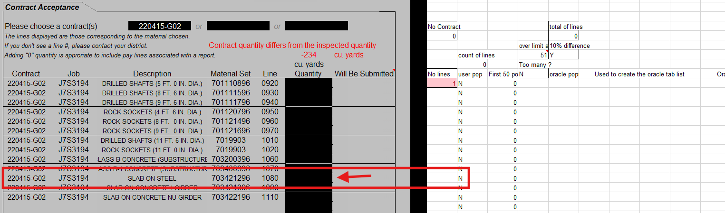
Putting the 0 quantity back by line 1080 the value is now 89625. The sheet needs to be re-submitted but should process now:

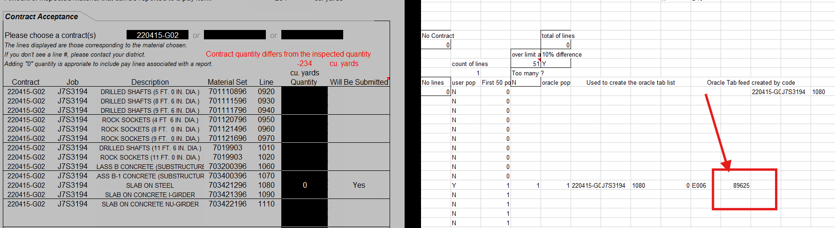
“Contractor password is incorrect. It is rejected”
This error can occur under multiple conditions:
- Using wrong password for the “Reporting Contractor”
  - Will need to contact the district to get the right password
- The wrong “Reporting Contractor” was selected
  - Will need to contact the district to make sure the right selection has been made
  - List pulls from the Vendor table in AWP and some contractors have similar names
  - The contractor’s initials will always be the same for a given company**, if the initials aren’t the same as previous CRE2O records for a given company then the “Reporting Contractor” isn’t right
- The “Reporting Contractor” name doesn’t match AWP anymore
  - Contractor names come from their vendor record in AWP so any change to the contractor’s name in AWP (even adding only a comma or adding “LLC”, etc.) will require the user to update picklists and re-select the contractor on the General tab
  - Updating picklists will clear cell Z10 and remove the contractor’s initials from the Sample ID on the General tab if the contractor’s name in AWP doesn’t match what’s on the CRE2O sheet
  - Sheet will need to be re-submitted after re-selecting the contractor

**unless the company changes names and switches to a separate vendor record in AWP

Rejected sheet as submitted:
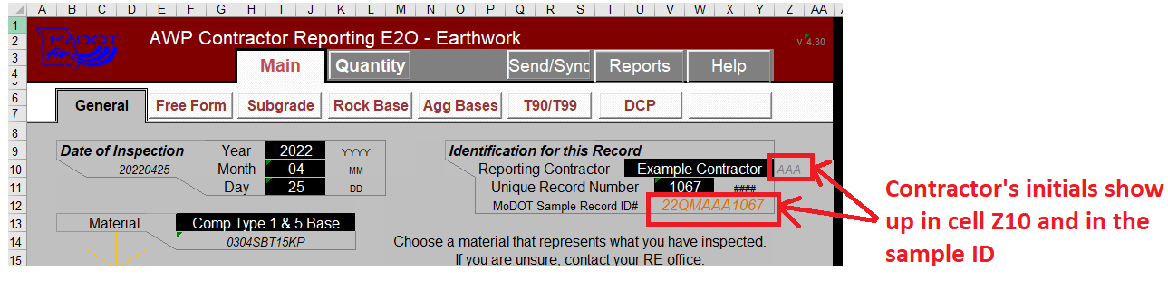
Updating picklists on the rejected sheet clears the values on the General tab shown below:
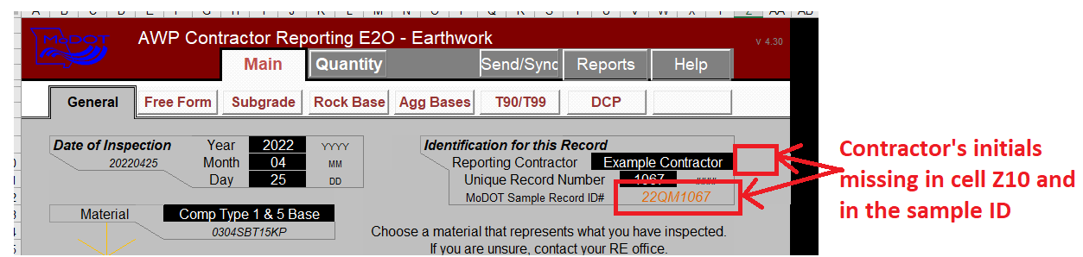
Re-selecting the contractor under their new name brings back the initials, note that the name here doesn’t match what was on the rejected sheet:
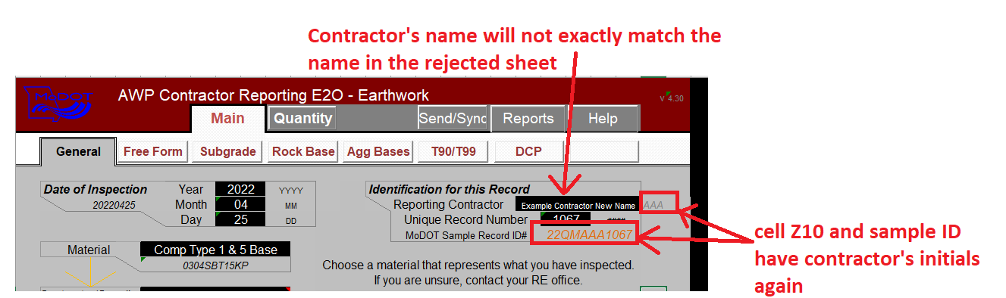

“23QMAAA0700 is already in AWP but with a different sample date than this excel file. Please re-submit your file with a different Unique Record Number on the General tab accordingly. If you are revising the sample date the MoDOT inspector will need to change the sample date of 23QMAAA0700 in AWP before you can re-submit. It is rejected”

The sample ID of the rejected sheet will appear in the error message instead of “23QMAAA0700”

The “Updating Enabled” feature overwrote the existing sample record in AWP regardless of contract or material type. “Updating Enabled” now requires the sample date on the CRE2O sheet to match the sample date in AWP so a user doesn’t accidentally use the same sample ID on different contracts. However, if there is an error on the sample date that the rejected CRE2O sheet is trying to correct then the MoDOT inspector will need to update the sample ID in AWP to match the CRE2O sheet before the CRE2O sheet is submitted. If there are questions on this please contact HQ.

Sample date in AWP will need to be revised to match the CRE2O sheet’s sample date
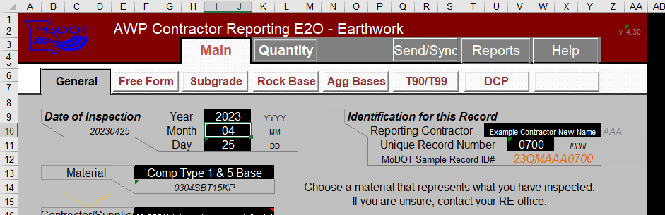

“startIndex cannot be larger than length of string. Parameter name: startIndex It is rejected.”
The sample date incomplete on the General Tab so cell V12 doesn’t have a valid sample ID for the Excel2Oracle program to use, error indicates Excel2Oracle doesn’t have a valid sample ID to use

Rejected sheet – sample date incomplete and cell V12 blank:
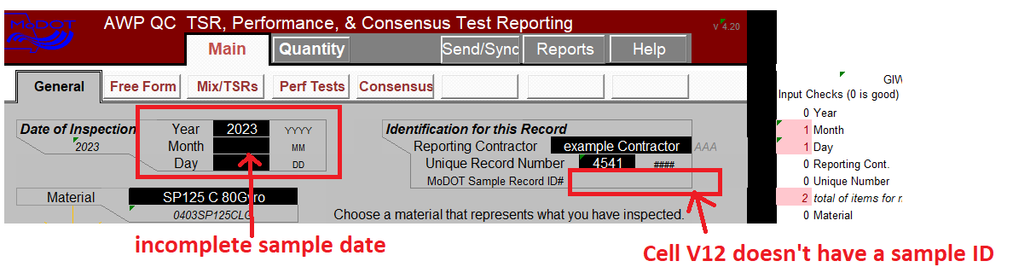
Sheet ready to re-submit – sample date filled out and cell V12 has a valid sample ID:
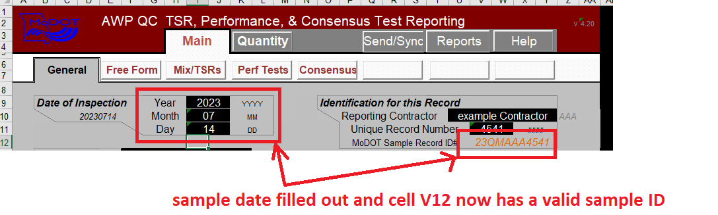

“Error occurred while reading RetestQuantity in SampleRecordTest data. Required field is empty. It is rejected.”
Older versions of CRE2O sheets can become incompatible with Excel2Oracle due to database changes in AWP. This error message is from an update to AWP adding additional database fields that were not present in version 3.## CRE2O sheets. The rejected sheet cannot be fixed. The data must be entered into the latest sheet available from MoDOT prior to re-submitting

A change to the first digit of the version number requires the user to download the latest CRE2O sheet from MoDOT and start over. The first digit is only changed when the update to CRE2O is such that the older sheets become unusable.

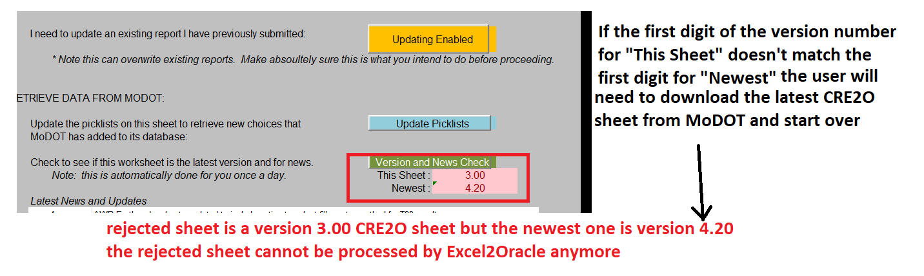

Errors from using Cut/Paste and/or altering fields
Cut/Paste or altering the fields on the Quantity tab* can prevent the sheet from submitting or processing correctly. If updating the picklists doesn’t resolve this error, the sheet may need to be recreated starting with a new CRE2O sheet.

That is, actions to alter functions/cells with in the CRE2O sheets can cause them to be rejected. The rejection notice will depend on what functions/cells were modified.

*or other tabs in the sheet

