Request a 30-Day Temp on a Haz Waste Transporter License
External Procedure

Overview
On an active license, you have the option to add a unit on a temporary basis. This temporary is good for 30 days.

Process
- Access MoDOT Carrier Express (MCE) through the log in page located at www.modot.org/mce. Enter the user id and password assigned to you by Motor Carrier Services and click log in.

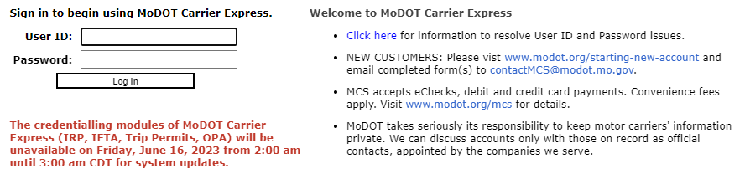

Note: Only one username and password are issued per company. If you have to reset a password, make sure no one else in the company is using the login before resetting it.

Once logged in, your account name, customer id, and USDOT number will be displayed at the top of the page.

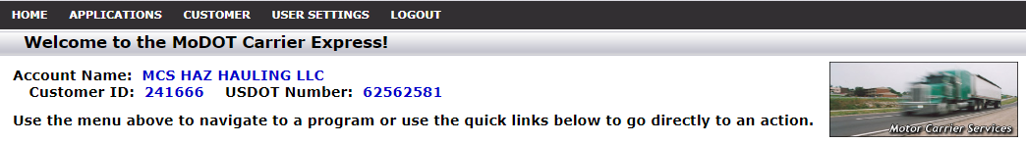

- Click applications and select HW/WT.

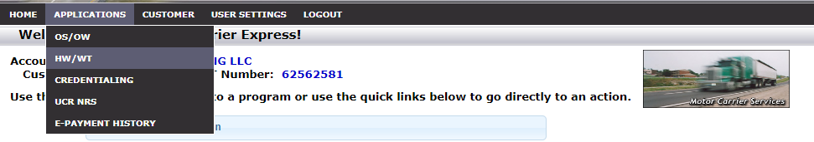

- Now that you have made it to the hazardous waste system, you are ready to begin your supplement. Click supplement.

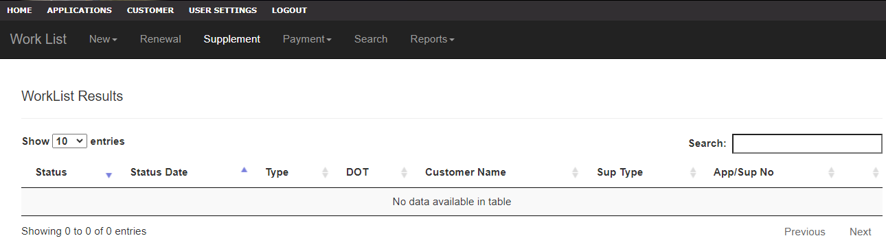

- Locate the license you wish to process a supplement for, click the license number.

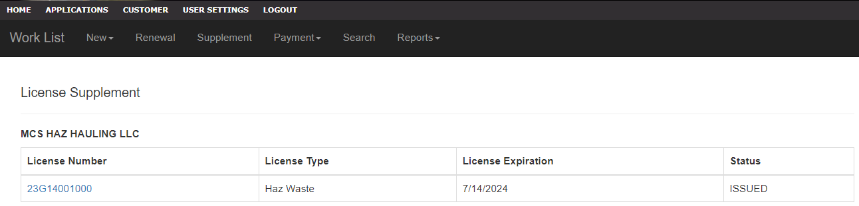

- You will see the supplement application.

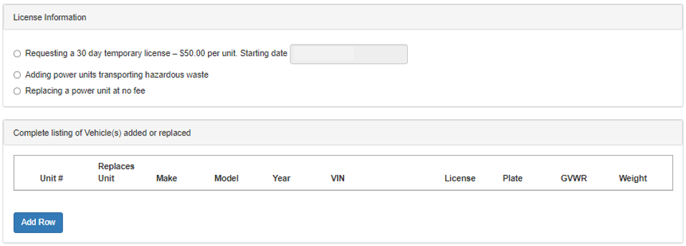

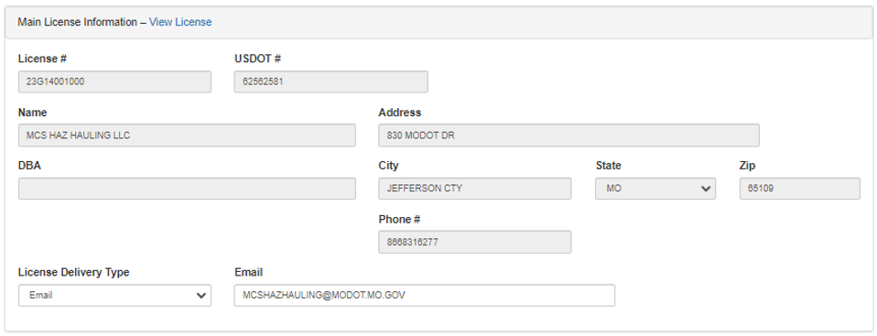

- Select requesting a 30-day temporary license and enter the day you wish the temporary to start.

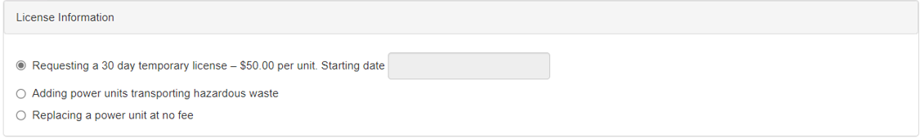
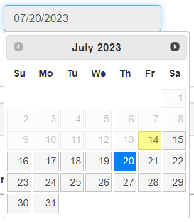

- Now click add row and enter the truck information. Click submit so the unit you added displays in the list. Continue adding units until all units have been added to the list.

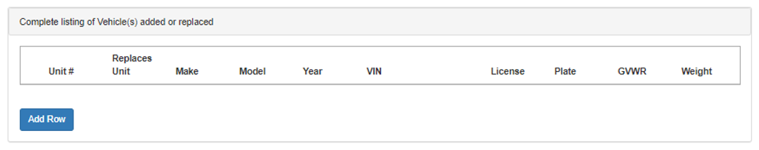
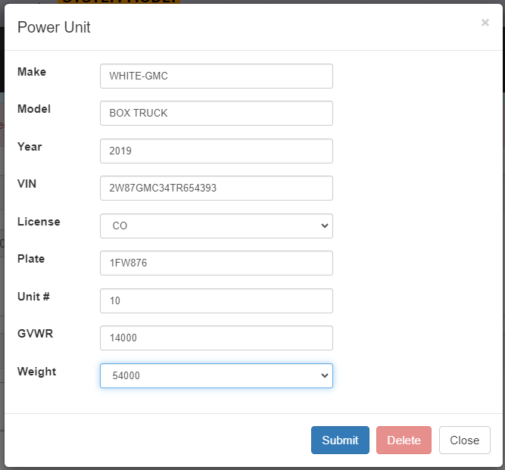

- Once all units have been added, you may click fees to review the total fees charged prior to invoicing the supplement. Click back to return to the previous tab after viewing fees.

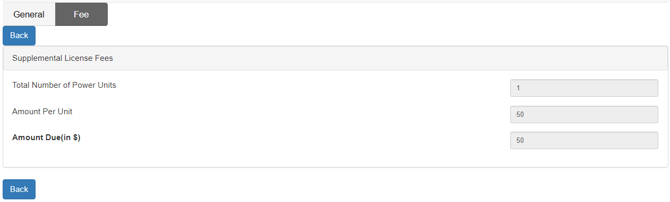

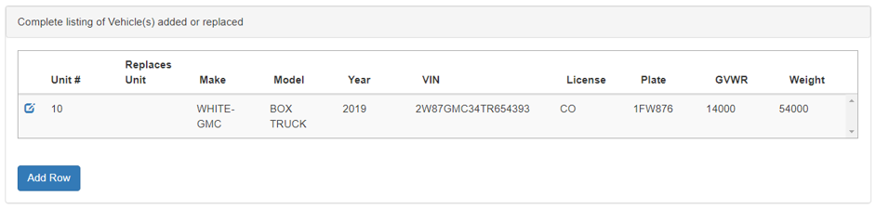

- After adding all units needing a 30-day temporary have been entered, click submit to MCS and then confirm by clicking submit in the popup box.

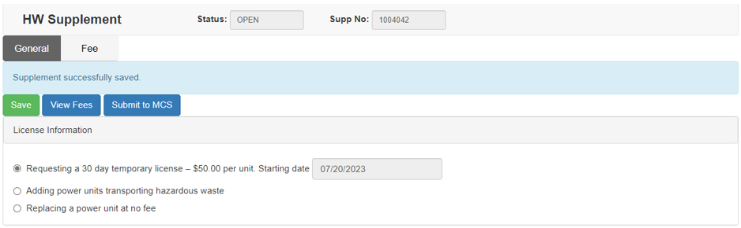

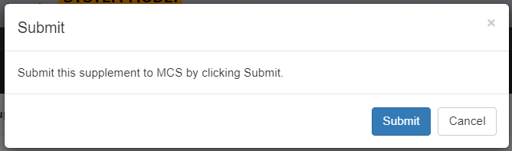

Your application has been sent to MCS for review and will now show up in your worklist results.

