

MEMORANDUM

Missouri Department of Transportation

City of St. Louis Area Team
SL District

TO: JST0117 Project Files

CC: Thomas Evers, PE, SL District Engineer
Steve Miller, SL Communications Manager
Anastasia Smith, Project Director

FROM: Ryan Pearcy, PE
Area Engineer

DATE: June 10, 2026

SUBJECT: I-44 between Route 109 and Route 141 public meeting summary

This memo serves as a summary of the open-house style public meeting the Missouri Department of Transportation held on May 12, 2026, from 4 to 6 p.m. on the second floor of the Timbers of Eureka Recreation Center, 1 Coffey Park Ln, Eureka MO, 63025. Information from the public meeting was available for two weeks after the public meeting, until May 27, 2026, for additional public review and comment. That information was shared on the project website: https://www.modot.org/projects/Forward44SLPaveBridge . The department had 298 attendees personally attend the public meeting, while 1,923 viewed the information on-line. During the in-person and on-line meetings, 117 people submitted comments.

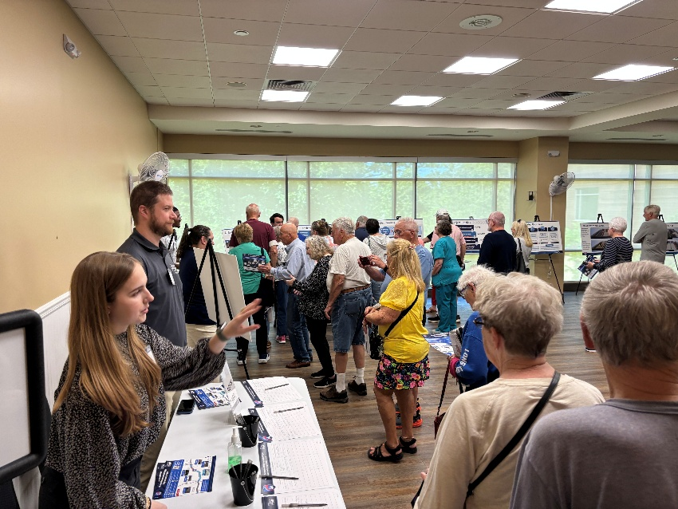
Meeting participants:
Presenting team: MoDOT and the consultants from AECOM.
Administrative team in attendance: Tom Blair, Steve Miller.
Notable public attendees: Representatives from Discover STL, Wyman Center, Midwest Motors, Eureka Fire Department.

The purpose of the public meeting was to share information about planned construction on Interstate 44 between Route 109 and Route 141, including bridge and culvert replacements, pavement repairs and safety updates along Antire Hill. The public meeting shared what work was planned to be completed, as well as the expected impacts and duration of those impacts to traffic in the corridor.

Attendees were asked to share their thoughts about concerns on the project, the impacts and on the safety updates on Antire Hill. Comments were focused in the following areas:

- Concerns about impacts from other projects, including planned I-64 closures in St. Louis
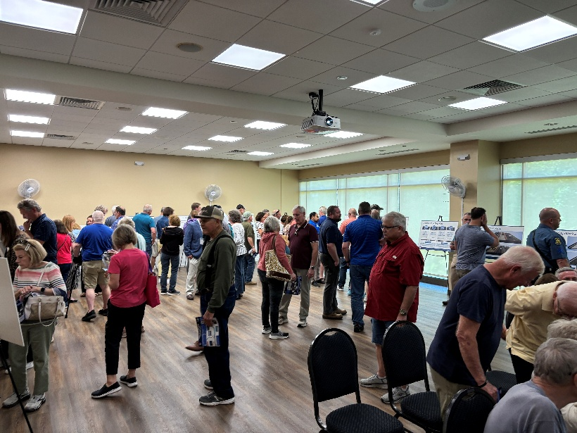
  - There will be some overlap with the construction of this work and the planned closure of eastbound I-64 in the city of St. Louis. Although the section of I-44 between I-270 and the city will be a detour route for traffic trying to avoid the eastbound closure, there is significant space available on I-44 to accept any detouring traffic from I-64. As commuters approach the city, I-44 is about 1 mile away from I-64; I-64 can be accessed from I-44 east of the closure at Jefferson. MoDOT continues to work with the city to monitor and help time several signals on corridors around the eastbound I-64 closure. To ensure the regular maintenance of roughly 6,000 miles of roadway, MoDOT has to maintain about 600 miles of road each year. Since many projects are two years, that means that roughly one-fifth of the department-maintained roadways have some type of construction impact. This helps ensure that the department is able to keep Missouri roads in good condition and operational for the foreseeable future.
- Suggested changes to interchanges
  - There were several comments about extending the ramps to and from I-44 to Route 109, creating a slip ramp to 5th Street east of the railroad bridge and extending the ramp from Route 141 to westbound I-44. None of those are currently a part of this plan, nor are there currently any plans to construct any of these changes. There is a project coming up next year to make some changes that includes upgraded left turns at Route 109 and 5th Street. MoDOT can continue to look at other improvements between Route 109 and I-44 as other priorities and funding permit.

- Changes to the grade or curve on Antire Hill.
  - Any changes to how the interstate travels through Antire Hill – especially because of various public lands on either side of the I-44 corridor and the overall expense of changing the grade are well outside of the money set aside for this project. There are no plans to make any future changes to the elevation or curve on Antire Hill. Any changes would require significant additional planning, environmental evaluations and public outreach, and would be extremely costly. As stewards of taxpayer money, the department works with communities around the state to identify the priority projects with the greatest overall impact to the state transportation network.
- Speeding, truck speeds and dictating lanes for trucks
  - MoDOT is not an enforcement agency, and the Missouri State Highway Patrol partners with, but does not work for, MoDOT. Any truck speed enforcement issues would fall under the purview of the MSHP or local law enforcement. There is currently a law that trucks over a certain weight in areas with more than two lanes are required to drive in the right two lanes. Those signs are posted along the corridor, and the department is looking to see if there needs to be additional signage. Any further restrictions on which lanes trucks can travel in would have to be done legislatively.
- Concerns that the barriers would continue to break when struck
  - The barriers, especially along Antire Hill, on this project are more robust and are less likely to be significantly damaged due to being struck by a vehicle – including fully loaded tractor trailers.
- Flooding concerns
  - Although this project will help update and upgrade drainage along the corridor to help with flash flooding or ponding, there is no intent to make the corridor flood proof – especially from when the Meramec River floods. The cost to make the roadway flood-proof is too significant for the state to reasonably afford, especially when there are higher priority concerns and the Meramec River floods the interstate very irregularly. None of the work, however, will make any existing flash flooding worse and should reduce the time any lanes are impacted by flash flooding.

- Construction impacts
  - MoDOT is always concerned about giving good value to the taxpayers of Missouri. Construction projects are bid by the project and Missouri Highways and Transportation Commission usually awards the project to the contractor with the lowest qualified bid. Projects like bridge rehabilitation and replacement are usually done best by closing the roadway and detouring traffic. On projects such as the I-44 project between Route 109 and Route 141, the best course is to reduce the number of lanes and run the interstate traffic with traffic in the opposing direction, separated by a barrier. Since the driving surface on the bridge has been completely removed, it is impossible to run traffic on the bridge safely when work is not underway. During regular traffic periods, it should have little to no impact on traffic (except during crashes), but it will make rush periods tend to last a little bit longer. Drivers can look for alternate routes (as appropriate) depending on where they may be going, or may be able to work with their employers to stagger what times they arrive for work and depart, or where applicable, may be able to telecommute.

More specifically, the department asked for feedback in several areas during the open house style public meeting. These questions were open-ended and are sorted by the general topic of the concern. Not every individual shared thoughts on every question.

Question 2: I have the following questions or concerns about the I-44 pavement repairs between Route 109 and Route 141:

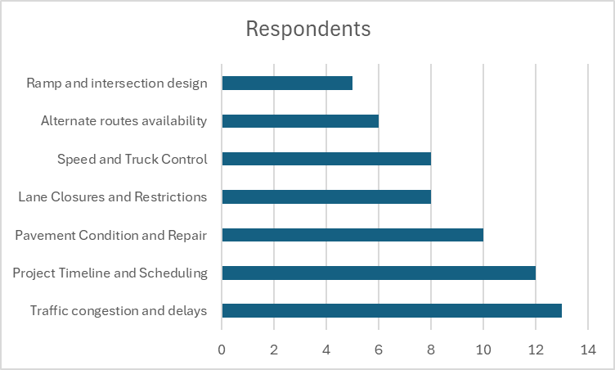
Respondents expressed mostly neutral to negative sentiments about the I-44 pavement repairs between Route 109 and Route 141. Many raised concerns about lane closures, traffic congestion, and project duration, with some questioning the pavement’s long-term quality and safety, especially regarding truck speed and control. A few mentioned the need for better alternate routes and nighttime work to reduce disruption. Some also noted worries about outer road access and bridge closures. Overall, feedback highlights a desire for clear communication, improved safety, and minimized travel delays during construction.

Question 3: I have the following questions or concerns about the safety updates around I-44 at Antire Hill:

Feedback on I-44 Antire Hill safety updates is mixed, with most respondents expressing neutral or negative views. Many are concerned about truck speed, lane restrictions, and the effectiveness of proposed measures, especially regarding accident prevention and road grade. Some highlight the need for better signage, lighting, and speed enforcement. A few question detour plans and barrier safety. While one respondent supports the plan, most seek more robust solutions to address frequent accidents and truck-related hazards. Overall, safety and traffic flow remain key concerns for the community.

Question 4: I have the following questions or concerns about the bridge replacements or rehabilitations along I-44 between Route 109 and Route 141:

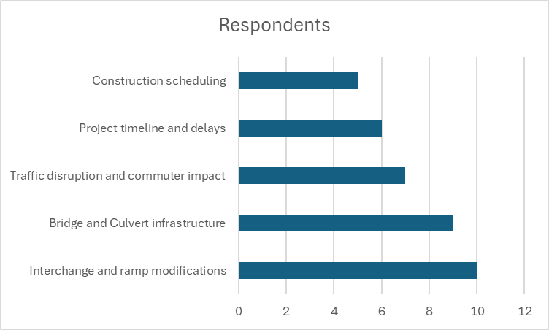
Feedback on the I-44 bridge projects is mostly neutral, with some negative concerns. Many respondents are focused on potential traffic disruptions, project scheduling, and the impact of overlapping construction with other highways. Some also question ramp modifications, project timelines, and flood mitigation efforts. A few mention concerns about construction quality and navigation during the project. Overall, respondents seek clear communication on timing, traffic management, and efforts to minimize commuter impact during construction activities along I-44 between Route 109 and Route 141.

Question 5: I have the following questions or concerns about traffic flow during the bridge replacements or rehabilitations along I-44 between Route 109 and Route 141:

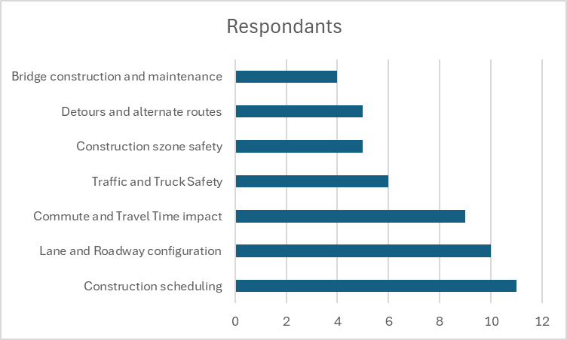
Feedback on traffic flow during I-44 bridge work is mixed, with most respondents expressing neutral or negative sentiment. Many are concerned about lane configurations, construction scheduling, and increased commute times, especially with overlapping projects and limited detour options. Safety in construction zones, truck traffic, and police presence are also recurring themes. A few appreciate the planned improvements and acknowledge the need for the project. Overall, while the necessity is recognized, concerns focus on minimizing disruptions and ensuring safety throughout construction phases.

Next steps:
MoDOT and our partners will continue to work to develop the final plans for the project, Any significant changes to the final plans from what was shared at the public meeting will be shared on the project website.

