Structural Engineering Guidance No. 25-01

Date: December 12, 2025
Distribution: All Engineering Resources
SUBJECT: NEW POLICY FOR DESIGN AND INSTALLATION OF FRICTION PILE
Contact: Darren Kemna
EPG Status: Revisions to Conflicting Language Submitted to Policy Group
Std. Drawing Status: NA
Effective Date: Immediately For Jobs Not Yet Submitted to Design
Expiration/Duration: Indefinite

C O N T E N T S:

Sections
- Office Practice History………………………………………………………...1-2
- Purpose of this Guidance……………………………………………………....2-3
- Background: MTI Research Results…………………………………………...3-4
- Guidance for Pile Driving Verification Method……………………………….4-7
- Guidance for Pile Length Estimates…………………………………………...7-8
- Brief Overview of GRLWEAP 14 Static Analysis Methods………………….8-9

Appendices
A: Case Studies using GRLWEAP 14………………………………………….10-20
Case A: Schuyler County (Clay Profile)……………………………..10-14
Case B: Scott County (Sandy Profile)………………………………..15-20
B: References………………………………………………………………………21

Note: This guidance is written by a structural engineer for bridge designers. There may be some language that is not completely accurate from the viewpoint of a geotechnical engineer.

- Office Practice History:

Prior to 2017, the FHWA/DRIVEN software (now Driven Piles) was commonly used by MoDOT bridge designers to estimate friction pile (CIP) lengths. The DRIVEN software used FHWA endorsed methods developed by Nordlund and Tomlinson.

Until approximately 2007, an Allowable Stress Design (ASD) method was used for estimating pile lengths. The maximum vertical service load per pile was calculated and then compared to the ultimate capacities from DRIVEN. Prior to 2006, a factor of Safety of 3.5 was applied to the service load to determine the design bearing and required pile length. In 2006, an interoffice email was sent out directing designers to compare pile lengths for two separate factors of safety, 3.5 and 2.0. Shortly thereafter direction was given to use 2.0 for all jobs to avoid underruns during pile installation. For plans reporting, the following information was included: 1) approximate length, 2) Minimum tip elevation, 3) design bearing and 4) minimum hammer energy required. The field verification procedure utilized the Engineering News formula to calculate the safe allowable bearing value.

For LRFD designs, the original policy is documented in “Design Procedure for CIP Pile Bents” and Development Section Bulletin 14-05. In 2007, designers were recommended to use a factor of safety of 3.0, in conjunction with DRIVEN analysis, to determine CIP pile lengths. It appears that, even though the pile length was determined using service loads the 2.0 factor was not carried over from ASD. A drivability analysis using GRLWEAP was also incorporated to help predict driving issues in the field. The static resistance profile used in GRLWEAP was imported from DRIVEN. The designer was instructed to check three hammer sizes (Delmag D15, Birminghammer 300, Delmag D30-23) to ensure there is a feasible pile driving system available for the project. The maximum service load per pile is calculated and then multiplied by 3. The factored value is compared to both the WEAP drivability analysis and the DRIVEN static analysis so that adjustments can be made to the design if overstressing or refusal is predicted prior to reaching the estimated pile penetration. For field verification the maximum factored load per pile, P_{u}, is calculated and then divided by the dynamic resistance factor, φ_{dyn}, used for field verification. The P_{u}/φ_{dyn} calculation determines the minimum nominal axial compressive resistance, MNACR or R_{ndr}, shown on the plans. The policy was to use φ_{dyn} = 0.65 for dynamic testing (PDA).

In 2009, the factor of safety method was dropped from the design procedure and instead the required nominal driving resistance, Rndr, was used to compare to the DRIVEN analysis. Using factored loads and a static resistance factor of 0.65 (PDA) is similar to using a factor of safety of 2.

In 2017, a survey was sent to contractors to determine their preferred hammers and designers started incorporating the most popular hammers into the drivability analyses.

In 2019, the hammer energy was no longer reported on the plans and the contractor is required to perform a drivability analysis per specifications. Bridge designers were also directed to use the AASHTO static resistance factors instead of the dynamic resistance factor when estimating pile lengths. Designers began using alternate static analysis methods offered by GRLWEAP which led to the need to require resistance factors developed for each static method.

In 2022, the Bridge Division upgraded to GRLWEAP 14. GRLWEAP 14 incorporates the static analysis methods previously provided by the FHWA Driven program. GRLWeap 14 replaced Driven as the program for calculating geotechnical static resistance by the Bridge Division. GRLWeap 14 is only used to determine the static resistance of a friction pile when bearing graphs are not provided by the Geotechnical Section. Note that a static analysis method is required to determine skin and tip resistances for use in the drivability analysis and is not the primary function of the GRLWeap 14 program. The static analysis methods provided by GRLWEAP are discussed further in section 6 and Appendix A.

- Purpose of this Guidance:

MoDOT is experiencing issues with the use of dynamic testing (PDA) for field verification of driven pile. The primary issues identified are:
- The delay between PDA data collection and pile capacity verification: There is a rough capacity determined in the field during PDA testing, but the actual verification capacity is determined in the office. It is not practical to order a single pile for testing and go back and forth with the office to determine the desired length and then order the rest of the piles for the bent. In practice the contractor typically shoots for a buffer in the target capacity (10 to 15% higher) that will most likely lead to an adequate capacity in the final verification.
- Predicting accurate pile lengths on the plans using static methods: If the pile length is overpredicted then the contractor orders too much pile and is not typically paid for the cutoff portion so they are incentivized to drive the full length. If the pile length is underpredicted the contractor may need to order additional pile which can cause project delays. See further discussion below.
- Driving piles short of estimated plan length may result in a galvanization depth that is inadequate.

This SEG outlines the current policy for the design and field verification methods for friction pile lengths. This guidance attempts to address the first two issues stated above that may result in considerable under or overruns. The third issue has been at least partially addressed by recent changes to the EPG.

Section 4 outlines the required driving criteria to be included in the plans and discusses the required deliverable for the project.

Section 5 gives recommendations for static resistance factors for various static analysis methods. These methods are only to be used for estimating pile lengths for plans reporting.

Further Discussion on Issue #2: Static Resistance Factors for Estimating Pile Length
The design pile lengths resulting from using AASHTO static resistance factors are typically, but not always, longer than what is required when verified by dynamic methods in the field. The static resistance factors provided in AASHTO LRFD Table 10.5.5.2.3-1 may be considerably lower than the dynamic testing resistance factor (0.65) or wave equation analysis (0.5) used for field verification. The relatively lower static friction factor is in part because the static friction factors are developed to prevent pile foundation failures with no field verification other than the penetration depth. The static resistance factors are not developed for predicting pile lengths when dynamic methods are used for field verification. Designers need static analysis methods that can accurately estimate pile lengths for plans production. See Appendix B for more background.

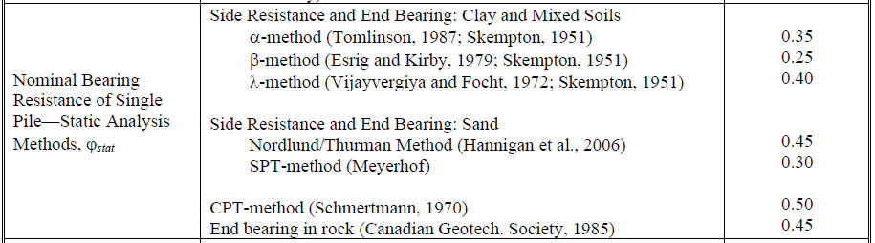
Fig 2.1 - Excerpt from AASHTO LRFD Bridge Design Specifications Table 10.5.5.2.3-1 Resistance Factors for Driven Piles

- Background: MTI Research Results

The research report “Calibration of Resistance Factors for Axial Capacity of Driven Pile into Missouri Soil” was released in 2011 following a MTI Geotechnical Research Program. Three static analysis methods were compared in this research: Nordlund, Meyerhoff and Beta. The report recommended the following resistance factors for two geological regions in Missouri.

Table 3.1 – Static resistance factors calibrated for Missouri geological regions.
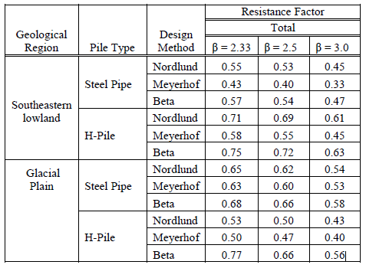

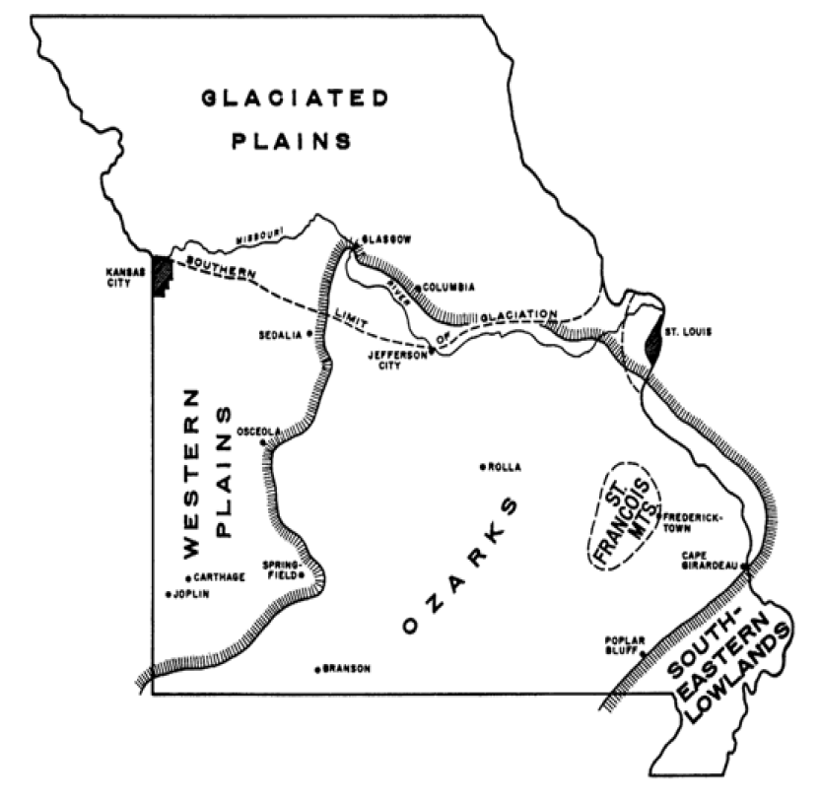
Fig. 3.1 – Map of five geological regions as reported by Saville et al., 1962.

The resistance factors were developed for prevention of pile foundation failures. The authors claimed that these factors can be used without field verification other than penetration depth which was rejected by MoDOT due to insufficient data. The resistance factors are provided above and they were considered when determining the recommended policy in Section 5. More information about the research and recommendations can be found in Appendix B.

- Guidance for Pile Driving Verification Method
This guidance shall be used as a supplement to EPG 751.36.5.3 and EPG 751.36.5.10.

For bridges where the soil profile is comprised primarily of sand, which is typical for the Southeastern Lowlands, the recommended verification method is dynamic testing. Dynamic testing allows for a reduced required driving resistance in an area where large driving resistances are often difficult to obtain. When calculating the minimum nominal axial compressive resistance, MNACR, to be reported on the plans, the factored axial load on the pile is divided by 0.65. The Dynamic Pile Testing pay item shall be included with the project which requires the contractor to hire an independent dynamic pile testing consultant. A drivability analysis shall be performed by the bridge designer in accordance with EPG 751.36.5.11 Check Pile Drivability. The drivability analysis is included in the design computations but is not provided as an electronic deliverable.

For bridges where the soil profile is comprised primarily of clays or evenly mixed clays and sands the recommended verification method is the Wave Equation Analysis of Piles (WEAP). When calculating the MNACR to be reported on the plans the factored axial load on the pile is divided by 0.50. The Pile Wave Analysis pay item shall not be included with the project, and instead a plans note will be placed below the Foundation Data Table to inform the contractor that an inspector’s chart is provided as an electronic deliverable. The drivability analysis shall be performed by the bridge designer in accordance with EPG 751.36.5.11 Check Pile Drivability, both to check the design and to provide the Inspector’s Chart. At the contractor’s request, a revised Inspector‘s Chart may be provided by MoDOT after contract that adheres to the contractor’s specific driving system. The FHWA Pile Driving and Equipment Data Form should be used for the submittal.

To develop an inspector’s chart in GRLWEAP 14, the desired driving resistance must be entered as shown below. For the contract plans the manufacturer recommended settings will be applied for the hammer selected (e.g,, Delmag D19-42) including the hammer cushion.

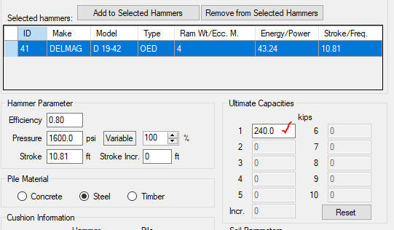

The electronic deliverable to be included in the project is a PDF of the summary report for the inspector’s chart. The Inspector’s Chart provides the blow count required to reach capacity based on the actual hammer stroke or energy setting. The chart also gives information about the maximum stresses in the pile when the capacity is obtained.

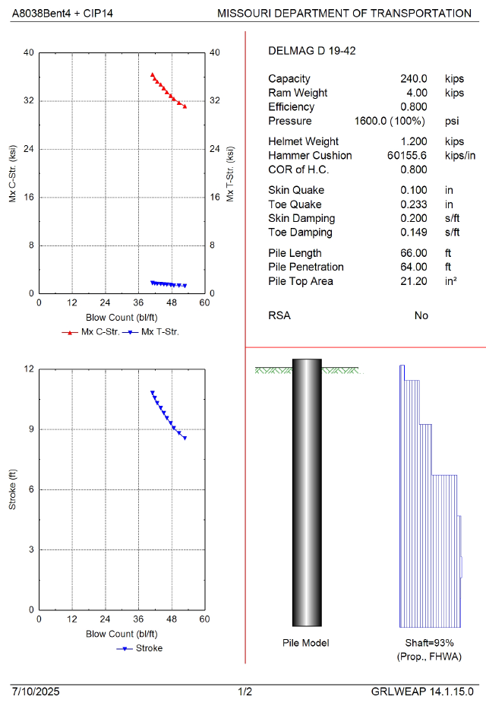
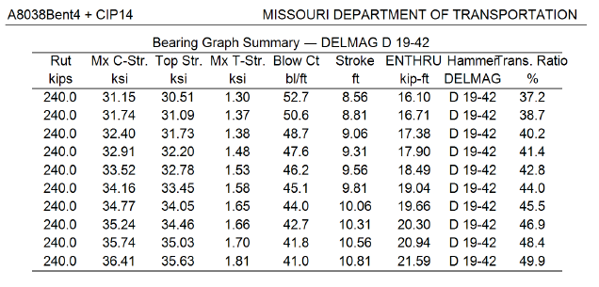

- Guidance for Pile Length Estimates

The GRLWEAP 14 software is available to the MoDOT Bridge Staff for performing a static analysis for driven piles. The following static methods are provided in GRLWEAP 14.
- ST (Soil Type): Beta (Sands), Alpha modified (Clays)
- SA (SPT-N): Uses correlated pile-soil friction angles
- FHWA: Nordlund/Thurman (Sands), Tomlinson (Clays)
- CPT: Schmertmann (Sands and Clays)

Table 5.1 shows the recommended static analysis methods as well as the resistance factors that shall be used on MoDOT bridge projects. The table provides resistance factors for clays and sands so engineering judgement is required for other soil types such as silts.

For clays the recommended method for static analysis of geotechnical axial resistance is alpha (Tomlinson). While the AASHTO LRFD BDS specs recommend a value of 0.35 for the resistance factor, the recommendation reflected in the table is to match the dynamic resistance factor for the pile driving criteria. MoDOT believes that we get fairly accurate results using the alpha (Tomlinson) method with clays and since clays tend to experience set-up there are some tools for contractors to prevent overruns when the estimate is low. Set-up should not be included in the pile length estimate unless specified in the foundation investigation report.

For sands the recommended methods for static analysis of geotechnical axial resistance are the FHWA method (Nordlund/Thurman) and the LCPC method. The FHWA method shall be used when CPT direct measurements are not available. The structural designers in the Bridge Division have historically used the FHWA method with limited success. The 0.45 factors for the Nordlund/Thurman method in Table 5.1 match the value in AASHTO LRFD BDS Table 10.5.5.2.3-1, 10th edition and the tabulated value provided in the research by Luna for the Southeastern Lowlands with a beta of 3. The 0.55 factor is a hedge on the Nordlund/Thurman method that often underpredicts the pile length in Missouri sands. The FHWA method is only calibrated for 18-inch and smaller diameter pile and is even more likely to underpredict the pile length at larger diameters. The structural project manager or structural liaison engineer shall be consulted before reducing the resistance factor below the values in Table 5.1.

The LCPC method is used by the MoDOT Geotechnical Section when the soil data collection method is the cone penetration test (CPT). The geotechnical engineer typically provides a bearing graph to the designer using the resistance factors listed in Table 5.1 (also see Case Study B). These graphs are marked as “preliminary” because they do not account for the finished ground elevation or any reduction in capacities due to scour or pre-bore. These graphs may be used for final pile length estimates if the resistance in the scourable area, pre-bore region or ground elevation shift is removed or otherwise added to the load. There currently is no recommendation for adjusting the LCPC resistance factors for the driving criteria used in the field.

Resistance factors are provided in Table 2 for the Scmertmann method. The Schmertmann method has not historically been used by MoDOT as it requires raw CPT data to be imported into the GRLWEAP 14 program. This procedure may be used but requires some effort to correctly input the CPT data and has not been tested by MoDOT to date. Thus, the resistance factors reflected in the table match the values provided in the AASHTO LRFD BDS, 10th Edition and are not adjusted for the driving criteria.

Table 5.1 - Static Analysis Resistance Factors used for Pile Length Estimates

Pile Type | Soil Type | Static Analysis Method | Software  (may not be comprehensive) | Side Friction¹  φ_{stat} | End Bearing  φ_{stat}
CIP Piles - Steel Pipe Shells | Clay | FHWA (Alpha – Tomlinson) | GRLWEAP 14  DrivenPiles | φ_{dyn}² | φ_{dyn}²
CIP Piles - Steel Pipe Shells | Sand | FHWA (Nordlund/  Thurman)³ | GRLWEAP 14  DrivenPiles | 0.45 - Gates  0.45 – WEAP  0.55 – PDA | 0.45 - Gates  0.45 – WEAP  0.55 – PDA
CIP Piles - Steel Pipe Shells | Sand | LCPC⁴ | CPet-IT | 0.70 | 0.45
CIP Piles - Steel Pipe Shells | Sand | Schmertmann⁵ | GRLWEAP 14 | 0.50 | 0.50
¹For mixed soil profiles the lowest applicable resistance factor for clay or sand may be used to simplify the analysis.
²φ_{dyn} = 0.4 (FHWA-Modified Gates Dynamic Pile Formula), 0.5 (Wave Equation Analysis of Piles), 0.65 (Dynamic Testing)
³The Nordlund method is recommended for sand layers in mixed soil profiles where CPT data is not available.
⁴The resistance factors associated with the LCPC method are not statistically calibrated for reliability, but studies have shown this method to be one of the most reliable methods for predicting soil behavior from CPT data.
⁵Per LRFD 10.7.3.8.6g the Schmertmann method shall only be used for sands and nonplastic silts.

While potentially more accurate for some cases, it is not recommended to use different resistance factors for different soil layers in mixed profiles. The potential increase in accuracy is not warranted when a dynamic driving criteria is used, and it is just as likely to develop a less accurate pile length estimate.

- Brief Overview of GRLWEAP 14 Static Analysis Methods

This section provides documentation of the equations used by the GRLWEAP 14 software for MoDOT Bridge designers. AASHTO LRFD BDS 10th Edition references are given if available. Further guidance can be found in the program’s user manual.

GRLWEAP 14 Notes
FHWA/DRIVEN method (Recommended):
Clay: Tip Resistance …LRFD 10.7.3.8.6e
Side Friction …Tomlinson 1979 or LRFD 10.7.3.8.6b – Tomlinson 1980

Sand: Tip Resistance …LRFD 10.7.3.8.6f - Thurman
Side Friction …LRFD 10.7.3.8.6f – Nordlund

Soil Type/ SPT-N method (not recommended):
Toe Resistance (Sand/Clay) …AASHTO Reference Not Available
Side Friction (Sand) …β-method (not the same method given in LRFD 10.7.3.8.6c)
Side Friction (Clay) … AASHTO Reference Not Available
Note: The blow counts entered for the SPT-N method should be corrected for overburden pressure for cohesionless soils; commonly referred to as N1 values. GRLWEAP also recommends correcting for hammer efficiency (i.e, N₆₀) values for all soil types. SPT-N values corrected for overburden and hammer efficiency are referred to as N1₆₀.
CPT method:
Side and tip resistance is directly measured by a cone but requires correction factors for production pile.
Clay: Tip Resistance …uses average cone penetration resistance below the pile (Schmertmann)
Side Friction …(Schmertmann)

Sand: Tip Resistance …average cone penetration resistance below pile (LRFD 10.7.3.8.6g - Schmertmann)
Side Friction … (LRFD 10.7.3.8.6g - Schmertmann)

APPENDIX: Case Studies using GRLWEAP 14

In this appendix two case studies are provided. The first case is an end bent in Schuyler County which is located in the Glacial Plains area.

Case A: Schuyler County (Clay Profile)
Bridge No: A8038, Bent No: 4
Pu = 120 k
Pile: 14” Steel Pipe – Closed End
Water Table: 3.66’ depth
Soil Profile:
Layer 1 – 3.66’ Clay, γ_{s} = 113 pcf, S_{u} = 150 psf
Layer 2 – 10.80’ Clay, γ_{s} = 104 pcf, S_{u} = 500 psf
Layer 3 – 12.40’ Clay, γ_{s} = 120 pcf, S_{u} = 1783 psf
Layer 4 – 5.00’ Clay, γ_{s} = 121 pcf, S_{u} = 1500 psf
Layer 5 – 5.00’ Clay, γ_{s} = 122 pcf, S_{u} = 1500 psf
Layer 6 – 10.00’ Clay, γ_{s} = 124 pcf, S_{u} = 1725 psf
Layer 7 – 5.00’ Clay, γ_{s} = 128 pcf, S_{u} = 1800 psf
Layer 8 – 5.00’ Clay, γ_{s} = 129 pcf, S_{u} = 2050 psf
Layer 9 – 10.00’ Clay, γ_{s} = 128 pcf, S_{u} = 1700 psf
Layer 10 – 15’ Clay, γ_{s} = 135 pcf, S_{u} = 4500 psf
Layer 11 – 5.00’ Clay, γ_{s} = 135 pcf, S_{u} = 6600 psf

SPT ‘N’ Values:
Layer 1 – SPT N₆₀ = 5, Depth = 1.86’
Layer 2 – SPT N₆₀ = 1, Depth = 6.86’
Layer 3 – SPT N₆₀ = 2, Depth = 11.86’
Layer 4 – SPT N₆₀ = 7, Depth = 16.86’
Layer 5 – SPT N₆₀ = 13, Depth = 21.86’
Layer 6 – SPT N₆₀ = 8, Depth = 26.86’
Layer 7 – SPT N₆₀ = 11, Depth = 31.86’
Layer 8 – SPT N₆₀ = 12, Depth = 36.86’
Layer 9 – SPT N₆₀ = 13, Depth = 41.86’
Layer 10 – SPT N₆₀ = 14, Depth = 46.86’
Layer 11 – SPT N₆₀ = 33, Depth = 51.86’
Layer 12 – SPT N₆₀ = 18, Depth = 56.86’
Layer 13 – SPT N₆₀ = 19, Depth = 61.86’
Layer 14 – SPT N₆₀ = 100, Depth = 66.86’
Layer 15 – SPT N₆₀ = 100, Depth = 71.86’
Layer 16 – SPT N₆₀ = 100, Depth = 76.86’
Layer 17 – SPT N₆₀ = 100, Depth = 81.86’
Layer 18 – SPT N₆₀ = 62, Depth = 86.86’

No Restrike is considered (i.e…Setup Factor is assumed to be 1.0).
No scour is considered.

GRLWEAP 14 Solutions

- The Soil Type-based Input form is used. The cohesive type for each soil layer was selected based off the descriptions in the boring log for Bent No. 4. The final selections for all soil layers are shown in the figure below.

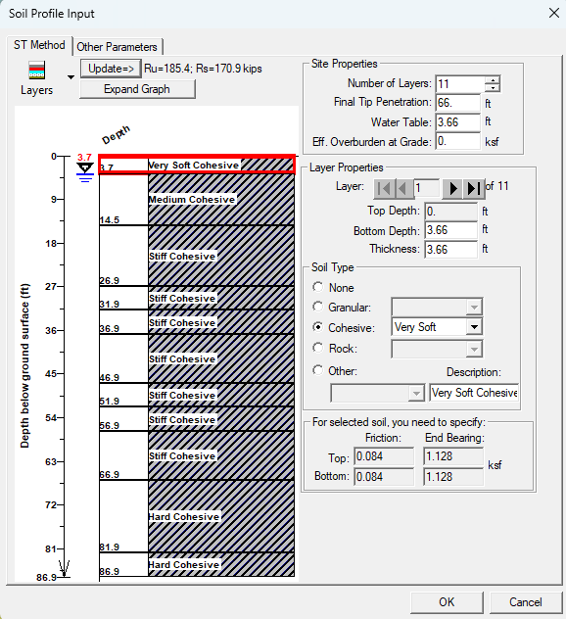

No recommendation for φ_{stat} is given in Table 2. If φ_{stat} is taken as 0.65 (skin & bearing) for all layers the required nominal static resistance can then be calculated by factoring up the design load…
R_{nstat} = 120 k / 0.65 = 185 k

The figure above shows that a penetration depth of 66 feet gives a nominal static resistance of
185.4 kips > 185 kips.

Note: If φ_{stat} = 0.50 then R_{nstat} = 240 kips and a 72’ pile length would be estimated.

- SPT N vs. Depth (SA method)
SPT N₆₀ values are tabulated at 5’ depths and then weighted averages are used for the eleven layers used in the Soil Type-Based method. The side friction and end bearing are then determined based on the N₆₀ values and not the Soil Type entered. GRLWEAP will populate unit weights correlated from N values, but these values were overridden using the values given above. It should be noted that N values typically are not recommended for defining properties of clays. GRLWEAP also recommends N values that are adjusted for the overburden pressure, N1₆₀, but this isn’t necessary for cohesive soils.

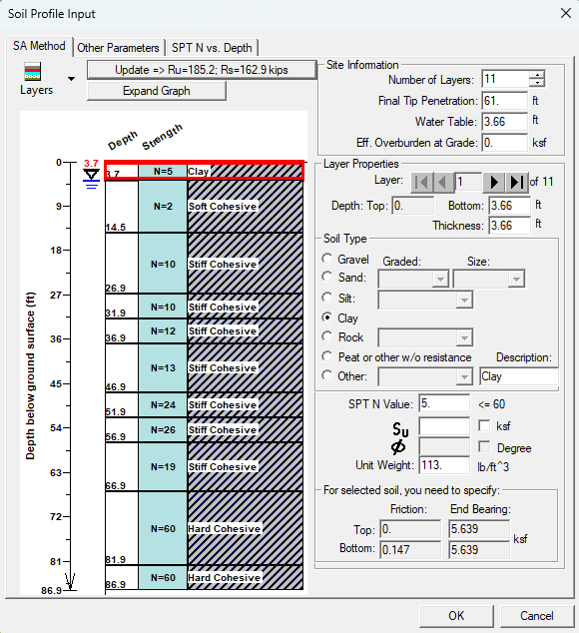

The figure above shows that a penetration depth of 61 feet gives a nominal static resistance of
185.2 kips > 185 kips.

Note: If the R_{nstat} was set at 240 kips a 67’ pile length would have been estimated.

- FHWA method
The undrained shear strengths and unit weights are entered for each layer. The soil stiffness category is also required for the program to determine the correct adhesion graph. The soil types chosen match the values selected for the Soil-Type method in Section A.

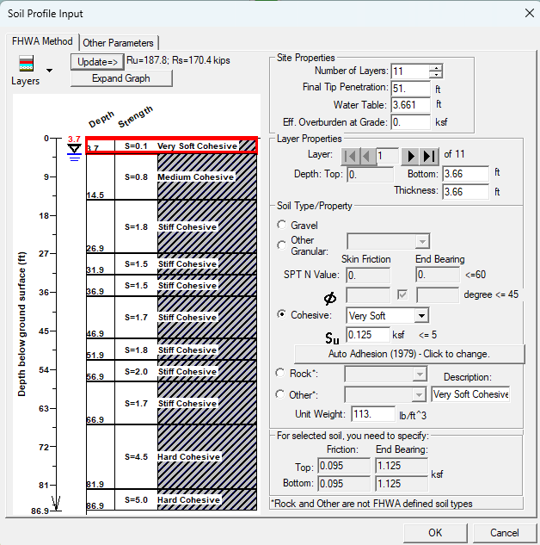

Per Table 2, φ_{stat} = 0.65 (skin & bearing) for all layers. The required nominal static resistance can then be calculated by factoring up the design load…
R_{nstat} = 120 k / 0.65 = 185 k

The figure above shows that a penetration depth of 52 feet gives a nominal static resistance of
187.8 kips > 185 kips.

Note: If φ_{stat} = 0.50 then R_{nstat} = 240 kips and a 63’ pile length would be estimated.

- CPT - data is not available

- Data Review
Unfortunately, there is no correct answer, but if data is available we can compare to the pile length required from the PDA results. Note that the results of this case may not be typical for all sites in the Glacial Plains.

The PDA test pile for this end bent was driven to a 45.5 feet penetration. The recorded PDA driving resistance is 200 kips. The following penetrations are estimated for both the R_{nstat} per static design and setting R_{nstat} to the measured PDA value using the three analysis techniques discussed above.

Software/Static Analysis Method | R_{nstat} | Pile Penetration Estimate | R_{nstat} = PDA | Pile Penetration Estimate
GRLWEAP (Soil Type-Based) | 185 k | 66 ft | 200 k | 67 ft
GRLWEAP (SPT ‘N”) | 185 k | 61 ft | 200 k | 64 ft
GRLWEAP 14 (FHWA) | 185 k | 51 ft | 200 k | 53 ft
CPT (Schmertmann) | 185 k | NA | 200 k | NA
PDA (Dynamic) |  |  | 200 k | 45.5 ft

For this example the FHWA analyses give the most accurate pile length estimates, but they still overpredicted the pile length by about 6 feet. A pile length estimate of 51 feet versus a 45.5 feet required length is a reasonable discrepancy. In the field the piles could be cutoff without too much waste for the contractor or the contractor might be able to drive the full plan length without too much extra cost to MoDOT.

Case B: Scott County (Sandy Profile)
Bridge No: A8682, Bent No: 1
Pu = 145.6 k
Pile: 14” Steel Pipe – Closed End
Water Table: 3.76’ depth
Soil Profile:
Layer 1 – 6.26’ Clay, γ_{s} = 110.3 pcf, S_{u} = 1000 psf, N₆₀ = 3.7
Layer 2 – 5.50’ Sand, γ_{s} = 108.8 pcf, φ = 37.2°, N₆₀ = 12.0
Layer 3 – 4.50’ Sand, γ_{s} = 114.3 pcf, φ = 40.5°, N₆₀ = 20.1
Layer 4 – 12.50’ Sand, γ_{s} = 115.4 pcf, φ = 40.8°, N₆₀ = 26.2
Layer 5 – 10.00’ Sand, γ_{s} = 115.4 pcf, φ = 40.8°, N₆₀ = 26.2
Layer 6 – 7.00’ Sand, γ_{s} = 117.6 pcf, φ = 39.8°, N₆₀ = 29.6

No Restrike is considered (i.e…Setup Factor is assumed to be 1.0).
No scour is considered.

Warning! The friction angles and N60 values given for this case study were correlated from CPT data which may make them inherently inaccurate.

Warning! The maximum factored axial load for 14-inch steel shell CIP pile in sands should be limited to 136 kips for PDA tested piles. This case study uses a design before the axial load limits were implemented in EPG 751.36.5.10.

GRLWEAP Solutions

- The Soil Type-based Input form is used. The cohesive or granular type for each soil layer was selected based off the table provided in the GRLWEAP help manual. For example, Dense is defined as a layer with a friction angle between 35° and 40°. Since layer 2 has a friction angle of 37.2°, Dense is selected. The final selections for all soil layers are shown in the figure below.

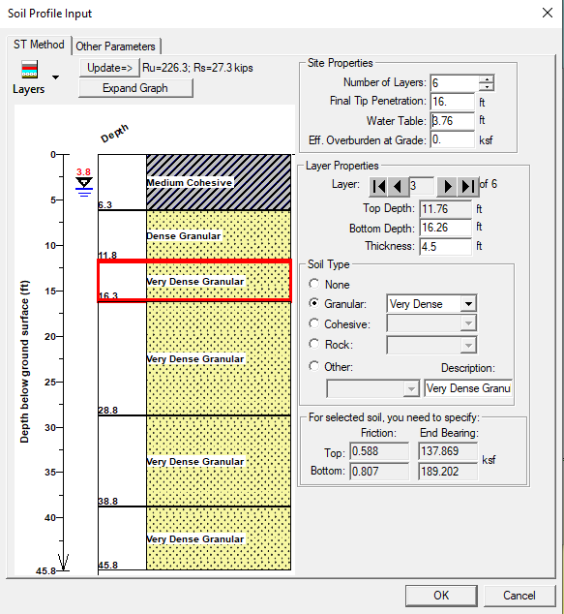

No recommendation for φ_{stat} is given in Table 2. If φ_{stat} is taken as 0.65 (skin & bearing) for all layers the required nominal static resistance can then be calculated by factoring up the design load…
R_{nstat} = 145.6 k / 0.65 = 224 k

The figure above shows that a penetration depth of 16 feet gives a nominal static resistance of
226.3 kips > 224 kips.

Note: If φ_{stat} = 0.50 then R_{nstat} = 291.2 kips and a 21’ pile length would be estimated.

- SPT N vs. Depth (SA method)
N₆₀ values were entered based on the value provided at the top of each layer. The side friction and end bearing are determined based on the N₆₀ values and not the Soil Type entered. It should be noted that N values typically are not recommended for defining properties of clays. GRLWEAP also requires N values that are adjusted for the overburden pressure, N1₆₀, but these were not readily available from the boring logs. To convert N₆₀ values to N1₆₀ use the following equation:
${N1}_{60}=N_{60}\sqrt{\frac{2000}{{σ'}_{v}}}$, where σ’_{v} = overburden pressure at depth of N60 measurement (psf)
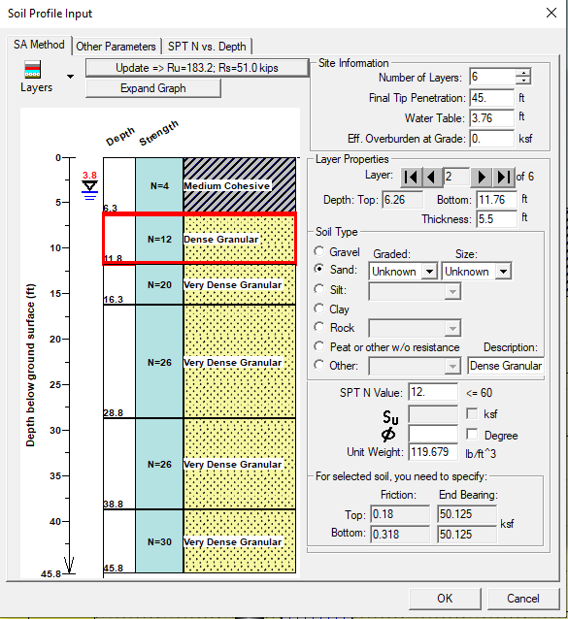

The largest penetration depth based on the available data is 45 feet. This depth results in a nominal resistance of 183.2 kips which is less than the required value of 224 kips (φ_{stat} = 0.65). If the N₆₀ values for this example were adjusted for overburden pressure the nominal static resistance is reduced significantly at a 45 feet penetration depth.

- FHWA Method
General Adhesion for Cohesive Soils (Tomlinson 1979) is selected for the adhesion type of the clay layer. Friction angles are entered directly for the sand layers using the correlated values.

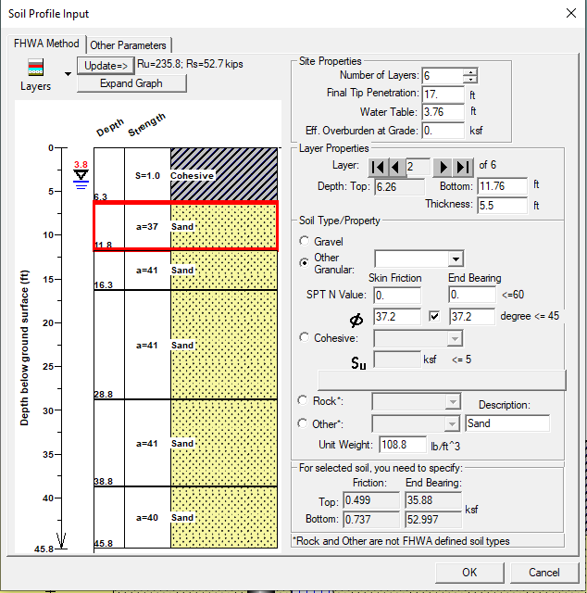

Per Table 2, if dynamic testing is used to verify pile resistance, φ_{stat} = 0.55 for sand and 0.65 for clay (skin & bearing). For simplification and since the soil stratum is comprised primarily from sand, we will assume φ_{stat} = 0.55 is used for all layers. The required nominal static resistance can then be calculated by factoring up the design load…
R_{nstat} = 145.6 k / 0.55 = 264.7 k

The figure above shows that a penetration depth of 19 feet gives a nominal static resistance of 264.4 kips ~ 264.7 kips.

Note: If the R_{nstat} was set at 224 kips a 17’ pile penetration would have been required.

- LCPC Method
The LCPC method is used by the MoDOT Geotechnical Section when CPT data is collected. Factored static resistance graphs are provided in the Foundation Investigation Geotechnical Report (FIGR). The factored static resistance graph provided for this end bent is shown below. Since factored resistances are provided they need to be compared to the factored load, P_{u} = 145.6 kips.

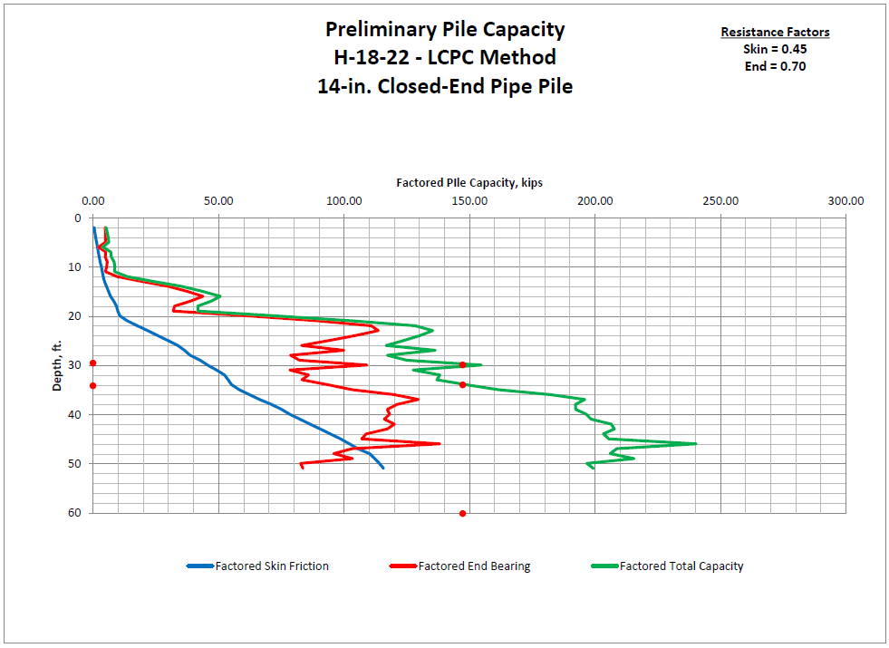

The CPT graphs are provided from the boring elevation and not the finished ground line. The boring elevation for H-18-22 is 320.80. The bottom of beam elevation listed on the plans for Bent No. 1 is 314.86. The skin resistance should be removed for the top 5.94 feet. At a 6’ depth the skin resistance is approximately 2 kips. To use the graph as shown above the negated resistance can be added to the factored load (145.6 k + 2 k = 147.6 k). Per the graph the estimated depth when capacity is first reached would be 30 feet. It is more appropriate to use the second depth, 34 feet, where capacity is reached and is not reduced at further depths..

- Data Review
Unfortunately, there is no correct answer, but if data is available we can compare to the pile length required from the PDA results. Note that the results of this case may not be typical for all sites in the Southeastern Lowlands.

The PDA test pile for this end bent was driven to a 39.7 feet penetration. The recorded PDA driving resistance is 229 kips. The following penetrations are estimated using the four static analysis techniques discussed above.

Software/Static Analysis Method | R_{nstat} | Pile Penetration Estimate | R_{nstat} = PDA | Pile Penetration Estimate
GRLWEAP 14 (FHWA) | 265 k | 19 ft | 229 k | 17 ft
GRLWEAP 14 (Soil Type-Based) | 291 k | 21 ft | 229 k | 17 ft
GRLWEAP 14 (SPT N60) | 224 k | >45 ft | 229 k | >45 ft
LCPC | 224 k | 34 ft | 229 k | 34 ft
PDA (Dynamic Testing) |  |  | 229 k | 39.7 ft

For this case study the primary takeaway is not to trust correlated soil parameters from CPT data. The GRLWEAP 14 methods either significantly underestimated or potentially significantly overestimated the pile length. The cone penetration test directly measures side and tip resistance and procedures like the LCPC method are developed for use with CPT data. The LCPC method gave a fairly accurate pile length, (the penetration was underestimated by about 6 feet), but the estimate could have been further off if the first depth was used. If the factored load on the pile had been limited to current EPG criteria that may have resulted in a more accurate estimate. If the LCPC method is not used it is recommended to import the raw CPT data into the GRLWEAP 14 software. Contact the Geotechnical Engineer for the CPT data file.

Appendix B: References
- Initial in-house LRFD CIP pile design procedure released in 2006 and last updated in 2009
Design Procedure for Pile Bents.doc
- Development Section bulletin alerting designers to an increase in the Dynamic Resistance Factor for WEAP analyses
14-05-DSB-Increased Resistance Factor for WEAP.pdf
- Research conducted by MoDOT comparing actual driven pile length to those estimated by Driven.
CIP_PileLengths_Memo1999.pdf
- Interoffice email with handwritten notes documenting factor of safety changes.
CIP_PileLengths_Memo2006.pdf
- Calibration of Resistance Factors for Axial Capacity of Driven Pile into Missouri Soil (Luna & Kebede, 2010)
SupportingDocumentsPiles-LunaKebede-July2011.pdf
- Initial research report for the statistical calibration of static and dynamic analysis methods for deep foundations.
NCHRP 507 Load and Resistance Factor Design (LRFD) for Deep.pdf
- Secondary research report for inclusion of static and dynamic resistance factors into the LRFD code.
Development of Geotechnical Resistance Factors FHWA-NHI-05-052.pdf …an excerpt is given below:

*********************************(Allen 2005)*******************************************
5.3 Resistance Factor Application Issues for Static Analysis of Pile Resistance
Note that the resistance factors for static pile bearing resistance should only be used for final sizing of the pile foundation for bearing if the pile resistance is not field verified using a dynamic method. In this scenario, the pile resistance is determined by the static analysis method at a specific tip elevation, and is then driven to that specific tip elevation without using a driving formula or dynamic measurements such as from a pile driving analyzer combined with signal matching – in this case the reliability of the pile resistance is dependent on the reliability of the static analysis method used.
The current LRFD specifications “(2005)” imply that the reliability of the nominal pile resistance is a combination of the reliability of the static analysis method used and the field resistance verification method used through the use of the λv factor. However, if the pile resistance is field verified using a dynamic method, the reliability of the pile resistance is fully dependent on the reliability of the dynamic method used to verify the pile resistance, and the resistance factor developed for the dynamic method and its associated resistance factor should be used to determine the number of piles of a specified feasible nominal resistance that is required to support the applied factored loads for the various limit states. The static analysis method, in that case, is only used to establish a feasible resistance as a starting point for the pile foundation design and to estimate pile length for contract quantities. The actual location where the pile tip is stopped is dependent only on the field verification of pile bearing resistance, provided the pile tip is below any established minimum tip elevation requirement resulting from settlement, lateral resistance, uplift, scour, or downdrag considerations.
26
*********************************(Allen 2005)*******************************************

