Resurfacing and Sign Replacements on Route AP from Route NN to MoDOT's End of Maintenance Line
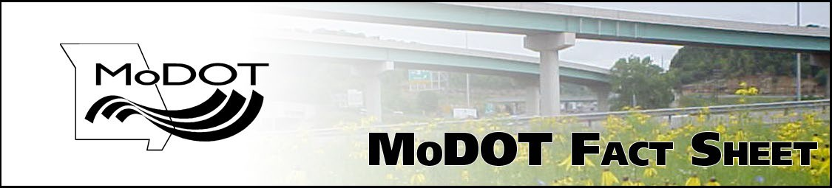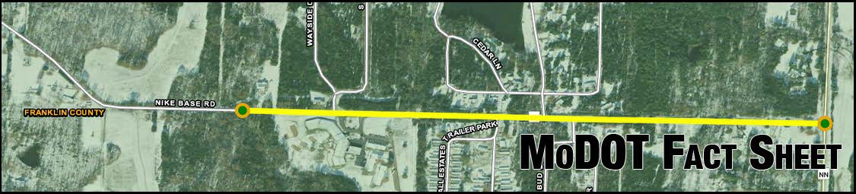

What’s is the problem?
The Missouri Department of Transportation is implementing a project to address the aging pavement and signage on Route AP. There is a need to replace signage throughout this stretch of road due to the reflectivity. The average life span of reflectivity for signage is approximately 10-12 years. MoDOT will also be conducting pavement resurfacing on Route AP from Route NN to MoDOT’s End of Maintenance Line.

What are the anticipated impacts?
Crews will be working during off-peak daytime hours. MoDOT will send out any updates and closures relating to the project ahead of time to the public through press releases and social media updates. Message boards will also be in place during the project.

What does the project include?
The project includes pavement resurfacing and replacing signage from 0.1 miles west of Wayside Drive to Route NN in Franklin County. Motorists can also look forward to new pavement markings along the corridor. The length of the project is approximately 0.68 miles.

What is the timeline?

Contract Awarded | January 2024
Construction Begins | February 2024

Once construction begins, the project will be completed in approximately one month.

What's the total cost of the project?

The total cost of the project is estimated at $127,000. MoDOT will not have to purchase right-of-way or obtain easements.

What if I have questions?

Shirley Norris– Project Manager Shirley.Norris@modot.mo.gov Phone – (314) 565-5648

