**Southeast Coalition for Roadway Safety**

**Law Enforcement Grant Outcomes Report**

All law enforcement agencies that received grant funded equipment in the current fiscal year (FY24, July 1, 2023 – present day) from the Southeast Coalition for Roadway Safety are required to submit the form below at the end of the grant cycle. This form is also included in the current Law Enforcement Grant application. If your agency is applying for the FY25 grant, please submit information within your grant application. Email reports to [Ashley.metelski@modot.mo.gov](mailto:Ashley.metelski@modot.mo.gov)

Agency Name: _________________________________________________________________________________________________

**Type of Citation**

|  |  |  |  |  |  |  |  |
| --- | --- | --- | --- | --- | --- | --- | --- |
|  | Seat Belts/ and or Car Seats | Speeding | DWI | Distracted Driving | C&I Driving | Other HMV | Total Stops |
| January |  |  |  |  |  |  |  |
| February |  |  |  |  |  |  |  |
| March |  |  |  |  |  |  |  |
| April |  |  |  |  |  |  |  |
| May |  |  |  |  |  |  |  |
| June |  |  |  |  |  |  |  |
| July |  |  |  |  |  |  |  |
| August |  |  |  |  |  |  |  |
| September |  |  |  |  |  |  |  |
| October |  |  |  |  |  |  |  |
| November |  |  |  |  |  |  |  |
| December |  |  |  |  |  |  |  |

List any campaigns, programs, community or school events, presentations or any other outreach efforts you have participated in promoting roadway safety in your area.

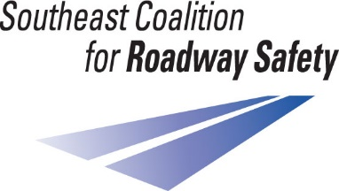  
Email reports to [ashley.metelski@modot.mo.gov](mailto:ashley.metelski@modot.mo.gov)