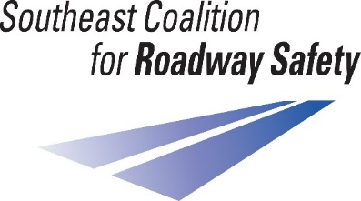
Coalition Membership
Information

The Southeast Coalition for Roadway Safety is one of seven regions of the Missouri Coalition for Roadway Safety. This is a diverse group of individuals and agencies located throughout South Central and Southeast Missouri, dedicated to saving lives and reducing serious injuries from traffic crashes. These efforts are implemented through community outreach education and Law Enforcement projects funded by the National Highway Traffic Safety Administration.
The SCRS is governed by an Executive Board from a variety of professions. The Coalition will aid the Executive Board in determining the use of funds based on crash and other safety data analysis to identify and address safety issues on our public roads. The Coalition provides the focus, foundation and fundamental resources necessary to save lives and reduce serious injuries as outlined in Missouri’s Blueprint, Show Me Zero.
Code of Conduct:
- If a potential conflict arises, the Coalition member must disclose the situation to the Southeast Coalition for Roadway Safety Representative and Executive Board as soon as possible
- Coalition members are ambassadors to the State of Missouri and should promote the Southeast Coalition for Roadway Safety as a vital organization within the region and aid in the enhancement of the organization’s public standing
Duties:
- Be willing to learn the Coalition’s purposes, goals, policies and programs
- Be actively involved in the Coalition
- Have a passion/vested interest in roadway safety
- When called upon to do so, represent the Southeast Coalition for Roadway Safety at meetings, State events and community functions
- Assist in recruiting Coalition members
- Complete the Coalition Member Application
- Attend a minimum of 2 Coalition meetings per year (virtual or in-person)
- If you cannot attend a minimum of 2 Coalition meetings per year, another representative from your organization must attend in your place (virtual or in-person)

To join the Southeast Coalition for Roadway Safety, please contact SCRS Representative Ashley Metelski, 573-380-9432 or ashley.metelski@modot.mo.gov

