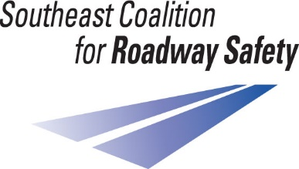
Executive Board
Member Information
The Southeast Coalition for Roadway Safety is one of seven regions of the Missouri Coalition for Roadway Safety. This is a diverse group of individuals and agencies located throughout South Central and Southeast Missouri, dedicated to saving lives and reducing serious injuries from traffic crashes. These efforts are implemented through community outreach education and Law Enforcement projects funded by the National Highway Traffic Safety Administration.
The SCRS is governed by an Executive Board from a variety of professions. This team determines the use of funds based on crash and other safety data analysis to identify and address safety issues on our public roads. The Coalition provides the focus, foundation and fundamental resources necessary to save lives and reduce serious injuries as outlined in Missouri’s Blueprint, Show Me Zero.
Duties:
- Be willing to learn the Coalition’s purposes, goals, policies and programs
- Be actively involved in the Coalition, with the opportunity to lead or serve on a Sub-Committee, if interested
- Have a passion/vested interest in roadway safety
- Exercise prudence in making decisions about grants the Coalition awards
- When called upon to do so, represent the Southeast Coalition for Roadway Safety at meetings, State events and community functions
- Assist in recruiting Coalition members
- Be willing to attend planning sessions for the Board that will determine the direction, budget and activities of the Coalition
Code of Conduct:
- Serve the Coalition as a whole, rather than a specific interest group or constituency, regardless of whether that person was invited to fill a vacancy reserved for a certain group
- Avoid even the appearance of a conflict that would arise a bad light on the Coalition and the Board
- If a potential conflict arises, the board member must disclose the situation to the Southeast Coalition for Roadway Safety Representative and Executive Board as soon as possible
- Never accept, or offer, gifts or favors (or to) anyone who does business with the Coalition or State of Missouri
- Board members are ambassadors to the State of Missouri and should promote the Southeast Coalition for Roadway Safety as a vital organization within the region and aid in the enhancement of the organization’s public standing
Expectations:
- Complete Board Application
- Term of service is 3 years and up to 2 consecutive terms may be served
- Attend a minimum of 2 Board and Coalition meetings per year (virtual or in-person)

