Southeast Coalition for Roadway Safety
Law Enforcement Grant Outcomes Report
All law enforcement agencies that receive grant funded equipment (in the current fiscal year,
July - June) from the Southeast Coalition for Roadway Safety are required to submit the form below twice during the grant cycle. This timeframe for this is as follows: December 1 – May 31- due by June 15; June 1 - November 31- due by December 31. Email reports to Ashley.metelski@modot.mo.gov
Agency Name: _________________________________________________________________________________________________

Reporting Period: _____________________________________________________________________________________________

Type of Citation
 | Seat Belts/ and or Car Seats | Speeding | DWI | Distracted Driving | C&I Driving | Other HMV | Total Stops
January
February
March
April
May
June
July
August
September
October
November
December

List any campaigns, programs, community or school events, presentations or any other outreach efforts you have participated in promoting roadway safety in your area.

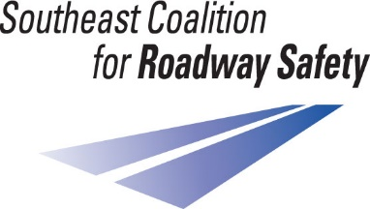
Email reports to ashley.metelski@modot.mo.gov

