Terry L. Ecker
Member
Missouri Highways and Transportation Commission

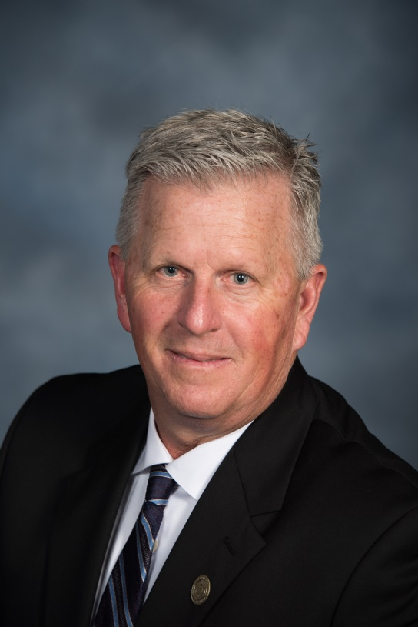

Terry L. Ecker was initially appointed to the Missouri Highways and Transportation Commission on September 8, 2017 by Governor Eric Greitens. His term expires March 1, 2023.

Ecker and his wife, Susan, raise corn, soybeans, and cattle on their farm Northwest of Elmo, just one-quarter of a mile from where Ecker’s great, great grandfather settled in Nodaway county in 1868. He received a Bachelor of Science degree in Agriculture Economics from the University of Missouri-Columbia and is a graduate of Agriculture Leaders of Tomorrow Class IX.

Ecker was appointed by three different U.S. Secretaries of Agriculture to represent the State of Missouri on the United Soybean Board. He is a past Vice-Chairman of the U.S. Soybean Export Council. Ecker has served as an Agriculture Field Representative for Congressman Sam Graves. He is a member of Missouri Farm Bureau and served as a past Nodaway County Farm Bureau President. Ecker is a member of the Missouri Cattlemen’s Association, Missouri Corn Growers, and Missouri Soybean Association.

