JOB SPECIAL PROVISIONS TABLE OF CONTENTS
(Job Special Provisions shall prevail over General Provisions whenever in conflict therewith.)

A. General - State JSP-09-03H 2
B. Contract Liquidated Damages JSP-13-01B 2
C. Work Zone Traffic Management JSP-02-06L 3
D. Emergency Provisions and Incident Management JSP-90-11A 5
E. Project Contact for Contractor/Bidder Questions JSP-96-05 6
F. Project Details and Quantities 7
G. Permanent Aggregate Edge Treatment NJSP-15-40B 19
H. Optional Road Closure in Lieu of Flagger Controlled Lane Closure 19
I. Contractor Quality Control for Plant Mix Bituminous Surface Leveling NJSP-15-21A 22
J. Flagging Procedure for Two-Lane Roadways (3-2-1 Cone Precedure) NJSP-17-03A 24
K. Pilot Car in Use – Wait and Follow Sign NJSP-1803 25
L. Bridge End Transitions 26
M. Pavement Marking Log 26
N. Multi-Year, Multi-Location Project – Special Requirements NJSP-22-02 27
O. Supplemental Revisions JSP-18-01V 28
P. Sensitive Stream Near Project Area 43

MISSOURI HIGHWAYS AND
TRANSPORTATION COMMISSION
105 W. CAPITOL AVE.
JEFFERSON CITY, MO 65102
Phone 1-888-275-6636
If a seal is present on this sheet, JSP’s have been electronically sealed and dated.
JOB NUMBER: JNW0094
PUTNAM, SULLIVAN, AND
LINN COUNTIES, MO
DATE PREPARED: 05/31/2022
ADDENDUM DATE:

Only the following items of the Job Special Provisions (Roadway) are authenticated by this seal: ALL

JOB
SPECIAL PROVISION

General - State JSP-09-03H

1.0 Description. The Federal Government is not participating in the cost of construction of this project.

1.1 This contract requires payment of the prevailing hourly rate of wages for each craft or type of worker required to execute the contract as determined by the Missouri Department of Labor and Industrial Relations. The current State Wage Rates can be found on the Missouri Department of Transportation web page at www.modot.org under "Doing Business with MoDOT”, “Contractor Resources” for the applicable bid opening. This supplemental bidding document has important legal consequences. It shall be conclusively presumed that they are in the bidder's possession, and they have been reviewed and used by the bidder in the preparation of any bid submitted on this project.

State Wage Rates

1.2 The following documents are available on the Missouri Department of Transportation web page at www.modot.org under "Doing Business with MoDOT"; “Standards and Specifications”. The effective version shall be determined by the letting date of the project.

General Provisions & Supplemental Specifications

Supplemental Plans to July 2022 Missouri Standard Plans
For Highway Construction

These supplemental bidding documents contain all current revisions to the published versions and have important legal consequences. It shall be conclusively presumed that they are in the bidder's possession, and they have been reviewed and used by the bidder in the preparation of any bid submitted on this project.

Contract Liquidated Damages JSP-13-01B

1.0 Description. Liquidated Damages for failure or delay in completing the work on time for this contract shall be in accordance with Sec 108.8. The liquidated damages include separate amounts for road user costs and contract administrative costs incurred by the Commission.

2.0 Period of Performance. Prosecution of work is expected to begin on the date specified below in accordance with Sec 108.2. Regardless of when the work is begun on this contract, all work shall be completed on or before the date specified below. Completion by this date shall be in accordance with the requirements of Sec 108.7.1.

Notice to Proceed: August 18, 2022
Completion Date: June 30, 2023

2.1 Calendar Days. The count of calendar days will begin on the date the contractor starts any construction operations on the project.

Job Number Calendar Days Daily Road User Cost
JNW0094 NA $1800

3.0 Liquidated Damages for Contract Administrative Costs. Should the contractor fail to complete the work on or before the completion date specified in Section 2.0, or within the number of calendar days specified in Section 2.1, whichever occurs first, the contractor will be charged contract administrative liquidated damages in accordance with Sec 108.8 in the amount of $2000 per calendar day for each calendar day, or partial day thereof, that the work is not fully completed. For projects in combination, these damages will be charged in full for failure to complete one or more projects within the above specified completion date or calendar days.

4.0 Liquidated Damages for Road User Costs. Should the contractor fail to complete the work on or before the completion date specified in Section 2.0, or within the number of calendar days specified in Section 2.1, whichever occurs first, the contractor will be charged road user costs in accordance with Sec 108.8 in the amount specified in Section 2.1 for each calendar day, or partial day thereof, that the work is not fully completed. These damages are in addition to the contract administrative damages and any other damages as specified elsewhere in this contract.

Work Zone Traffic Management JSP-02-06L
1.0 Description. Work zone traffic management shall be in accordance with applicable portions of Division 100 and Division 600 of the Standard Specifications, and specifically as follows.

1.1 Maintaining Work Zones and Work Zone Reviews. The Work Zone Specialist (WZS) shall maintain work zones in accordance with Sec 616.3.3 and as further stated herein. The WZS shall coordinate and implement any changes approved by the engineer. The WZS shall ensure all traffic control devices are maintained in accordance with Sec 616, the work zone is operated within the hours specified by the engineer, and will not deviate from the specified hours without prior approval of the engineer. The WZS is responsible to manage work zone delay in accordance with these project provisions. When requested by the engineer, the WZS shall submit a weekly report that includes a review of work zone operations for the week. The report shall identify any problems encountered and corrective actions taken. Work zones are subject to unannounced inspections by the engineer and other departmental staff to corroborate the validity of the WZS’s review and may require immediate corrective measures and/or additional work zone monitoring.

1.2 Work Zone Deficiencies. Failure to make corrections on time may result in the engineer suspending work. The suspension will be non-excusable and non-compensable regardless if road user costs are being charged for closures.

2.0 Traffic Management Schedule.

2.1 Traffic management schedules shall be submitted to the engineer for review prior to the start of work and prior to any revisions to the traffic management schedule. The traffic management schedule shall include the proposed traffic control measures, the hours traffic control will be in place, and work hours.

2.2 The traffic management schedule shall conform to the limitations specified in Sec 616 regarding lane closures, traffic shifts, road closures and other width, height and weight restrictions.

2.3 The engineer shall be notified as soon as practical of any postponement due to weather, material or other circumstances.
2.4 In order to ensure minimal traffic interference, the contractor shall schedule lane closures for the absolute minimum amount of time required to complete the work. Lanes shall not be closed until material is available for continuous construction and the contractor is prepared to diligently pursue the work until the closed lane is opened to traffic.

2.5 Traffic Congestion. The contractor shall, upon approval of the engineer, take proactive measures to reduce traffic congestion in the work zone. The contractor shall immediately implement appropriate mitigation strategies whenever traffic congestion reaches an excess of 10 minutes to prevent congestion from escalating to 15 minute or above threshold. If disruption of the traffic flow occurs and traffic is backed up in queues of 15 minute delays or longer, then the contractor shall immediately review the construction operations which contributed directly to disruption of the traffic flow and make adjustments to the operations to prevent the queues from reoccurring. Traffic delays may be monitored by physical presence on site or by utilizing real-time travel data through the work zone that generate text and/or email notifications where available. The engineer monitoring the work zone may also notify the contractor of delays that require prompt mitigation. The contractor may work with the engineer to determine what other alternative solutions or time periods would be acceptable.

2.5.1 Traffic Safety.

2.5.1.1 Recurring Congestion. Where traffic queues routinely extend to within 1000 feet of the ROAD WORK AHEAD, or similar, sign on a divided highway or to within 500 feet of the ROAD WORK AHEAD, or similar, sign on an undivided highway, the contractor shall extend the advance warning area, as approved by the engineer.

2.5.1.2 Non-Recurring Congestion. When traffic queues extend to within 1000 feet of the ROAD WORK AHEAD, or similar, sign on a divided highway or to within 500 feet of the ROAD WORK AHEAD, or similar, sign on an undivided highway infrequently, the contractor shall deploy a means of providing advance warning of the traffic congestion, as approved by the engineer. The warning location shall be no less than 1000 feet and no more than 0.5 mile in advance of the end of the traffic queue on divided highways and no less than 500 feet and no more than 0.5 mile in advance of the end of the traffic queue on undivided highways.

3.0 Work Hour Restrictions.

3.1 Except for emergency work, as determined by the engineer, and long term lane closures required by project phasing, all lanes shall be scheduled to be open to traffic during the five major holiday periods shown below, from 12:00 noon on the last working day preceding the holiday until 6:00 a.m. on the first working day subsequent to the holiday unless otherwise approved by the engineer.

Memorial Day
Labor Day
Thanksgiving
Christmas
New Year’s Day

3.1.1 Independence Day. The lane restrictions specified in Section 3.1 shall also apply to Independence Day, except that the restricted periods shall be as follows:

12:00 noon July 1, 2022 – 6:00 a.m. July 5, 2022
12:00 noon June 30, 2023 – 6:00 a.m. July 5, 2023
12:00 noon July 3, 2024 – 6:00 a.m. July 5, 2024

3.2 The contractor shall not perform any construction operation on the roadway, including the hauling of material within the project limits, during restricted periods, holiday periods or other special events specified in the contract documents.

4.0 Detours and Lane Closures.

4.1 When a changeable message sign (CMS) is provided, the contractor shall use the CMS to notify motorists of future traffic disruption and possible traffic delays one week before traffic is shifted to a detour or prior to lane closures. The CMS shall be installed at a location as approved or directed by the engineer. If a CMS with Communication Interface is required, then the CMS shall be capable of communication prior to installation on right of way. All messages planned for use in the work zone shall be approved and authorized by the engineer or its designee prior to deployment. When permanent dynamic message signs (DMS) owned and operated by MoDOT are located near the project, they may also be used to provide warning and information for the work zone. Permanent DMS shall be operated by the TMC, and any messages planned for use on DMS shall be approved and authorized by the TMC at least 72 hours in advance of the work.

4.2 At least one lane of traffic in each direction shall be maintained at all times except for brief intervals of time required when the movement of the contractor’s equipment will seriously hinder the safe movement of traffic. Periods during which the contractor will be allowed to interrupt traffic will be designated by the engineer.

5.0 Basis of Payment. No direct payment will be made to the contractor to recover the cost of equipment, labor, materials, or time required to fulfill the above provisions, unless specified elsewhere in the contract document. All authorized changes in the traffic control plan shall be provided for as specified in Sec 616.

Emergency Provisions and Incident Management JSP-90-11A

1.0 The contractor shall have communication equipment on the construction site or immediate access to other communication systems to request assistance from law enforcement or other emergency agencies for incident management. In case of traffic accidents or the need for law enforcement to direct or restore traffic flow through the job site, the contractor shall notify law enforcement or other emergency agencies immediately as needed. The area engineer's office shall also be notified when the contractor requests emergency assistance.

2.0 In addition to the 911 emergency telephone number for ambulance, fire or law enforcement services, the following agencies may also be notified for accident or emergency situation within the project limits.

Missouri Highway Patrol (660)-359-2060
Putnam County Sherrif | Sullivan County Sherrif | Linn County Sherrif
(660)-947-3200 | (660)-265-3313 | (660)-895-5312

2.1 This list is not all inclusive. Notification of the need for wrecker or tow truck services will remain the responsibility of the appropriate law enforcement agency.

2.2 The contractor shall notify law enforcement and emergency agencies before the start of construction to request their cooperation and to provide coordination of services when emergencies arise during the construction at the project site. When the contractor completes this notification with law enforcement and emergency agencies, a report shall be furnished to the engineer on the status of incident management.

3.0 No direct pay will be made to the contractor to recover the cost of the communication equipment, labor, materials or time required to fulfill the above provisions.

Project Contact for Contractor/Bidder Questions JSP-96-05

All questions concerning this project during the bidding process shall be forwarded to the project contact listed below.

Richard Orr, Project Contact Telephone Number: (816) 387-2483
Northwest District Email: Richard.Orr@modot.mo.gov
3602 North Belt Hwy
Saint Joseph, MO 64506

All questions concerning the bid document preparation can be directed to the Central Office – Design at (573) 751-2876.

Project Details and Quantities

1.0 Description. This project consists of applying a plant mix bituminous pavement (surface leveling) as described here in.

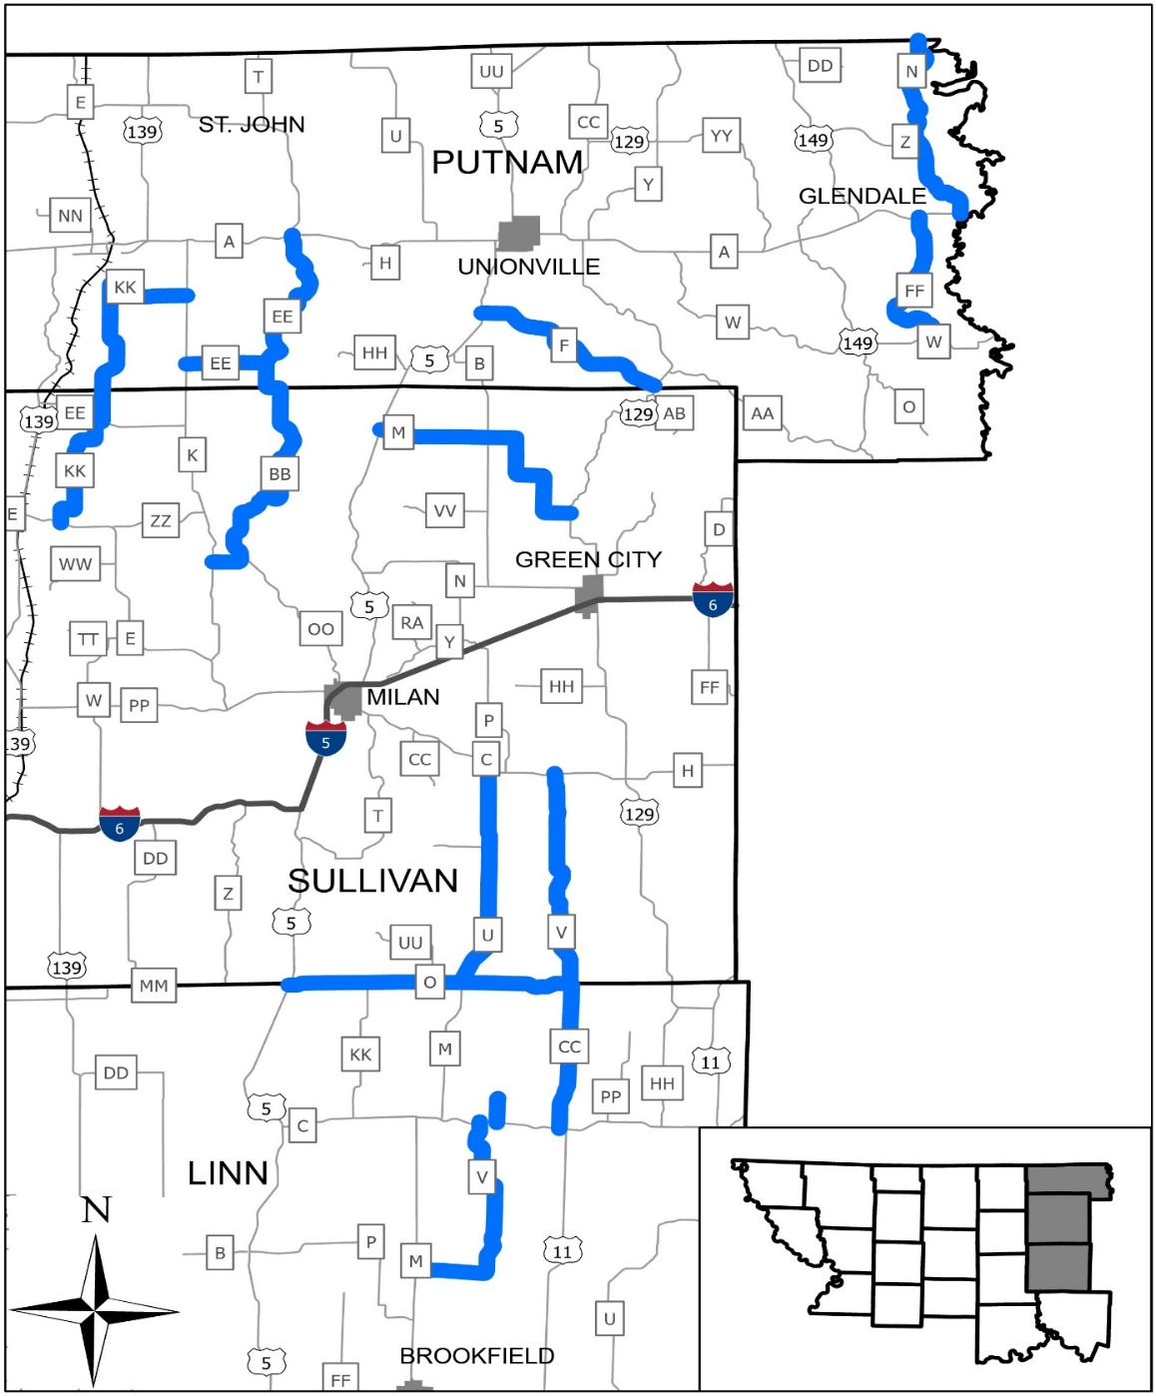

The project limits are from Log Mile 0.00 to 11.175, Rte. BB; 0.00 to 5.938, Rte. CC; 0.00 to 9.344, Rte EE; 0.00 to 7.618, Rte. F; 0.00 to 6.707, Rte. FF; 0.00 to 8.969, 9.212 to 14.222, Rte. KK; 0.00 to 9.982, Rte.M; 0.00 to 8.562, Rte. N; 0.00 to 10.317, Rte. O; 0.00 to 8.798, Rte. U; 0.00 to 0.986, 1.609 to 10.933, Rte. V; 0.00 to 8.93, Rte. V. The total length of pavement limits are 111.90 miles.

  - Mobilization. Mobilization will be measured and paid for once per contract regardless of the number of routes in the contract.

  - Pavement will not be placed at the following exception locations listed below:

2.0 Mix and Pavement Transitions.

2.1 1” Plant Mix Bituminous Surface PG 58-28 pavement shall be placed the entire width of the lanes, one pass per lane with no superelevation correction. Tack coat shall be applied at the rate of 0.08 gal/yd² the entire width of the travleway for the length of the pavement limits.
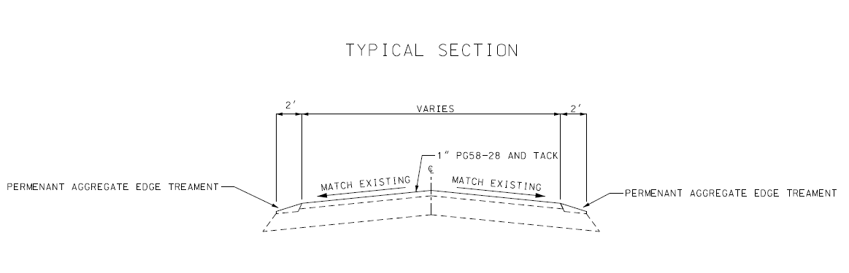

2.2 Depth transitions when beginning and ending at a state route shall be coldmilled at the rate of 1” in 50’. When beginning or ending mid-route, including exceptions, shall be coldmilled at the rate of 1” in 50’.

2.3 Coldmilling and pavement tapers at intersecting state routes will vary. See quantities for the approximate paved approach and coldmilling areas (see transition area details below).

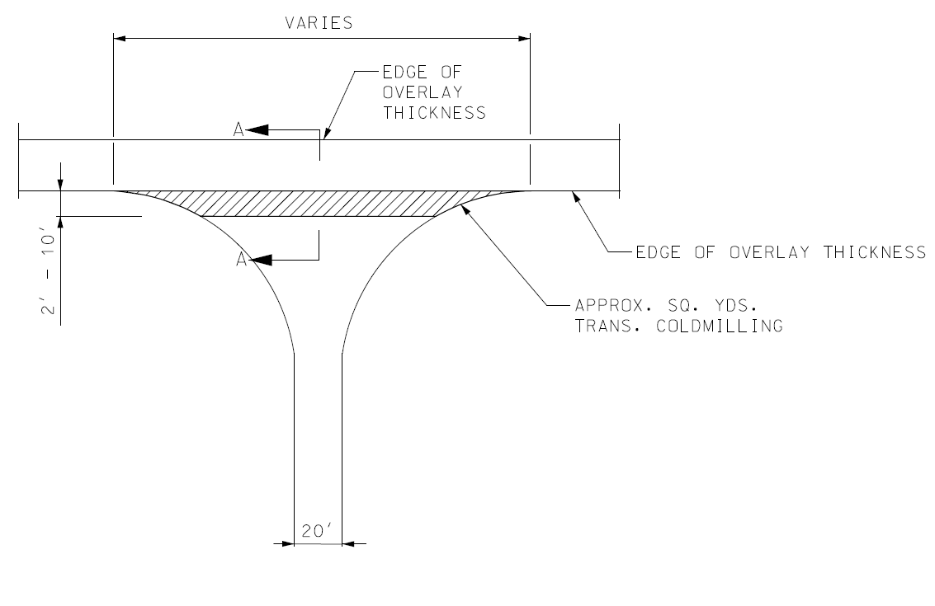

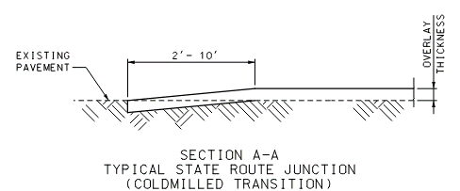

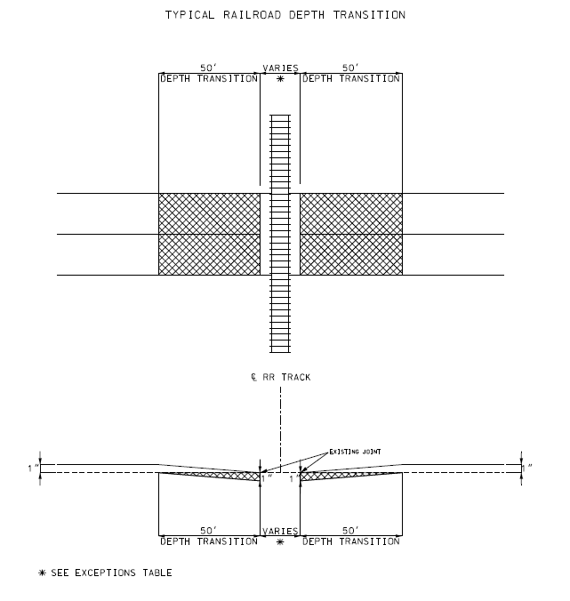

2.4 The bituminous pavement shall be tapered at entrances and non-state routes (see pavement taper details below).
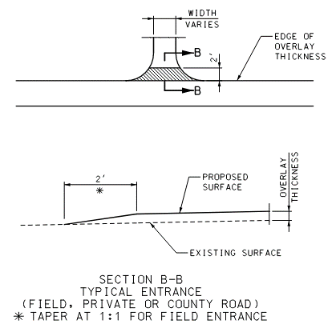

3.0 Pavement and Coldmilling Quantities.

3.1 Surface leveling mixture, permanent aggregate edge treatmetnent and tack quantities calculated for this project are presented in the next tables. The conversion factors used to determine the pay quantities listed in the tables are as follows:

- Bituminous Pavement Mixture PG58-28 (Surface Leveling) 1.98 Tons per yd³
- Tack Application Rate for Unmilled Surfaces 0.08 Gallons per yd²
- Tack Application Rate for Milled Surfaces 0.10 Gallons per yd²
- Permenant Aggregate Edge Treatment 1.6 Tons per yd³

3.2 Coldmilling Quantities are as follows:

3.3 Permanent Aggregate Edge Treatment is as follows:
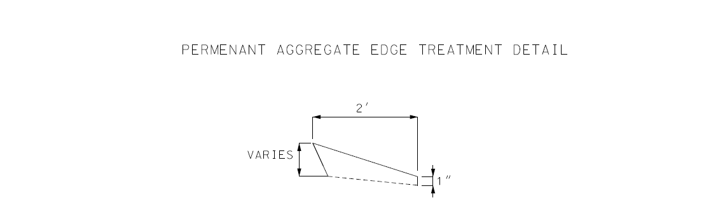

4.0 Temporary Traffic Control Plans. See Standard Plans 616.20 for standard temporary traffic control requirements.

4.1 Traffic Control Devices and Construction sign quantities are as follows:

4.2 Description. This work shall consist of providing and installing construction signs for lane closures on two-lane roadways using a Pilot Car in conjunction with flaggers.

4.3 Roadway Requirements. The contractor shall provide and utilize construction signs and devices on the project in accordance with all provisions of Section 616.1, 616.2, 616.3, and 616.4 of the Missouri Standard Specifications for Highway Construction. Installation of construction signs shall be in accordance with Standard Plans for temporary traffic control.

4.4 Measurement. The quantities depicted in the plans are for informational purposes only. The actual quantities may increase or decrease depending upon the methods of construction. Field measurements will not be made.

4.5 Payment. All cost associated with construction signs and devices including the material, manpower, time and equipment necessary to install, remove or relocate them shall be completely covered by the contract unit price for Item Number 616-99.01, “Traffic Control”, per Lump Sum. Traffic control will be paid once per contract regardless of the number of routes in the contract.

5.0 Pavement Marking. Pavement marking quantities are as follows:

Permanent Aggregate Edge Treatment NJSP-15-40B

1.0 Description. This work shall consist of furnishing and installing a permanent aggregate edge treatment along the edge of shoulder or pavement as shown on the plans or as directed by the engineer.

2.0 Construction Requirements. Aggregate shall be simultaneously deposited and spread on the sub-grade and shall not be deposited on the pavement or shoulder and bladed into place. Aggregate material shall be shaped according to the typical section and compacted until there is no visible evidence of further consolidation.

3.0 Material Requirements. Material used for the aggregate edge treatment shall be Type 1, 5, or 7 Aggregate in accordance with Sec 1007 or an allowable substitute approved by the engineer. Bituminous cold millings meeting the gradation for Type 1, 5 or 7 Aggregate may be used in lieu of aggregate. Limestone screenings or other material with excessive fines will not be allowed. Material will be accepted based on certification in lieu of testing contingent upon satisfactory results being obtained in the field.

4.0 Measurement by Weight. Measurement of the aggregate edge treatment material shall be per ton and in accordance with Sec 310.5.3.

5.0 Basis of Payment. The accepted quantities of aggregate edge treatment will be paid for at the contract unit price for 304-99.10, Permanent Aggregate Edge Treatment, per ton and will be full compensation for all labor, equipment and material to complete the described work. No fuel adjustment will be made for Permanent Aggregate Edge Treatment.

Optional Road Closure in Lieu of Flagger Controlled Lane Closure

1.0 To expedite resurfacing operations and minimize exposure to workers, the contractor has the option to close roadways identified in this contract as approved by the engineer. Road closure requirements shall meet the following:

- In order to minimize inconveniences, the contractor shall coordinate roadway closures with local residents, schools, and emergency service providers two weeks prior to the roadway being closed. .
- Roadway closures shall begin and end at logical termini or intersections.
- Closure time for any roadway shall not exceed one day’s production limit. All roadways shall be open to all traffic when resurfacing operations have stopped.
- Intersecting roadways shall not have simultaneous resurfacing operations taking place at the same time (e.g. intersecting roadways MO J and MO HH shall not be simultaneously resurfaced).
- Periods during which the contractor will be allowed to halt traffic will be designated by the engineer.
- The contractor shall provide temporary traffic control plans for optional roadway closures to the engineer for approval. Detour signing is not required.

2.0 Basis of Payment. No direct payment will be made for additional temporary traffic control devices, signs, equipment, labor, or materials should the contractor opt to close the roadway and shall be considered completely covered by the contract unit price for 616-99.01 Misc. Temporary Traffic Control lump sum or 616-99.02 Misc. Temporary Traffic Control each.

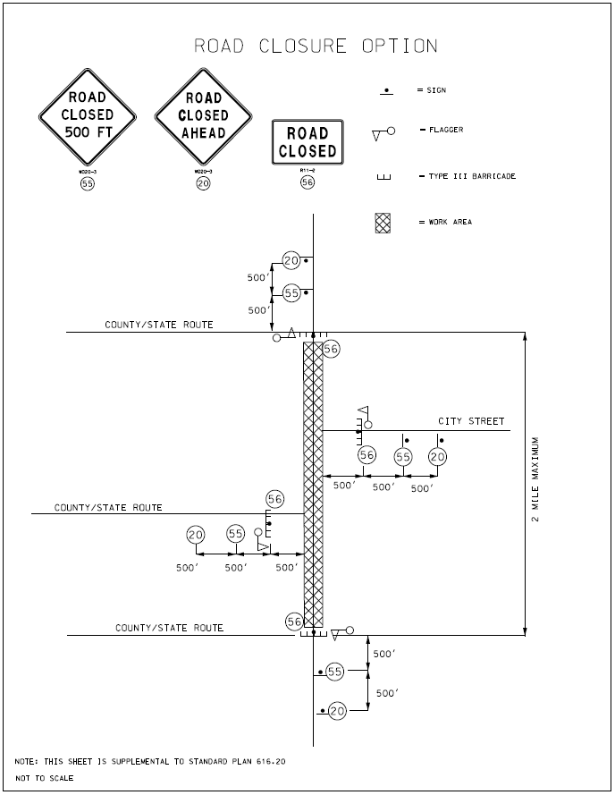

Contractor Quality Control for Plant Mix Bituminous Surface Leveling NJSP-15-21A

1.0 Description. The contractor shall provide Quality Control (QC) testing and shall perform verification procedures associated with the production and placement of Plant Mix Bituminous Surface Leveling Mixture in accordance with this provision.

2.0 Asphalt Plant Requirements. The contractor shall perform quality control testing in the production of the Surface Leveling Mixture and report the results electronically on MoDOT-provided forms. All reports shall include the Contract ID, Project Number, Route, County, and Job Mix number.

2.1 Calibration of the asphalt plant shall be in accordance with Sec 403.17.2.2. Record retention for verification of test reports shall be in accordance with Sec 403.17.3.2.

2.2 At a minimum, the contractor shall perform one QC sieve analysis test for each day of production of Surface Level mixture in excess of 100 tons to verify the aggregate is within the required gradation range. Results of the QC sieve analysis test shall be reported to the engineer daily. A split of each sample shall be clearly labeled and stored by the contractor in a manner that prevents contamination. The engineer will collect a minimum of one random QC split sample, and one full sample from plant production, for testing per each 10,000 tons of production. Uncollected QC split samples shall be retained by the contractor until the engineer authorizes disposal or until the Final Inspection, whichever occurs earlier.

2.3 The contractor shall monitor the quantity of asphalt binder used in the production of the mix, including any commercial mix, and report that quantity to the engineer. Original asphalt binder delivery tickets shall accompany the report submitted to the engineer. The engineer will perform a minimum of one asphalt binder content test per each 10,000 tons of production for any project that exceeds a total of 5,000 tons of production.

2.4 The contractor shall take a daily QC sample of the asphalt binder per instructions in Section 460.3.13 of the EPG. The engineer will collect the QC samples and ship to the MoDOT Central lab for random testing. In addition, the engineer will take a minimum of one random Quality Assurance sample per project from the binder line. The engineer sample will be shipped to the Central Lab along with the daily samples and will be designated for testing.

2.5 The contractor shall perform one moisture content test for each day of production of Surface Level mixture in excess of 100 tons. The frequency of the moisture test may be reduced if approved by the engineer.

3.0 Roadway Requirements. The contractor shall perform quality control verification of the Surface Leveling Mixture on the roadway and shall monitor the asphalt tonnage placed in relation to plan quantity.

3.1 Irregularities. Additional tons of Surface Leveling mix will be provided for irregularities in the existing roadway surface. The tonnage specified for irregularities is an estimated quantity and shall only be placed at locations where it is necessary to fill ruts and other low points. Prior to placing the mix, the contractor and engineer shall evaluate the entire route and develop a plan that best utilizes the tonnage needed for irregularities. Any excess quantity of irregularities shall not be placed.

3.2 Tack. On the first day of production, the contractor shall demonstrate proper application of tack coat in the presence of the engineer. Thereafter, when the engineer is not present to witness the application of the tack coat, the contractor shall document the tack application by taking a minimum of two high-resolution date/time stamped photographs of the tacked surface per one-mile segment. Pictures should be taken just in front of the paver in order to account for loss of tack from truck tires. The contractor shall also monitor and document the application rate. The contractor shall take distributor readings at the beginning and ending of each shift and document the quantity used.

3.3 Spreading and Rolling. On the first day of production, the contractor shall demonstrate successful spreading and compaction of the mixture, including proper rolling patterns, in the presence of the engineer. Thereafter, the contractor shall monitor all roadway production procedures and document daily. Use of approved Intelligent Compaction technology is an allowable substitute for daily documentation.

3.4 Monitoring of Quantity. The contractor shall monitor the quantity of Surface Level mix placed and report that information to the engineer and production staff as specified herein.

3.4.1 The contractor shall verify that the quantity of Surface Leveling mix in the contract for each route is sufficient to cover the roadway as shown on the typical sections, including any surface irregularities. Any discrepancies shall be brought to the engineer's attention in writing prior to the pre-construction conference. Plan quantity shall be defined as the total tons computed to cover the surface area according to the typical section, plus any amount pre-approved by the engineer for pavement irregularities.

3.4.2 The contractor shall provide temporary log mile reference points at no less than ½ mile intervals along each route to monitor the tons of Surface Leveling mix laid in relation to plan quantity. Entrances, shoulders, or other irregular areas will be monitored as directed by the engineer.

3.4.3 During production, the contractor shall document the total tons placed in each one-mile segment, along with the plan quantity and the percent over/under for that segment. The cumulative quantity and percent over/under for the route should also be documented. After each one-mile segment, the contractor shall provide a status report to the production manager and the engineer. When the engineer is not present on the project, the contractor shall send an electronic status report to the engineer.

3.4.4 The goal is to keep the placed quantity within 2% of plan quantity for the project. The engineer will monitor the status reports and will advise the contractor on how to proceed when there is an excessive variance from plan quantity. The engineer may decrease the frequency of the electronic status reports when the variances are consistently low.

3.4.5 The contractor shall collect asphalt tickets from the delivery trucks and group them per each one-mile segment. The contractor shall submit to the engineer a daily summary report that includes all of the information specified in Section 3.4.3. The contractor shall sign the summary report confirming that the information is accurate and that the attached tickets represent the asphalt material placed.

3.4.6 The contractor shall be equipped with a contractor-furnished cellular device capable of providing and maintaining a reliable means of immediate communication with the engineer when the engineer is not present on the project.

4.0 Excessive Quantity. If the contractor places Surface Level mix on any one-mile segment, or any other isolated areas, in excess of plan quantity by 5% or more, without prior approval from the engineer, further investigation may be required to determine if the excess was warranted. If directed by the engineer, the contractor shall core the pavement at locations established by the engineer to determine the amount that was excessive, if any. No payment will be made for the cost to core the pavement or for the tons of Surface Level mix that the engineer determines to be excessive. If the amount of Surface Level mix is determined to be justified, payment will be made for the mix, and for the cost of coring at the fixed price established in Sec 109. Placement of asphalt in excess of plan quantity for two consecutive segments without prior approval from the engineer may result in issuance of an Order Record to stop work.

5.0 Basis of Payment. No direct payment will be made for compliance with this provision. All costs shall be considered completely covered under the pay items provided in the contract.

Flagging Procedure for Two-Lane Roadways (3-2-1 Cone Precedure) NJSP-17-03A

1.0 Description. Flagging operations shall be in accordance with the Manual on Uniform Traffic Control Devices (MUTCD) Chapter 6, Section 107 and 616 in Missouri Standard Specifications for Highway Construction, Missouri Standard Plans for Highway Construction, temporary traffic control plans, and as described herein.

2.0 Procedures for Flagging Short, Intermediate, or Long-Term Stationary Operations. This procedure includes the use of three traffic cones or other channelizing devices.

2.1 Step 1. The flagger shall place three cones across the lane of traffic to be stopped, from centerline to shoulder. When no vehicles are present, the flagger should remain on the shoulder with the stop paddle visible.

2.2 Step 2. When traffic has stopped, the flagger shall move towards the centerline of the roadway, keeping the stop paddle visible, and keeping a visual contact with the stopped drivers. Once the flagger has confirmed that opposing traffic is clear, the flagger shall prepare to release the stopped traffic.

2.3 Step 3a. If the vehicles are to travel in the current lane, the flagger shall remove the center cone from the center of the lane.

2.4 Step 3b. If the vehicles are to travel in the opposite lane, the three cones shall remain across the closed lane.

2.5 Step 4. If opening the lane (Step 3a above) the flagger shall walk back to the shoulder with the cone, turn the stop paddle to slow, and then release traffic using a hand signal to direct vehicles between the two remaining cones. If releasing traffic to the other lane (Step 3b above) the flagger shall remain near the centerline of the roadway, turn the stop paddle to slow, and use a hand signal to direct the traffic around the cones into the open lane.

2.6 Once all traffic has cleared, the flagger shall return the slow paddle to stop. The flagger shall replace the cone to the center of the lane or leave the cones across the lane. The flagger then returns to the shoulder and repeats the steps.

2.7 If the roadway width is less than 12 feet, the number of cones may be reduced to two or one, or other channelizing devices may be used.

3.0 Basis of Payment. No direct payment will be made for any cost associated with this provision.

Pictorial Representation of Steps for Flagging Procedure for Two-Lane Roadways (3-2-1 Cone Procedure)

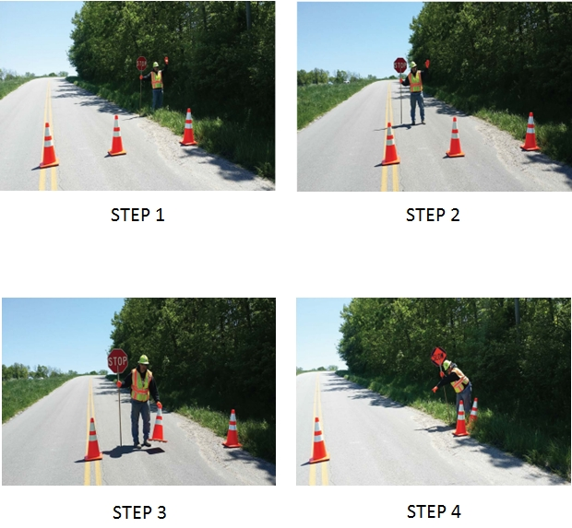

Pilot Car in Use – Wait and Follow Sign NJSP-1803

- Description. The sign shown below shall be printed on 4 mm corrugated plastic or similar and supported with a 10”x30”, 9 gauge, galvanized steel H-frame, or similar. This sign shall only be used at private and commercial entrances to enhance the work zone signing, and will not be permitted for use on intersecting state, county or city roads.

- Method of Payment. Signs shall be contractor furnished/contractor retained. The cost of the signs and stands are incidental to other traffic control items.

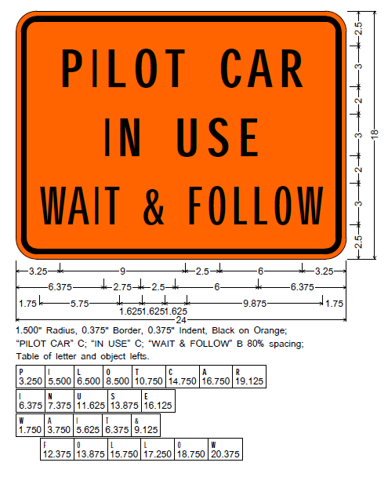

Bridge End Transitions

1.0 At all bridge exceptions, the engineer will determine in the field the ending point of the transition. This point will not necessarily be at the bridge end, but will be located at a point which provides the smoothest transition and approach to the bridge. Where bridges are to be resurfaced, the surfacing shall be from curb to curb.

Pavement Marking Log

1.0 Description. The contractor shall log the locations of existing pavement marking prior to any construction operations that may affect the existing pavement marking. The log shall contain all existing pavement marking and shall include center stripes, no passing stripes, lane lines, turn arrows, hash bars, cross walks, and stop bars. The contractor shall provide a copy of the existing pavement marking log to the engineer. The contractor shall place the new pavement marking at the same locations as the existing pavement marking, unless otherwise directed by the engineer or shown on the plans.

2.0 Basis of Payment. No direct payment will be made for logging of existing pavement marking.

Multi-Year, Multi-Location Project – Special Requirements NJSP-22-02

1.0 Description. Whereas this project is identified by a single Job Number, and the project requires work be performed at multiple Locations, and the contract allows for work to be performed in multiple calendar years, these special requirements and allowances shall apply. A Location is generally identified in the contract or plans by Route and County but may be otherwise identified.

2.0 Winter Shut-Down Period. A Winter Shut-Down Period is required if all work on the project is not completed prior to December 1 of the calendar year in which the Notice to Proceed is made. The date range of the Winter Shut-Down Period shall be determined by the contractor and shall be shown on the contractor’s most current Progress Schedule. The contractor’s designated Winter Shut-Down Period shall begin no later than December 1 of the calendar year in which the Notice to Proceed is made and shall end on or after March 15 of the following year. No work shall be performed during the Winter Shut-Down Period, except for maintenance work that may be required per Sec 104.7 or 105.13 unless approved by the Engineer. Regardless of the length of the Winter Shut-Down Period, all work shall be complete prior to the contract Completion Date. All weather limitations specified elsewhere in the contract shall apply

3.0 Completion of Work per Location. This contract includes work at multiple Locations, with non-contiguous project limits defined at each Location. Once work begins at a Location, the contractor shall diligently pursue completion of the work at that Location until all work is complete. If work at a Location begins prior to the Winter Shut-Down Period, all work at that Location shall be fully completed prior to the Winter Shut-Down Period, including permanent or temporary pavement marking. Work shall not begin at a Location if the long-range forecast is not conducive for completion of all work at that Location prior to the Winter Shut-Down Period.

3.1 Partial Acceptance per Location. Upon request by the contractor, a Location of work will be evaluated by the engineer for partial acceptance in accordance with Sec 105.15.1 after completion of all work at that Location.

4.0 Administration of Calendar Days. The total number of Calendar Days allowed to complete the work on this project and administration of Calendar Days shall be as specified in the Contract Liquidated Damages job special provision, except as specified herein. The count of Calendar Days will be paused during the Winter Shut-Down Period. The count of Calendar Days will be paused when work is complete at all Locations in which work had begun.

5.0 Pavement Marking. Pavement marking shall be as specified elsewhere in the contract, except as specified herein.

5.1 Temporary Raised Pavement Markers. All Temporary Raised Pavement Markers shall be removed as part of the Temporary Pavement Marking prior to the Winter Shut-Down Period. If Temporary Pavement Marking is required during the Winter Shut-Down Period, the contractor shall use and maintain Temporary Pavement Marking Paint at the contractor’s expense.

5.2 Cold Weather Pavement Marking Paint. If permanent pavement marking paint cannot be completed due to weather limitations specified in Sec 620.20.2.4, the contractor shall apply cold weather paint, as specified in Sec 620.10.6, in lieu of Standard Waterborne Paint, at no additional cost to the Commission. Retroreflectivity acceptance requirements and payment adjustments for Standard Waterborne Paint shall apply when using Cold weather paint. Cold weather paint that meets all contract requirements will be accepted in lieu of Standard Waterborne Paint and paid for as such. If retroreflectivity does not meet the minimum requirements for Standard Waterborne Paint but does meet the minimum requirements for Temporary Pavement Marking Paint, the Cold weather paint shall be considered Temporary Pavement Marking Paint and shall be re-marked with Standard Pavement Marking Paint when temperatures allow. No payment will be made until the Standard Pavement Marking Paint or Cold Weather Paint is accepted.

6.0 Basis of Payment. No additional payment will be made for compliance with these Special Requirements and Allowances provisions.

Supplemental Revisions JSP-18-01V

Compliance with 2 CFR 200.216 – Prohibition on Certain Telecommunications and Video Surveillance Services or Equipment.

The Missouri Highways and Transportation Commission shall not enter into a contract (or extend or renew a contract) using federal funds to procure or obtain equipment, services, or systems that uses covered telecommunications equipment or services as substantial or as critical technology as part of any system where the video surveillance and telecommunications equipment was produced by Huawei Technologies Company, ZTE Corporation, Hytera Communications Corporation, Hangzhou Hikvision Digital Technology Company, or Dahua Technology Company (or any subsidiary or affiliate of such entities).

Stormwater Compliance Requirements

1.0 Description. This provision requires the contractor to provide a Water Pollution Control Manager (WPCM) for any project that includes land disturbance on the project site and the total area of land disturbance, both on the project site, and all Off-site support areas, is one (1) acre or more. Regardless of the area of Off-site disturbance, if no land disturbance occurs on the project site, these provisions do not apply. When a WPCM is required, all sections within this provision shall be applicable, including assessment of specified Liquidated Damages for failure to correct Stormwater Deficiencies, as specified herein. This provision is in addition to any other stormwater, environmental, and land disturbance requirements specified elsewhere in the contract.

1.1 Definitions. The project site is defined as all areas designated on the plans, including temporary and permanent easements. The project site is equivalent to the “permitted site”, as defined in MoDOT’s State Operating Permit. An Off-site area is defined as any location off the project site the contractor utilizes for a dedicated project support function, such as, but not limited to, staging area, plant site, borrow area, or waste area.

1.2 Reporting of Off-Site Land Disturbance. If the project includes any planned land disturbance on the project site, prior to the start of work, the contractor shall submit a written report to the engineer that discloses all Off-site support areas where land disturbance is planned, the total acreage of anticipated land disturbance on those sites, and the land disturbance permit number(s). Upon request by the engineer, the contractor shall submit a copy of its land disturbance permit(s) for Off-site locations. Based on the total acreage of land disturbance, both on and Off-site, the engineer shall determine if these Stormwater Compliance Requirements shall apply. The Contractor shall immediately report any changes to the planned area of Off-site land disturbance. The Contractor is responsible for obtaining its own separate land disturbance permit for Off-site areas.

2.0 Water Pollution Control Manager (WPCM). The Contractor shall designate a competent person to serve as the Water Pollution Control Manager (WPCM) for projects meeting the description in Section 1.0. The Contractor shall ensure the WPCM completes all duties listed in Section 2.1.

2.1 Duties of the WPCM:

- Be familiar with the stormwater requirements including the current MoDOT State Operating Permit for construction stormwater discharges/land disturbance activities; MoDOT’s statewide Stormwater Pollution Prevention Plan ( SWPPP); the Corps of Engineers Section 404 Permit, when applicable; the project specific SWPPP, the Project’s Erosion & Sediment Control Plan; all applicable special provisions, specifications, and standard drawings; and this provision;

- Successfully complete the MoDOT Stormwater Training Course within the last 4 years. The MoDOT Stormwater Training is a free online course available at MoDOT.org;

- Attend the Pre-Activity Meeting for Grading and Land Disturbance and all subsequent Weekly Meetings in which grading activities are discussed;

- Oversee and ensure all work is performed in accordance with the Project-specific SWPPP and all updates thereto, or as designated by the Engineer;

- Review the project site for compliance with the Project SWPPP, as needed, from the start of any grading operations until final stabilization is achieved, and take necessary actions to correct any known deficiencies to prevent pollution of the waters of the state or adjacent property owners prior to the engineer’s weekly inspections;

- Review and acknowledge receipt of each MoDOT Inspection Report (Land Disturbance Inspection Record) for the Project within forty eight (48) hours of receiving the report and ensure that all Stormwater Deficiencies noted on the report are corrected as soon as possible, but no later than stated in Section 5.0.

3.0 Pre-Activity Meeting for Grading/Land Disturbance and Required Hold Point. A Pre-Activity meeting for grading/land disturbance shall be held prior to the start of any land disturbance operations. No land disturbance operations shall commence prior to the Pre-Activity meeting except work necessary to install perimeter controls and entrances. Discussion items at the pre-activity meeting shall include a review of the Project SWPPP, the planned order of grading operations, proposed areas of initial disturbance, identification of all necessary BMPs that shall be installed prior to commencement of grading operations, and any issues relating to compliance with the Stormwater requirements that could arise in the course of construction activity at the project.

3.1 Hold Point. Following the pre-activity meeting for grading/land disturbance and subsequent installation of the initial BMPs identified at the pre-activity meeting, a Hold Point shall occur prior to the start of any land disturbance operations to allow the engineer and WPCM the time needed to perform an on-site review of the installation of the BMPs to ensure compliance with the SWPPP is met. Land disturbance operations shall not begin until authorization is given by the engineer.

4.0 Inspection Reports. Weekly and post run-off inspections will be performed by the engineer and each Inspection Report (Land Disturbance Inspection Record) will be entered into a web-based Stormwater Compliance database. The WPCM will be granted access to this database and shall promptly review all reports, including any noted deficiencies, and shall acknowledge receipt of the report as required in Section 2.1 (f.).

5.0 Stormwater Deficiency Corrections. All stormwater deficiencies identified in the Inspection Report shall be corrected by the contractor within 7 days of the inspection date or any extended period granted by the engineer when weather or field conditions prohibit the corrective work. If the contractor does not initiate corrective measures within 5 calendar days of the inspection date or any extended period granted by the engineer, all work shall cease on the project except for work to correct these deficiencies, unless otherwise allowed by the engineer. All impact costs related to this halting of work, including, but not limited to stand-by time for equipment, shall be borne by the Contractor. Work shall not resume until the engineer approves the corrective work.

5.1 Liquidated Damages. If the Contractor fails to complete the correction of all Stormwater Deficiencies listed on the MoDOT Inspection Report within the specified time limit, the Commission will be damaged in various ways, including but not limited to, potential liability, required mitigation, environmental clean-up, fines and penalties. These damages are not reasonably capable of being computed or quantified. Therefore, the contractor will be charged with liquidated damages specified in the amount of $2,000 per day for failure to correct one or more of the Stormwater Deficiencies listed on the Inspection Report within the specified time limit. In addition to the stipulated damages, the stoppage of work shall remain in effect until all corrections are complete.

6.0 Basis of Payment. No direct payment will be made for compliance with this provision.

Anti-Discrimination Against Israel Certification

By signing this contract, the Company certifies it is not currently engaged in and shall not, for the duration of the contract, engage in a boycott of goods or services from the State of Israel, companies doing business in or with Israel or authorized by, licensed by, or organized under the laws of the State of Israel, or persons or entities doing business in the State of Israel as defined by Section 34.600 RSMo. This certification shall not apply to contracts with a total potential value of less than One Hundred Thousand Dollars ($100,000) or to contractors with fewer than ten (10) employees.

Ground Tire Rubber (GTR) Dry Process Modification of Bituminous Pavement Material

1.0 Description. This work shall consist of the dry process of adding ground tire rubber (GTR) to modify bituminous material to be used in highway construction. Existing GTR requirements in Section 1015 pertain to the wet process method of GTR modification that blends GTR with the asphalt binder (terminal blending or blending at HMA plant). The following requirements shall govern for dry process GTR modification. The dry process method adds GTR as a fine aggregate or mineral filler during mix production. All GTR modified asphalt mixtures shall be in accordance with Secs 401, 402, or 403 as specified in the contract; except as revised by this specification.

2.0 Materials. The contractor shall furnish a manufacturer’s certification to the engineer for each shipment of GTR furnished stating the name of the manufacturer, the chemical composition, workability additives, and certifying that the GTR supplied is in accordance with this specification.

2.1 Product Approval. The GTR product shall contain a Trans-Polyoctenamer (TOR) added at 4.5 % of the weight of the crumb rubber or an engineered crumb rubber (ECR) workability additive that has proven performance in Missouri. Other GTR additives shall be demonstrated and proven prior to use such as a five-year field performance history in other states or performance on a federal or state-sanctioned accelerated loading facility.

2.2 General. GTR shall be produced from processing automobile or truck tires by ambient or cryogenic grinding methods. Heavy equipment tires, uncured or de-vulcanized rubber will not be permitted. GTR shall also meet the following material requirements:

Table 1 – GTR Material Properties
Property | Test Method | Criteria
Specific Gravity | ASTM D1817 | 1.02 to 1.20
Metal Contaminates | ASTM D5603 | < 0.01%
Fiber Content | ASTM D5603 | < 0.5%
Moisture Content | ASTM D1509 | < 1.0%*
Mineral Filler | AASHTO M17 | < 4.0%

*Moisture content of the GTR shall not cause foaming when combined with asphalt binder and aggregate during mix production

2.3 Gradation. The GTR material prior to TOR or ECR workability additives shall meet the following gradation and shall be tested in accordance with ASTM D5603 and ASTM D5644.

Table 2 – GTR Gradation
Sieve | Percent Passing by Weight
No. 20 | 100
No. 30 | 98-100
No. 40 | 50-70
No. 100 | 5-15

3.0 Delivery, Storage, and Handling. The GTR shall be supplied in moisture-proof packaging or other appropriate bulk containers. GTR shall be stored in a dry location protected from rain before use. Each bag or container shall be properly labeled with the manufacturer’s designation for the GTR and specific type, mesh size, weight and manufacturer’s batch or Lot designation.

4.0 Feeder System. Dry Process GTR shall be controlled with a feeder system using a proportioning device that is accurate to within ± 3 percent of the amount required. The system shall automatically adjust the feed rate to always maintain the material within this tolerance and shall have a convenient and accurate means of calibration. The system shall provide in-process monitoring, consisting of either a digital display of output or a printout of feed rate, in pounds per minute, to verify feed rate. The supply system shall report the feed in 1-pound increments using load cells that will enable the user to monitor the depletion of the GTR. Monitoring the system volumetrically will not be allowed. The feeder shall interlock with the aggregate weight system and asphalt binder pump to maintain correct mixture proportions at all production rates.

Flow indicators or sensing devices for the system shall be interlocked with the plant controls to interrupt mixture production if GTR introduction rate is not within ± 3 percent. This interlock will immediately notify the operator if GTR introduction rate exceeds introduction tolerances. All plant production will cease if the introduction rate is not brought back within tolerance after 30 seconds. When the interlock system interrupts production and the plant has to be restarted, upon restarting operations; the modifier system shall run until a uniform feed can be observed on the output display. All mix produced prior to obtaining a uniform feed shall be rejected.

4.1 Batch Plants. GTR shall be added to aggregate in the weigh hopper. Mixing times shall be increased per GTR manufacturer recommendations.

4.2 Drum Plants. The feeder system shall add GTR to aggregate and liquid binder during mixing and provide sufficient mixing time to produce a uniform mixture. The feeder system shall ensure GTR does not become entrained in the exhaust system of the drier or plant and is not exposed to the drier flame at any point after introduction.

5.0 Testing During Mixture Production. Testing of asphalt mixes containing GTR shall not begin until at least 30 minutes after production or per additive supplier’s recommendation.

6.0 Construction Requirements. Mixes containing GTR shall have a target mixing temperature of 325 F or as directed by the GTR additive supplier. The additive supplier’s recommendations shall be followed to allow for GTR binder absorption/reaction. This may include holding mix in the silo to allow time for binder to absorb into the GTR. Rolling operations may need to be modified.

7.0 Mix Design Test Method Modification. A formal mixing procedure from the additive supplier shall be provided to the contractor and engineer that details the proper sample preparation, including blending GTR with the binder or other additives. Samples shall be prepared and fabricated in accordance with this procedure by the engineer and contractor throughout the duration of the project.

8.0 Mix design Volumetrics. Mix design volumetric equations shall be modified as follows:

8.1 Additional virgin binder added to offset GTR absorption of binder shall be counted as part of the mix virgin binder

8.2 GTR shall be included as part of the aggregate when calculating VMA of the mix.

8.2.1 GTR SPG shall be 1.15

8.3 VMA shall be calculated as follows:
$$VMA=100-G_{mb}\left(\frac{P_{s}}{G_{sb}}+\frac{P_{GTR}}{G_{GTR}}\right)$$

$$where:$$

$$P_{s}=percent aggregate by total mixture weight$$
$$P_{GTR}=percent GTR by total mixture weight$$
$$G_{sb}=bulk specific gravity of the combined aggregate$$
$$G_{GTR}=GTR specific gravity$$

8.4 G_{se} shall be calculated as follows:
$$G_{se}=\frac{\left(100- P_{b}-P_{GTR}\right)}{\left(\frac{100}{G_{mm}}-\frac{P_{b}}{G_{b}}-\frac{P_{GTR}}{G_{GTR}}\right)}$$
8.5 P_{be} shall be calculated as follows:
$$P_{be}=P_{b}-\frac{P_{ba}}{100}*\left(P_{s}+P_{GTR}\right)$$

9.0 Minimum GTR Amount. The minimum dosage rate for GTR shall be 5 % by weight of total binder for an acceptable one bump grade or 10 % by weight of total binder for an acceptable two bump grade as detailed in the following table. Varying percentage blends of GTR and approved additives may be used as approved by the engineer with proven performance and meeting the specified requirements of the contract grade.

Contract Binder Grade | Percent Effective Virgin Binder Replacement Limits | Required Virgin Binder Grade | Minimum GTR Dosage Rate
PG 76-22 | 0 - 20 | PG 70-22 | 5 %
 |  | PG 64-22 | 10 %
PG 70-22 | 0 - 30 | PG 64-22 | 5 %
 |  | PG 58-28 | 10 %
PG 64-22 | 0 – 40* | PG 58-28 | 5 %
 |  | PG 52-34 | 10 %
PG 58-28 | 0 – 40* | PG 52-34 | 5 %
 |  | PG 46-34 | 10 %

* Reclaimed Asphalt Shingles (RAS) may be used when the contract grade is PG 64-22 or PG 58-28. RAS replacement shall follow the 2 x RAS criteria when calculating percent effective binder replacement in accordance Sec 401.

Delete Sec 107 in its entirety and substitute the following:

107.1 Laws to be Observed The contractor shall know, observe and comply with all federal and state laws, local laws, codes, ordinances, orders, decrees and regulations existing at the time of or enacted subsequent to the execution of the contract that in any manner affect the prosecution of the work, except as specified in the contract or as directed by the engineer. The Contractor shall also ensure that any subcontractor know, observe and comply with all federal and state laws, local laws, codes, ordinances, orders, decrees and regulations as outlined above. The contractor and surety shall indemnify and save harmless the State, the Commission, the Commission’s agents, employees and assigns from any claim or liability arising from or based on the violation of any such law, code, ordinance, regulation, order or decree, except any local regulations, decrees, orders, codes or ordinances directed by the contract.

107.1.1 Contract and Legal Inconsistency The engineer shall be notified immediately in writing if any discrepancy or inconsistency is discovered between the contract and any law, ordinance, regulation, order or decree.

107.1.2 Local Building and Zoning Codes or Ordinances The projects of the Commission are not typically subject to local building or zoning codes or ordinances. Therefore, the contractor usually need not obtain a local building or zoning permit or variance for work done exclusively as the Commission's contractor on the Commission's project and the Commission's right of way. Other local codes or ordinances may not apply to the Commission, and thus to the contractor as well. If any questions arise concerning whether the contractor shall comply with a local code, ordinance, decree or order of any type, the contractor shall advise the engineer of the problem immediately, for resolution by the engineer. This provision will not exempt the contractor from the requirement of thoroughly researching and determining, before submitting a bid on the contract and from complying with, all federal, state or local laws, regulations, codes, ordinances, decrees or orders that may apply to the contract work. The Commission will not be responsible for the contractor's failure to be informed before bidding as to the federal, state and local laws, regulations, codes, ordinances, decrees or orders that may govern the contract work, or for the contractor's failure to determine before bidding which of these do not govern the contract work.

107.1.3 Authentication of Certain Documents If plans, plats, detailed drawings or specifications for falsework, cofferdams or any other work are required to be submitted to the engineer, the documents shall be signed, sealed and stamped in accordance with the laws relating to the practice of architecture and professional engineering in the State of Missouri (Chapter 327, RSMo).

107.2 Permits, Licenses and Taxes Except as otherwise provided in the contract, the contractor shall procure all permits and licenses, shall pay all charges, fees and taxes, and shall give all notices necessary and incidental to the due and lawful prosecution of the work. No direct payment will be made for the cost of complying with this requirement.

107.3 Patented or Copyrighted Devices, Material and Processes. If the contractor is required or desires to use any design, device, material or process covered by letters, patent, copyright, service or trademark, the contractor shall arrange and provide for such use by suitable agreement with the patentee or owner, and a copy of the agreement may be required by the Commission. The contractor and surety shall indemnify and save harmless the State, the Commission, the Commission’s agents, employees and assigns from any suits, claims or damages arising from the infringement upon or use of any patented, copyrighted or registered design, device, material, process or mark.

107.4 Safety and Sanitary Provisions The contractor shall at all times take necessary precautions to protect the life and health of all persons employed on the project or, who at the direction of the contractor are present on the right of way. The contractor shall be familiar with the latest accepted accident prevention methods and shall provide necessary safety devices and safeguards accordingly. The Commission will refuse to provide inspection services at plants or work sites where adequate safety measures are not provided and maintained.

107.4.1 Apparel. All workers within highway right of way shall wear approved ANSI/ISEA 107 Performance Class 2 or 3 safety apparel and more specifically as follows:

107.4.1.1 During daytime activities, flaggers shall wear a high visibility hard hat, safety glasses, a Performance Class 3 top OR a Performance Class 2 top, and safety footwear. Hard hats other than high visibility orange or green shall be covered with a high visibility covering.

107.4.1.2 During daytime activities, workers shall wear a hard hat, safety glasses, a Performance Class 3 top OR a Performance Class 2 top, and safety footwear.

107.4.1.3 During nighttime activities, flaggers shall wear a high visibility/reflective hard hat, safety glasses, a Performance Class 3 top AND Class E bottoms, OR Performance Class 2 top AND Class E bottoms, and safety footwear. Hard hats shall be reflective or covered with a high visibility covering.

107.4.1.4 During nighttime activities, workers shall wear a hard hat, safety glasses, a Performance Class 3 top OR Performance Class 2 top AND Class E bottoms, and safety footwear.

107.4.2 The contractor shall provide and maintain in a neat and sanitary condition, such accommodations for the use of employees as may be necessary to comply with the requirements and regulations of any agency having jurisdiction over public health and sanitation. The contractor shall permit no public or private nuisance.

107.4.3 All sanitary facilities and safety devices shall be furnished free to employees and no direct payment will be made for such facilities or devices.

107.5 Public Convenience and Safety The contractor shall conduct the work in a manner that will ensure, as far as practical, the least obstruction to traffic and shall provide for the convenience and safety of the general public and residents along and adjacent to the highway in an adequate and satisfactory manner.

107.5.1 Obstructions Prohibited Fire hydrants on and adjacent to the highway shall be kept accessible to firefighting apparatus at all times, and no obstruction shall be placed within15 feet of any such hydrant. Footways, gutters, sewers, outlets, inlets and portions of highways adjoining the work under construction shall not be obstructed. Pavements over which hauling is performed shall be kept clean of spilled or tracked-on material at all times when in use by traffic.

107.5.2 Objects Potentially Affecting Navigable Airspace. The contractor shall comply with all federal regulations pertaining to constructing, erecting or installing any object, temporary or permanent, which could potentially affect navigable airspace.

107.5.3 Material and Equipment. During construction hours, equipment, material and vehicles utilized in construction of the project will only be permitted on shoulders, medians or pavements where the locations are closed to traffic, properly signed and occupied by ongoing construction operations, unless otherwise approved by the engineer. Except in cases of emergency, construction equipment, material and vehicles will not be permitted on pavements or shoulders being utilized by traffic. If the contract specifies time periods the contractor will not be permitted to perform work, construction equipment or vehicles shall not enter or leave the construction area via the pavements handling traffic nor be operated on the pavements handling traffic within the construction area during the restricted time periods. During non-construction hours, construction equipment, material and vehicles will not be permitted within 30 feet of the edge of the pavement or shoulders carrying traffic unless the equipment, material and vehicles are located in a properly protected area, an off-site storage area or as otherwise directed by the engineer.

107.5.4 Distractions to the Traveling Public in Work Zones. In order to avoid distracting operators of vehicles traveling on the roadway, the Contractor and its sub-contractors shall not bring or display any signs, flags, logos, emblems, advertising, or any other communicative device on construction equipment that is large enough to be legible from the main traveled way of the highway in the work zone or on highway right of way. This prohibition does not apply to any sign, logo or emblem placed on Contractor equipment identifying the owner or manufacturer of the equipment or to any official highway signs approved by the Commission pursuant to 227.220 RSMo.

107.6 Bridges over Navigable Waters. All work on navigable waters shall be conducted such that free navigation of the waterways will not be interfered with and that existing navigable depths will not be impaired except as allowed by permit issued by the USCG or the USACE.

107.7 Use of Explosives. All blasting operations shall be conducted under the direct supervision of a licensed blaster as required by the Missouri Blasting Safety Act. When explosives are used in the prosecution of the work, the contractor shall use the utmost care to prevent bodily injury and property damage. The contractor shall be responsible for damage resulting from the use of explosives. The engineer will have the authority to suspend any unsafe blasting operation. The contractor shall be familiar and comply with the rules and regulations of any city, county, state or federal agency or any other agency that may have jurisdiction in the handling, loading, transporting, storage and use of explosives. All places used for explosives storage shall be marked clearly "DANGEROUS EXPLOSIVES".

107.7.1 Before beginning work, the contractor shall furnish the engineer letters of approval for the proposed operation from the appropriate regulating agencies. The contractor shall notify in writing the appropriate fire protection jurisdiction of the intent to store, transport or use explosives and shall provide proof of notice to the engineer. The contractor shall provide the engineer with copies of all permits, blasting logs and seismic monitoring data.

107.7.2 The contractor shall notify in advance each property owner, tenant and public utility company having structures or facilities close to the work of any intention to use explosives.

107.7.3 Removal of any item or material of any nature by blasting shall be done in such a manner and at such time as to avoid damage affecting the integrity of the design and to avoid damage to any new or existing structure, whether on Commission right of way or private property, included in or adjacent to the work. Unless the contract documents or the engineer restricts such operation, the contractor shall be responsible for determining a method of operation to ensure the desired results and the integrity of the completed work.

107.7.4 The contractor and surety shall indemnify and save harmless the State, the Commission, the Commission’s agents, employees and assigns from any claim related to the possession, transportation, storage or use of explosives.

107.8 Preservation of Monuments and Artifacts.

107.8.1 Monuments. The contractor shall not disturb or damage any land monument or property landmark unless authorized by the engineer.

107.8.2 Human and Archaeological Remains. The contractor shall report to the engineer the discovery of human remains, artifacts, fossils and other items of historical, archaeological or geological significance discovered within the right of way during construction. Such items will remain in the Commission's custody and shall not be removed from the site unless directed by the engineer. The preservation and handling of such items shall be in accordance with Sec 203.4.8.

107.9 Forest and Park Protection. Environmental and sanitary laws and regulations regarding the performance of work within or adjacent to state or national forests or parks shall be obeyed. The contractor shall keep the project site in an orderly condition, dispose of all refuse, obtain permits for the construction and maintenance of all construction camps, stores, warehouses, residences, latrines, cesspools, septic tanks and other structures in accordance with the regulations and instructions issued by the forest or park supervisor. The contractor shall require employees and subcontractors, independently, and at the request of forest officials, to prevent and suppress forest fires, and to notify a forest official of the location and extent of any fire.

107.10 Environmental Protection. The contractor shall comply with all federal, state and local laws and regulations controlling pollution of the environment. Pollution of streams, lakes, ponds and reservoirs with fuels, oils, bitumens, chemicals or other harmful material and pollution of the atmosphere from particulate and gaseous matter shall be avoided.

107.10.1 Fording of streams and fill for temporary work not specified on design plans will not be permitted unless the plan for such operation is authorized by the Corps of Engineers, meets the approval of the engineer, complies with the current MoDOT Pollution Plan and results in minimum siltation to the stream. Temporary stream crossings shall not be constructed unless specifically designated as a condition of the Corps of Engineers Section 404 permit or a permit is obtained, and the temporary stream crossing is in accordance with Sec 806.

107.10.2 When work areas or pits are located in or adjacent to streams, the areas shall be separated from the main stream by a dike or barrier to keep sediment from entering the stream. Care shall be taken during the construction and removal of such barriers to minimize siltation of the stream.

107.10.3 Disposal of Portland cement concrete residue and wash water, water from aggregate washing, or other operations producing sediment laden runoff shall be treated in accordance with Sec 806.

107.10.4 Oil distributors or tanker trucks used for the transport or application of any petroleum-based products, and that have a capacity greater than 1,320 gallons, shall not be left unattended on MoDOT right of way within the project limits during non-construction hours unless secondary containment is deployed as per the Spill Prevention Control and Countermeasure rule. Parking of these vehicles on MoDOT right of way outside of the project limits, or on any MoDOT owned property, shall not be allowed without the aforementioned secondary containment and prior authorization from the engineer.

107.11 Responsibility for Claims for Damage or Injury. The contractor and insurance company shall indemnify and save harmless the State, the Commission, the Commission’s agents, employees and assigns from all claims or suits made or brought for bodily injury, death or property damage, arising from performance of the work to the extent of:

(a) The negligent acts or omissions of the contractor, subcontractors, suppliers or their respective officers, agents or employees.

(b) The creation or maintenance of a dangerous condition of or on the Commission's property or right of way, which condition occurred due to the acts or omissions of the contractor, subcontractors, suppliers or their respective officers, agents or employees or for which the contractor had knowledge of or could have had knowledge of the condition in time to warn of or repair said condition.

(c) The failure of the contractor, subcontractors, suppliers or their respective officers, agents or employees, to perform the work in accordance with the plans and specifications.

107.11.1 The contractor will not be required to defend, indemnify or hold harmless any other person, including the State, the Commission, or the Commission’s agents, employees or assigns for any acts, omissions or negligence of other persons.

107.11.2 Neither the Commission nor the contractor, by execution of a contract, shall intend to or create a new or enlarge an existing cause of action in any third party. This provision shall not be interpreted to create any new liability that does not exist under the law, or to waive or extinguish any defense that either party to this contract or their respective agents and employees may have to an action or suit by a third party.

107.12 Contractor's Responsibility for Work From the earlier of the date of commencement of the work or the effective date of the notice to proceed, and until any work is accepted by the engineer, the work shall be in the custody and under the charge and care of the contractor. Issuance of a payment estimate on any part of the work done will not be considered as final acceptance of any work completed up to that time.

107.12.1 Damages to any portion of the work before the work is completed and accepted, caused by the action of the elements or from any other reason, shall be repaired or replaced at the contractor's expense. The contractor, at the contractor’s option, may insure against any such damages. The Commission may, in its discretion, make such a payment, determined in accordance with Sec 109.4, for damage to the work due to unforeseeable causes beyond the control of, and without fault or negligence on the part of the contractor, unless the contractor has been reimbursed for such damages by the contractor’s insurer. Prior to reimbursement, the contractor shall furnish documentary evidence of all efforts to recover such repair costs.

107.12.2 The contractor shall immediately give written notice to the engineer of any pedestrian, worker and/or vehicular accident. The contractor may be directed by the engineer to repair permanent Commission facilities that have been damaged by events that are beyond the control of the contractor. Reimbursement will be provided by the Commission, determined in accordance with Sec 109.4, for the actual direct cost of labor, equipment and material, exclusive of overhead, indirect or consequential costs of profit. The Commission may elect to make such repairs in lieu of the contractor.

107.13 General Insurance Requirements. The Contractor shall procure and maintain at the Contractor’s expense until Final Acceptance of the project by the engineer, insurance for all damages and losses imposed by law and assumed under the contract, of the kinds and in the amounts specified in Secs 107.13.1 through 107.13.8.

107.13.1 Sovereign Immunity Limits for Missouri Public Entities. The Contractor shall procure and maintain at least minimum insurance coverages to meet the sovereign immunity limits for Missouri public entities as calculated by the Missouri Department of Insurance and published annually in the Missouri Register pursuant to Section 537.610 RSMo., for Secs 107.13.2 through 107.13.5, unless specified otherwise for each type of insurance coverage. Each policy shall provide additional insured status for the Missouri Highways and Transportation Commission (Commission), the Missouri Department of Transportation (MoDOT) and its employees up to Missouri’s sovereign immunity limits.

107.13.2 Commercial General Liability Insurance. The Contractor shall procure, and maintain during the term of the project, commercial general liability insurance with coverage at least as broad as Insurance Services Office (ISO) policy form CG 00 01. The general aggregate limit shall, by endorsement or otherwise, provide a designated aggregate limit solely for this project using ISO form CG 25 03 05 09 or an equivalent form. General liability policies shall be endorsed to add the Commission, MoDOT, and its employees as additional insureds (the “Additional Insureds”) using Insurance Services Office forms CG 20 10 or the equivalent under such policy. For construction contracts, an endorsement providing completed operations coverage to the Additional Insureds, ISO form CG 20 37 or the equivalent, is also required. This form, CG 20 37, shall be endorsed on each subsequent commercial general liability policy issued to the Contractor for three (3) years after final acceptance of the project. The contractor could provide extended completed operations for specific project needs. Discontinued operations coverage shall be provided for three (3) years when applicable. Coverage shall not be reduced by insured versus insured exclusions or by explosion, collapse and underground (XCU) exclusions.

107.13.3 Commercial Automobile Liability Insurance. The Contractor shall procure and maintain automobile liability coverage at least as broad as ISO policy form CA 00 01 covering owned, hired, and non-owned autos. The policy shall include as insureds anyone liable for the conduct of an insured as described by policy provision or by endorsement added to the policy.

107.13.4 Contractor’s Pollution Liability (CPL) Insurance. The Contractor performing excavation, remediation, hazardous materials removal, or any other work involving potential pollution arising from construction operations shall procure and maintain contractor’s pollution liability insurance for liability arising out of sudden, accidental, and gradual pollution and remediation. The policy shall have minimum limits of $1,000,000 and the Commission, MoDOT and its employees shall be endorsed as additional insureds under such policy. The policy shall provide coverage for the hauling of waste from the project site to the final disposal location, including non-owned disposal sites. Products/completed operations coverage for pollution liability insurance shall extend a minimum of three (3) years after final acceptance of the project. Coverage shall be included on behalf of the insured for covered claims arising out of the actions of independent contractors. If the insured is using subcontractors, the Policy must include work performed “by or on behalf” of the insured. Policy shall specifically provide for a duty to defend on the part of the insurer.

107.13.5 Aircraft Liability Insurance. If aircraft, including unmanned aircraft, will be used on the project, Contractor shall provide, or cause to be provided, aircraft liability insurance protecting against claims for damages resulting from such use in all cases where any aircraft that is owned, leased or chartered by any Contractor-Related Entity used on the Project. The policy shall have minimum limits of $1,000,000 and the Commission, MoDOT and its employees shall be additional insureds on the policy by endorsement or policy provision. The use of any aircraft in performance of the Work, the aircraft crew, flight path and altitude, including landing of any aircraft on the Site or on any property owned by the Commission, MoDOT or other parties at interest, shall be subject to review and written acceptance by the Commission prior to any such usage. If any aircraft are leased or chartered with crew and/or pilot, evidence of non-owned aircraft liability insurance will be acceptable to meet these requirements but must be provided prior to use of the aircraft. For use of unmanned aircraft vehicles, the contractor may provide insurance either through an aircraft liability insurance policy, or by endorsement to the Contractor’s commercial general liability insurance policy and excess liability policies. Use of unmanned aircraft must comply with all state and federal rules and regulations, including FAA requirements.

107.13.6 Excess or Umbrella Liability Insurance. The Contractor may satisfy the required limits for Secs 107.13.2 through 107.13.5 by use of excess or umbrella liability insurance policies in any combination that meets the contract limits requirements. Such policies shall include as insureds, the Missouri Highways and Transportation Commission (Commission), the Missouri Department of Transportation (MoDOT) and its employees.

107.13.7 Workers' Compensation Insurance. The Contractor shall provide evidence to the engineer that the Contractor has obtained workers' compensation insurance and employers liability insurance as required by the state or is exempt and provides proper documentation to the engineer. Coverage shall include all statutory workers’ compensation benefits to Contractor employees who may sustain work-related injury, death or disease. If applicable, commensurate with the requirements of the U.S. Longshore and Harbor Workers’ Compensation Act (USL&H) and the Jones Act, with a minimum limit of $2,000,000 per occurrence and in the aggregate, or as may be specified by law, for each. The required insurance must be endorsed to include a waiver of subrogation in favor of the Commission, MoDOT and its employees.

107.13.8 Railroad Protective Liability Insurance. In addition to other forms of required insurance, the Contractor shall provide railroad protective liability insurance when any of the Contractor’s work is to be performed within any railroad right of way and in some cases may be required when the project improvements are near a railroad right of way. The name or names of the railroad companies known to be in the vicinity of the contract improvements will be specified in each contract, but the contractor shall confirm the railroad companies impacted and the final insurance needed with each railroad. The minimum limits of the insurance indicated by each railroad to the Commission will be included in the contract bid documents for informational purposes, but the contractor shall be bound by each individual railroad company requirements. Each railroad agency has final determination in the content and coverage limits of the policies required. No work will be permitted within any railroad’s right of way until the railroad involved has reviewed and approved the insurance policy. Any day upon which the Contractor cannot perform work due to such a policy not being approved by the railroad will not be counted as a contract day under Sec 108.7.

107.13.9 Evidence of Insurance. Required evidence of insurance providing confirmation of compliance with these requirements shall consist of a certificate of insurance, an endorsement to any workers compensation policy waiving the subrogation by the insurer, and any endorsements adding the Commission, MoDOT and its employees as additional insureds where specified. “Blanket” or “automatic” additional insured endorsements providing additional insured coverage “where required by contract,” may be used, provided that such forms provide coverage at least as broad as provided by the specified endorsement forms required. The contractor and any subcontract work shall not commence under the contract until the contractor obtains the applicable insurance coverage required and receives approval for such insurance from the engineer. All evidence of insurance for the prime contractor, including certificates of insurance and required endorsements, and notices shall be submitted electronically by the insurance agent to ContractorSupport@MoDOT.mo.gov. The Contractor shall promptly furnish the engineer with a complete copy of its policy upon request. Failure to furnish evidence of proper insurance, or complete insurance policies when requested, may result in the suspension of work as provided in Sec 108, and may result in other claims or actions for breach of contract or otherwise, as may be recognized at law or in equity.

107.13.9.1 Work Performed by Subcontract. Prior to its commencement of the applicable work, the contractor shall cause each of its subcontractors to provide insurance that complies with the requirements for contractor-provided insurance. Contractor’s determination of such insurance shall not be interpreted as relieving Contractor or its insurer of any liability otherwise imposed on Contractor or its insurers under these Contract Documents. The Contractor shall promptly furnish the engineer with a complete copy of its subcontractor policies upon request. Failure to furnish evidence of proper insurance, or complete insurance policies when requested, may result in the suspension of work as provided in Sec 108, and may result in other claims or actions for breach of contract or otherwise, as may be recognized at law or in equity.

107.13.10 Other Conditions and Requirements

107.13.10.1 Acceptability of Insurance Companies. All insurers must be authorized to transact business under the laws of the State of Missouri and hold an AM Best rating of no less than A-: VI.

107.13.10.2 Waiver of Right of Recovery. All insurance coverage maintained or procured pursuant to this agreement shall be endorsed to waive subrogation against the Commission, MoDOT and its employees or shall specifically allow the Contractor, or others providing insurance evidence in compliance with these specifications, to waive their right of recovery prior to a loss. Contractor hereby waives its own right of recovery against the Commission, MoDOT and its employees.

107.13.10.3 Enforcement of Contract Provisions (non estoppel). Contractor acknowledges and agrees that any actual or alleged failure on the part of the Commission, MoDOT or its employees to inform Contractor of non-compliance with any requirement imposes no additional obligations on the Commission, MoDOT or its employees, nor does it waive any rights hereunder.

107.13.10.4 Primary and Non-contributory. For any claims related to this contract, the Contractor’s insurance coverage shall be primary insurance with respects to the Commission, MoDOT and its employees as the additional insureds. Any other insurance or self-insurance maintained by any of these parties shall be excess of the Contractor’s insurance and shall not contribute with the Contractor’s insurance.

107.13.10.5 Specifications not Limiting. Requirements of specific coverage features, or limits contained in this Section are not intended as a limitation on coverage, limits or other requirements, or a waiver of any coverage normally provided by any insurance. Specific reference to a given coverage feature is for purposes of clarification only as it pertains to a given issue and is not intended by any party or insured to be all inclusive, or to the exclusion of other coverage, or a waiver of any type.

107.13.10.6 Notice of Cancellation and Change in Insurance Carrier. Contractor agrees to oblige its insurance agent or broker, and insurers by endorsement to the policy, to provide to the engineer with thirty (30) days advance notice of cancellation, except for nonpayment for which ten (10) days’ notice is required, or nonrenewal of coverage for each required coverage. If any policy is canceled or the insurance carrier is planned to change before the contract work is complete, a satisfactory replacement policy shall be obtained and in force, with notice and evidence of insurance submitted to the engineer, prior to the effective date of cancellation of the former policy.

107.13.10.7 Self-insured Contractors and Self-insured Retentions. A self-insured contractor will not be considered to comply with these specifications unless approved by the engineer prior to beginning work. A contractor with insurance policies arranged with self-insured retentions must be declared to and approved by the engineer prior to beginning work. The Commission reserves the right to require that self-insured retentions be eliminated, lowered, or replaced by a deductible or other policy type.

107.13.10.8 Timely Notice of Claims. Contractor shall give the engineer prompt and timely notice of claims made or suits instituted that arise out of or result from Contractor’s performance under this Agreement, and that involve or may involve coverage under any of the required liability policies. The Commission and MoDOT will provide timely notice to the contractor of any claims or lawsuits that it receives. If the Commission demands that the contractor defend the suit and/or indemnify the Commission, the contractor or its insurance company shall acknowledge that demand within 20 days of receiving it and the contractor shall respond within a total of 45 days of the claim receipt the intent of the contractor to defend.

107.13.10.9 Exhaustion of Policy Limits. It shall be the contractor’s responsibility to notify the engineer promptly when any provided insurance limits are not able to be maintained during the contract period or provide verification that additional coverage or excess coverage is also available.

107.14 Cooperation in Defense. The indemnified party shall cooperate with the indemnifying party in the defense of a third-party claim subject to the foregoing, (1) the indemnified party shall not have any obligation to participate in the defense of or to defend any third-party claim, and (2) the indemnified party’s defense of or its participation in the defense of any third-party claim shall not in any way diminish or lessen its right to indemnification as provided in this section.

107.15 Third Party Liability. Neither the State of Missouri, including the Commission, nor the contractor, by execution of the contract including these specifications, intend to create a right of action in a third-party beneficiary, except as specifically set out in these specifications and the contract. It is not intended by any required contractual liability in the contract or in these specifications that any third-party beneficiary has a cause of action arising out of the condition of the project when completed in accordance with the plans and accepted by the Commission.

107.16 Personal Liability of Public Officials. There shall be no personal liability upon the Chief Engineer, or any member, employee, or agent of the Commission in carrying out any of the provisions of the contract or in exercising any power or authority granted to the individual, it being understood that in such matters the individual acts as an agent and representative of the State, with official and public duty doctrine immunity. If any provision of the contract appears to impose a duty on such an individual, the duty will remain exclusively that of the Commission and will not be a personal duty or obligation of the individual.

107.17 Contractors That Are Not Resident In Missouri. Any contractor that is not a permanent resident of or domiciled in Missouri shall provide to the Commission proof of compliance with the Missouri "nonresident employers" financial assurance laws at Sections 285.230 to 285.234, RSMo, before the contractor performs any work on a project.

107.17.1 A nonresident contractor that is a "transient employer" as that term is defined in Section 285.230.1, RSMo, and 12 CSR 10-2.017(1)(A), shall file with the Commission a photocopy of the contractor’s current transient employer's certificate of registration issued by the Missouri Department of Revenue before performing any work on a project. A nonresident contractor that is not classified by the Missouri Department of Revenue as a "transient employer" because the nonresident contractor has properly registered with the Missouri Department of Revenue and the Missouri Division of Employment Security, and has filed and paid Missouri state income taxes for more than 24 consecutive months, shall file with the Commission a photocopy of the contractor’s certificate of registration, issued by the Missouri Department of Revenue, that it is not a "transient employer" before performing any work on a project.

107.17.2 The contractor shall require a nonresident subcontractor to file with the Commission a photocopy of the subcontractor’s current transient employer's or alternate certificate of registration, as issued by the Missouri Department of Revenue, before that subcontractor performs any work on a project.

107.17.3 Any nonresident contractor or subcontractor that fails to file the financial assurance forms with the Missouri Department of Revenue as required by Missouri law will be prohibited from contracting for or performing labor on any project for a period of one year.

107.18 Basis of Payment. No direct payment will be made for compliance with Sec 107, except as provided by Sec 618.

Sensitive Stream Near Project Area

1.0 Description. The project crosses two priority stream reaches (Shoal Creek and Yellow Creek) at bridge P0833 (40°28'17.00"N, 92°43'32.00"W) and bridge R0127 (40° 2'11.00"N, 93° 0'5.00"W). Waterbodies within and near Shoal and Yellow Creek may serve as habitat for federal and state listed sensitive species. To avoid any negative impacts to these species and their habitats, added precaution is required to ensure water quality is protected from construction impacts.

1.1 The contractor shall prevent any debris and materials from construction activities from entering Shoal and Yellow Creek. If debris or materials do enter waterbodies, and if deemed necessary by the engineer or MoDOT’s environmental personnel, it shall be removed as directed by the engineer at the contractor's expense.

2.0 Basis of Payment. No direct payment will be made for any expense incurred by the contractor by reason of compliance with the specific requirements of the provision, including any delay, inconvenience, or extra work except for those items for which payment is included in the contract.

