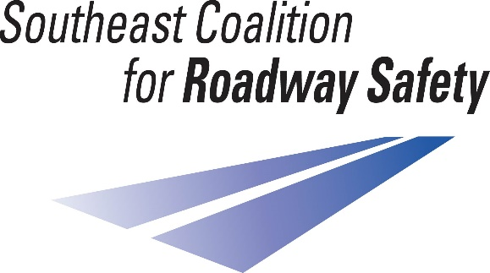
The Southeast Coalition for Roadway Safety’s Executive Board approved the purchase of car seats for health departments, hospitals, and other organizations with Certified Child Passenger Safety Technicians, to promote the importance of occupant protection and child safety.
The Coalition’s purpose is to end traffic fatalities and serious injuries on public roadways.
We believe we can do this, but it will take a team effort.

We will provide both convertibles and high back boosters through this initiative. There must be a guarantee from your organization that the car seats will not go out without being properly installed by a CPS Technician. Additionally, we will follow-up with organizations receiving the child safety seats to find out how many have been distributed throughout the year.

While we cannot guarantee we will be able to purchase all requested quantities, we do hope to help as much as possible. Active participation with the Southeast Coalition for Roadway Safety may increase your chances of receiving car seats donated to your organization. Please provide your projected quantity needs for the year.

Please send the following information via email by Friday, March 25, 2022 to Ashley.metelski@modot.mo.gov. We hope to place the order shortly after that.

Agency/Organization Name:
CPS Tech contact:
Phone number:
Physical address:
Email address:
Number of convertible car seats requested:
Number of high back booster seats requested:
On average, the number of convertible car seats given out per year:
On average, the number of high back booster seats given out per year:

