Southeast Coalition for Roadway Safety
Law Enforcement Grant Progress Report
Outcomes reports are due every 6 months. You may submit these when you submit your Law Enforcement Grant (or by June 1) and by December 31.
Email reports to Ashley.metelski@modot.mo.gov

Agency Name: _________________________________________________________________________________________________

Reporting Period: _____________________________________________________________________________________________

Type of Citation
 | Seat Belts/ and or Car Seats | Speeding | DWI | Distracted Driving | CNI Driving | Other HMV | Total Stops
January
February
March
April
May
June
July
August
September
October
November
December

List any campaigns, programs, community or school events, presentations or any other outreach efforts you have participated in promoting roadway safety in your area.

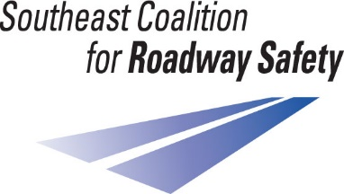
Signature: _________________________________________________________

