RE: Meeting on January 22, 2021
9:00 a.m. to 11:00 a.m.
Virtual WebEx Meeting
RSVP by January 15, 2021

Southwest District plans to host their annual asphalt contractor meeting virtually this year utilizing WebEx. This virtual meeting is for any asphalt contractors from around the state who may be interested in bidding projects in Southwest Missouri during the 2022 State Fiscal Year.

The agenda will include a general discussion on several items including recent staffing changes at MoDOT, consultant inspection, AASHTOWare and our expectations on PPE usage and safety in work zones. Following the general discussion, there will be a review of the groupings for the FY 2022 asphalt contracts. Your input can help shape how we structure the project combinations.

This meeting is planned for January 22, 2021, from 9:00 a.m. to 11:00 a.m. on WebEx. We encourage any contractors who plan to bid on our projects being let this fall to attend, as well as any local aggregate suppliers.

If you are interested in attending, please RSVP by January 15, 2021 to Jason Evenden at Jason.Evenden@modot.mo.gov or 417-408-4650. Please indicate in your email or phone call who will be attending the meeting. We also ask that you designate a primary contact for your company and provide all of their contact information. After receiving your RSVP, we will send a meeting invite to the primary contact which will include a link to join the meeting virtually thru WebEx. A dial in number will also be included in the event you can only join by phone. We encourage attendees to join using the link in order to see information shared on screen but will plan to make available electronic copies of the agenda and project grouping maps prior to the meeting. Your primary contact will be notified in the event we need to reschedule or cancel the meeting.

Sincerely,

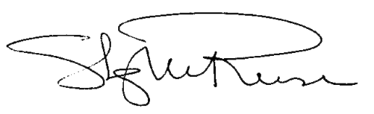

Stacy Reese, P.E.
Assistant District Engineer

