New CRE2O sheets will be needed for AASHTOWare Project (AWP) and these are currently in development.  In the interim, contractors will need to place their QC CRE2O spreadsheets on the External SharePoint site for their contracts.  A CRE2O folder should be created for each contract.  The project offices and/or materials inspectors should set an alert on that folder to be notified when new items are added to the folder, which will in turn email the person with the notification that a document has been added.

CRE2O picklists are pulled from the SiteManager database and will be missing Contract IDs and line numbers for AWP contracts.  Some mix designs (both concrete and asphalt) may have been entered only into AWP and might not be available as well.  To address these two issues:

1. Contracts administered in AWP are not listed in SiteManager and will not be available for selection on the Contract and Quantities tab shown below.  The contractor will need to enter the represented quantity for the sample at the top of the Contract and Quantities tab, but will have to leave the selections for Contract ID and line number blank.
2. If the mix design ID is not available for selection in the CRE2O picklist, have the contractor put the mix ID in the remarks on the General tab

Contract and Quantities Tab:

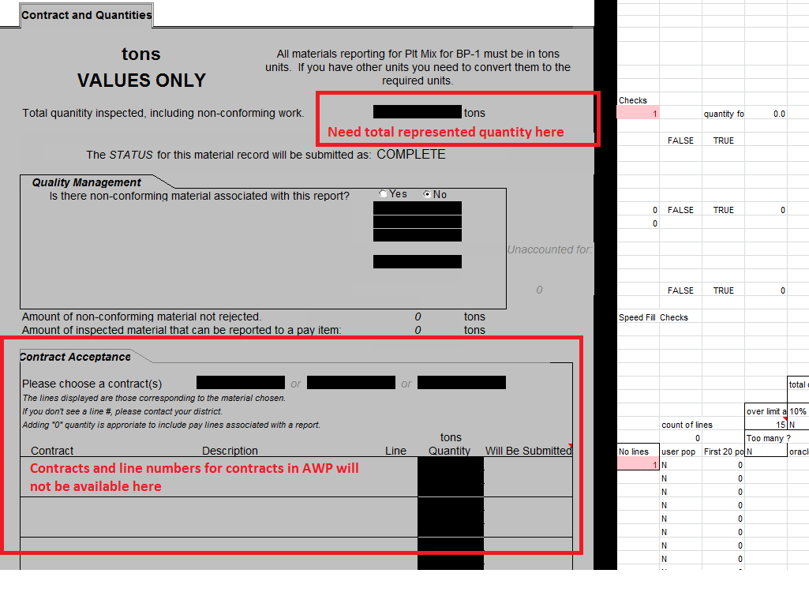

General Tab:

