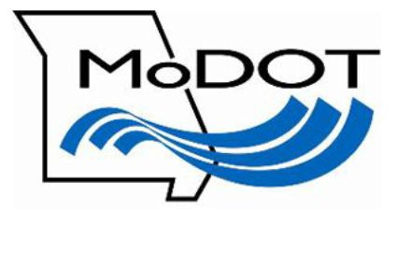
Howard County,
Route V
Bridge Replacement
Public Meeting
March 21, 2018

Welcome!

The purpose of today’s meeting is to help you learn more about plans to replace the bridge over Doxie Creek on Route V in Howard County. The work is currently scheduled to take place in 2018.

This is an open-house public meeting. MoDOT employees are here to help you and explain various aspects of the proposed project.

As you move through the displays, please share your questions and comments with us. Your input is very important.

For more information, contact us toll free at 1-888-ASK-MODOT (275-6636) or visit us online at www.modot.org/central.

Thank you for your participation.

