This readme file will help guide you through some of the aspects of using the MoDOT’s Bridge Office standard drawings.
Viewing Files
Some standard drawings require the use of a standard file and a reference file. To be able to use the reference sheet with the standard sheet they must both be downloaded.
Your first step is to open the Microstation standard file sheet. Once it is open, you must click on the Reference icon in the Primary Tool Bar.
After clicking on the icon the Reference File window will open
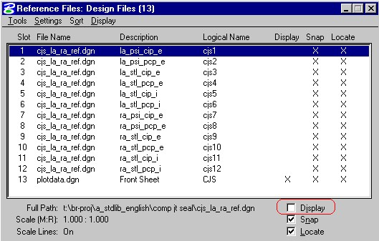
Select the reference which best suites your type of bridge and then click on the Display check box. The reference file will then appear on the screen.

