Structural Engineering Guidance No. 10-09

Date: August 17, 2010

Distribution: All Engineering Resources

SUBJECT: SIDE RESISTANCE ELEVATIONS PLAN REPORTING FOR ROCK
SOCKETS

Contact: Gregory Sanders

Effective Date: Immediately for Jobs Not Turned In To Review Section

EPG Submittal Status: To Be Submitted

Purpose:

This guidance will show how to report multiple side resistance elevations on the bridge plans for rock sockets. It is also being issued to support Construction and Materials Division and contractors in validating the Minimum Nominal Axial Compressive Resistance, MNACR_{SF}, for single or multiple rock layers to be reported on the bridge plans compared with the actual field nominal side friction resistance determined from foundation coring during construction of each rock socket that is required by Sec 701 of the Standard Specifications.

This guidance shall apply to all rock socket designs with single or multiple layers of rock where the side resistance elevation(s) is reported on the Geotechnical Report.

Guidance:

Elevations of rock layers at which the side friction resistance of the rock is utilized for the design of each rock socket diameter and length, and the MNACR_{SF} of each rock layer shall both be reported on the Foundation Data Table on the bridge plans for rock socket foundations.

Elevations are provided in the Foundation Investigation Geotechnical Report and are usually given in ranges. The nominal side resistance for rock sockets and a side resistance factor are also provided and should be used to determine the diameter and length of rock socket required.

See illustration below for example of plan reporting.

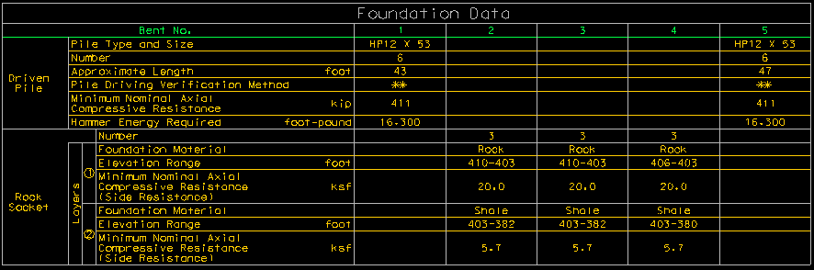

Guidance Cont.):

This guidance shall apply to all rock socket designs with single or multiple layers of rock where the side resistance elevation(s) is reported on the Foundation Investigation Geotechnical Report.

Do not report the side resistance elevations on the foundation (substructure) sheets.

Do not report the side resistance factors on the Foundation Data Table for either single or multiple layers.

______________________________________________________________________________________

Appendix - Background:

This guidance, August 17 Structural Engineering Guidance 10-09, was initially to address how to report multiple rock layers on the bridge plans that are utilized in designing the diameter and length of rock sockets which led to reviewing the current practice of reporting rock socket data on the bridge plans.

Of first importance related to this guidance, reviewing our current reporting practice showed that the only foundation data now required to be shown on the bridge plans are the diameter, length and MNACR_{SF} of each rock socket, and it is fair to state that not reporting the useable elevation ranges of the rock layers much less even just a single layer elevation range seemed irregular (‘useable’ is referring to any rock that can be utilized in developing geotechnical side resistance of the socket). But, previous to this guidance, important data such as the elevation of the rock layer(s) that was useable for developing the resistance of a rock socket and the MNACR_{SF} specific to each layer were not shown on the bridge plans. In fact, using mostly single layers was common practice in the past for whatever reasons. Layers were most likely combined/averaged into a larger layer by the Geotechnical Section or in design practice by the bridge designer in simplifying the calculation and estimation of the geotechnical resistance of a rock socket. Naturally, guidance was needed on how to report multiple rock layers on the bridge plans for consistency in detailing and in practice, and there have been two projects completed to date doing just this and used as a reference (provided upon request).

Of second importance, because elevations of either a single layer or multiple layers of rock are not shown on the bridge plans, the actual design length of socket used for developing resistance is unknown or worse, the inference could wrongly be made that the design geotechnical resistance is developed over the entire length of the rocket socket as shown on the bridge plans which is not correct in any case. Without the aid of supporting documentation in the form of either the Foundation Investigation Geotechnical Report or the design computations, both of which are not supplied with the contract documents, portions of the rock socket length not useable for developing the nominal geotechnical resistance would be unknown based on a reading of the bridge plans only. The fact that it is not possible to determine the MNACR_{SF} of a rock socket readily from a set of bridge plans because of incomplete information is overall the primary purpose of this guidance to rectify.

What this means is that by including more rock socket foundation information on the bridge plans, the required nominal resistance for each rock socket in the field can be estimated from the plans. And, based on more complete and more accurately represented rock socket data, Construction and Materials Division inspectors and contractors can confirm (validate) the MNACR_{SF} and rock layer elevation ranges reported on the plans with the actual field nominal side friction resistance for each layer that is determined from the foundation corings required in accordance with Sec 701 of the Standard Specifications during construction of each rock socket.

