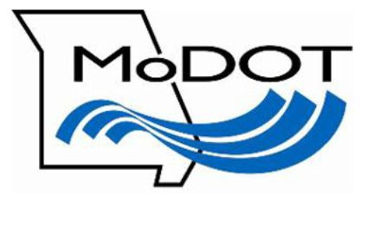
Howard County
Route V
Doxie Creek Bridge Replacement
Public Meeting
March 21, 2018

Frequently Asked Questions

What is the purpose of tonight’s meeting?
The purpose of tonight’s meeting is to provide information on plans to replace the bridge over Doxie Creek on Route V approximately 5 miles west of Route 3.

Why is this work necessary?
The existing Doxie Creek Bridge was built in 1947 and is seventy years old. The condition of the bridge has reached a point where replacement is necessary.

How will traffic be affected?
The bridge replacement will require full closure of Route V during construction. There are multiple alternate routes for motorists to use to drive around the work area. Motorists will be directed to use these alternate routes during the closure.

When will the work take place?
The project is scheduled to start in summer 2018, with construction scheduled to be complete in the fall of 2018.

Will additional right of way be needed to construct this project?
All of the work will be completed within existing right of way.

What will the project cost?
The total cost is approximately $600,000.

How can I learn more?
You may learn more by contacting us toll-free at 1-888-ASK-MoDOT (275-6636) or by visiting www.modot.org/central.

