Contractor Reporting Excel2Oracle (CRE2O) User Manual

General Information:
The CRE2O system uses Microsoft Excel forms with coding to allow contractors to submit testing information directly into MoDOT’s database. Each form makes a single sample record that covers a specific material and date of inspection. The quantities and tests entered on the forms count towards satisfying the contract sampling and testing requirements that control payment in MoDOT’s system.
The CRE2O sheets and the latest version of this help file can be found at: http://www.modot.org/quality
For the testing data to be acceptable to our database, it must meet certain criteria. The forms themselves should limit and verify your entries to ensure those criteria are met. Attempts to bypass checks included on the forms or alter the sheets are likely to result in a failure of the sheet to import properly. Be aware that altering calculations on the forms to affect results constitutes fraud and can be detected by MoDOT upon review. If you believe the forms are not allowing you the range of input you need or have other suggestions about their function please don’t hesitate to contact us.
Software Requirements:
The sheets are designed around Microsoft Excel 2010 and newer. The coding in the sheet that interfaces with MoDOT’s website uses base features found in every Microsoft operating system. At this time, other operating systems are not supported.
We understand the need to get CRE2O working on as many types of tablets as possible and will try to extend the coding to IOS and Android in the future. In the meantime, the CRE2O sheets may still be fillable on Apple products with Excel. This means that a person with an IPad could use the sheets, but would have to transfer them to a Microsoft computer for uploading.
Use:
Having macros turned on is a requirement as there is extensive programming in the sheets that needs to execute. To navigate the CRE2O sheets, use the “tabs” at the top. There are two rows of tabs as shown below:
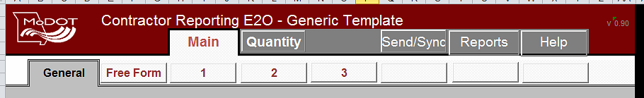

The Main Tab:

Identification Numbers and Record Numbers:
Each form must have an identification number. It is these ID#s that are used to track sample records in the system. MoDOT inspectors create their own ID#s in a certain format and kept track of which ones they’ve used. The formatting portion has been taken care of for you on CRE2O sheets. You are responsible for keeping track of which record numbers you have used. If you try to submit a record number twice, the second one will fail to be processed.
Standard ID# format: YYQM%%%#### (example: 14QMWAJ0001)
YY is the year in two digit format
QM stands for Quality Management and is used for all contractor submitted records
%%% are the contractors assigned three digit initials.
#### is the record number, 1 to 9999. Zeros count as unique; making 1, 01, 001 all different as far as the system is concerned . MoDOT strongly suggests the use of leading zeros as this will make an reports using the ID#s sort properly.

For any given year each contractor can make over ten thousand records without running out of numbers. Contractors with more than one QC person may wish to divvy up their record numbers into blocks for each QC person to use. This will prevent accidentally submitting multiple forms under one ID#. (Example: Jack 0-1000, Tom 1001-2000, Laura 2001-3000)

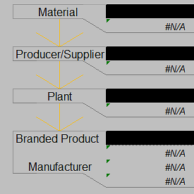
Material – Producer – Plant –Branded Product
Each CRE2O sheet describes a material and where it was produced or who supplied it. If you do not see the choices you are expecting in these picklists please consult your MoDOT inspectors for assistance.
The Sampling Checklist may be provided to you by MoDOT and can show which materials are expected for each contract line. Do not automatically follow the sampling checklist if it is incorrect. Work with your MoDOT inspector to ensure that what you are reporting describes what you actually did.

Free Form:
The Free Form acts as a sort of catch all for when there is no specific test made to cover what is being reported. It’s also a good place to put additional descriptions that explain testing results.

Quantity Tab:
This tab allows you to describe the amount of material you’ve inspected and what its status is. Note that all quantities must be reported in the official units for that material. The CRE2O sheet will tell you what the units must be. Quantities should be as accurate as possible. It is understood that some materials do not have exact measurements such as scale tickets. In those cases where quantities must be estimated discuss accuracy with your MoDOT inspector when needed.
There are two different types of quantities associated with MoDOT’s sample records.
- Total Inspected Quantity: All material reviewed or tested even if you know it is not going to be used on the job.
- Contract Quantity: Only material to be used and paid for on the job.

There are legitimate cases where the contract quantity is less than the sampled quantity. Rejected and wasted materials are such cases. There are also times where you may wish to report a whole stockpile of material as sampled quantity, but only a portion of the stockpile would be used on this job as contract quantity. This is useful because later if you have a second job, this CRE2O sheet could be “updated” to include the contract quantities for the second job. Bulk items like drainage fabrics that get moved from job to job until they are used up are easily handled that way.

Total Inspected Quantity:
This quantity includes everything reviewed including waste, rejected, deficient, and non-compliant materials. If you have deficient or non-compliant materials there are some additional questions to be answered. How you fill out these areas will determine the “status” of your report which gets conveyed to the MoDOT inspectors.

Contract Acceptance Quantity:
These quantities represent material that is acceptable for payment only. The units in this area are still in the official material units. It is very important to include all related pay lines. Leaving pay lines off these sheets could delay MoDOT’s payment for completed work. The exact quantity reported to each pay line does not have to be 100% accurate. In cases where you can specifically assign quantity to a line, you should. Otherwise try to proportion the quantities to lines as reasonably as possible.
Note that the material units may be different than the pay line units (MoDOTs system contains a “conversion factor” to translate between the individual materials and pay lines.)
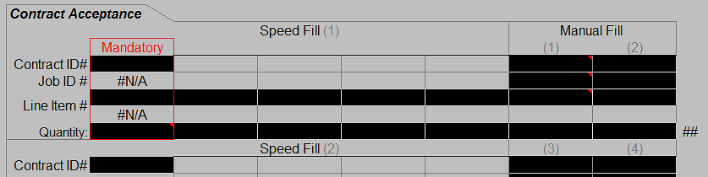
The contract acceptance quantity entry is broken down into two speed fill areas and four manual fill areas. The speed fills are for your convenience, as once you choose the correct contract, only line items with that material will show up. Each speed fill area can have up to five different line numbers. If you don’t see a line number in the speed fill choices that you are expecting it likely means the material you choose is not associated with that line. Please consult the sampling checklist or your MoDOT inspector for assistance.
The manual fill areas might be useful if you run out of speed fill slots or if you need to report to a contingent item pay line that is not showing up in the speed fills yet. Be aware that in the manual fill areas that your text must exactly match the contract, job, and line numbers (0010, NOT 10). The report will not process if the manual fill areas are not exactly the same as the database expects.

Testing Information:
Each sheet type contains different testing templates that are designed to accommodate typical inspection and testing work. Enough “sets” of testing forms are provided to cover 90+% of the work done. If you run into a case where more tests were performed than there are spaces consult with your inspector on what is the best way to handle that case.

Send/Sync Tab:
This tab houses the functions that connect to MoDOT’s website. In general you will need an Internet connection to use these functions.

Sending a Completed Form to MoDOT:
When you hit the send button, several things happen in the code. The first is that the form checks itself for completeness. If it finds required data is missing, the upload process is ended and a message is displayed to look for required information. You can find the problem area by looking for red highlights in the column AC just right of the black band that signifies the end of the form. Once you’ve found the red highlight, on or near that row, is where there is missing data. The red highlight will go away once you’ve entered the correct information and you can attempt upload again.
In the next step the form will write two temporary files to your computer. One of these files is a copy of the form itself with a standardized file name using the record ID#. Please be aware that whatever you name the file on your computer WILL NOT be what gets uploaded to MoDOT.
Next the actual upload takes place using DOS shell and ftp commands. If you are not connected to the internet an error message will be displayed and you will need to save the file locally and upload it later when you are connected to the Internet.
There is a feature on the Send/Sync tab called “Allow Updating” which is only used in specific cases. By default the processing server will not overwrite any existing information. This is a failsafe to prevent accidently wiping out an old record with a new one. When the server finds existing data the report will reject with a “unique constraint” error message. If you use the “Allow Updating” button, you turn off the failsafe protection and the server will overwrite the old report and its data. This feature should only be used if you are correcting or adding additional information to an existing report.

Rejection:
When the server processes your form, it can be rejected for any number of reasons. We’ve tried to prevent this from happening, but we can’t cover 100% of the possibilities on how everyone uses an Excel file. If your form is rejected you will receive an automated email stating such and the email may have enough description of the rejection cause for you to figure out the solution. If not, contact your Inspector for additional help. It is your responsibility to get your form corrected and submitted acceptability.

Contact Information:
Each time you submit a CRE2O sheet, you must enter two people for the processing server to use as contacts. A MoDOT person you work with on the job (available through picklist) and your email address.

Security Word:
Each contractor has been assigned a random security word for their whole company. This provides minimal security to prevent accidental cross reporting by one contractor to another. MoDOT can assign a new security word upon request if you feel it is necessary due to personnel changes. The security word is entered on the Send/Sync tab and must correlate to the reporting contractor field on the General tab to be accepted by the system.

Allow Updating:

The Excel2Oracle will not overwrite existing data by default. This is to protect the existing data from accidently being destroyed. Once clicked, the "allow updating" button will let Excel2Oracle to overwrite existing data in MoDOT’s system. This should be a rare case and care should be taken when doing this to make sure the sample ID is correct.

Picklists:
Throughout the form there are several fields where you must choose a value from a list. The values shown in the lists are specially validated to work in MoDOT’s database. Do not attempt to circumvent these picklists as the form will likely not process correctly. On the Send/Sync tab there is a way for you to retrieve and incorporate the latest picklist values from MoDOT.
If you do not see the value you need in a list:
- “Update Picklist” button on the Send/Sync tab. If that doesn’t bring in the value you are looking for, then;
- Contact your MoDOT inspector for assistance. After the MoDOT person adds your desired values to the MoDOT database, then the “Update Picklist” button can be used to retrieve them in the sheet. Keep in mind that the publishing of picklist information to the Internet is automated and on a two hour schedule so changes may not be available to retrieve instantly after the database is updated by MoDOT.
The “Update Picklist” function gives you the choice to download all or just portions of the picklist information available. This feature was included to reduce the amount of data retrieved to save you time and cost if you are on a limited Internet connection.

News and Sheet Versions:
On the Send/Sync tab there is a place at the bottom where information about the CRE2O system is displayed. The form is coded to attempt to automatically retrieve the latest news, but you can also force a news check using the button. The automatic update occurs the first time you visit the Send/Sync tab each day for a particular file.
Included in the news is a way to check the latest version of the form you are using. You should always attempt to use the most up to date version of each CRE2O sheet because versions that are too old may no longer process correctly. This is especially true when a major version comes out.
Version nomenclature: A.BC
“A” is the major version. Major changes are rare and usually will require switching to the newest form
“B” is the minor version. Minor changes may not require switching, but updating is recommended
‘C” is the errata version. Errata fixes do not require switching.

How It Works:
This diagram shows how data is passed around to make CRE2O work. MoDOT inspectors directly access our Oracle server using the SiteManager program. The oracle data is published to the website automatically every two hours. Contractors access the website using the CRE2O sheets. The processing server runs every 10 minutes to take your CRE2O sheets and input them into the Oracle database.
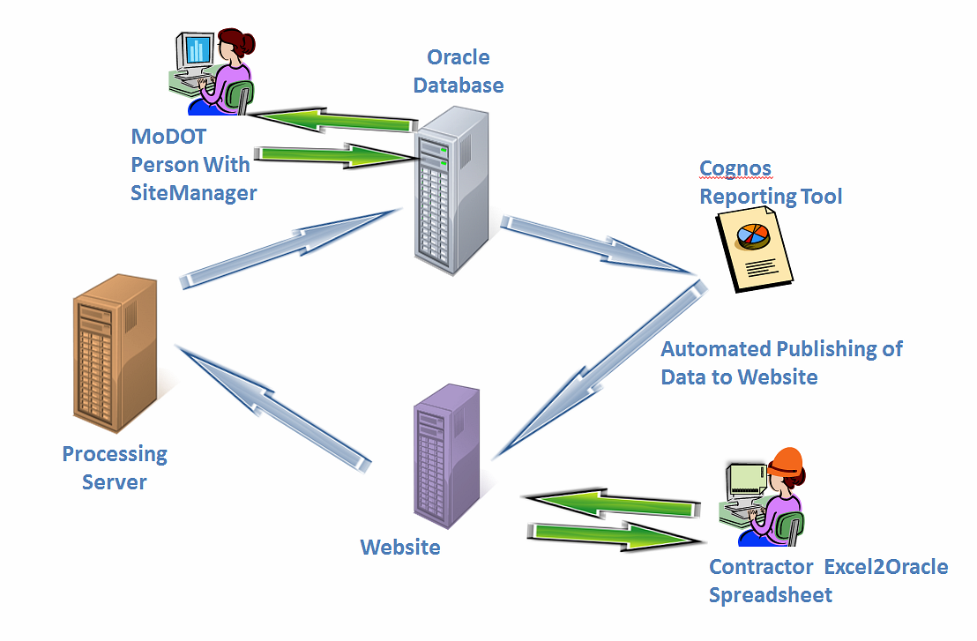

Reports Tab:
The reports tab is used for printable paper reports of the information entered on the CRE2O sheet. This area hasn’t been created yet. If you have suggestions on what is needed for paper reporting, please let us know.

Help Tab:
The sheets contain some basic help information. There is also a link to this manual online with more detailed help information.

Support Contact Information:
If you have questions about filling out the sheets or don’t see an option in a picklist you believe should be there, contact your district MoDOT inspector for assistance.
If you have suggestions about the layout or function of the sheets please contact Construction and Materials, Michael Meyerhoff (michael.meyerhoff@modot.mo.gov) or 573 522-5047.

